**Diploma Engineering**

Laboratory Manual

**(Advanced Computer Network)**

**(4350706)**

[ Computer Engineering, Semester V ]

|  |  |
| --- | --- |
| Enrolment No |  |
| Name |  |
| Branch |  |
| Academic Term |  |
| Institute |  |



**Directorate Of Technical Education Gandhinagar - Gujarat**

**DTE’s Vision:**

* To provide globally competitive technical education.
* Remove geographical imbalances and inconsistencies.
* Develop student friendly resources with a special focus on girls’ education and support to weaker sections.
* Develop programs relevant to industry and create a vibrant pool of technical professionals.

**Institute’s Vision:**

**Institute’s Mission:**

**Department’s Vision:**

**Department’s Mission:**

**Certificate**

This is to certify that Mr./Ms ………………………………………………………………………………………………. Enrollment No. …………………………… of 5th Semester of *Diploma in Computer Engineering* of ……………………………………………………………………… (GTU Code: ) has satisfactorily completed the term work in course Advanced Computer Network (4350706) for the academic year: ……………………… Term: Odd prescribed in the GTU curriculum.

Place: - ……………………

Date: - ………………………

**Signature of Course Faculty Head of the Department**

**Preface**

The primary aim of any laboratory/Practical/field work is enhancement of required skills as well as creative ability amongst students to solve real time problems by developing relevant competencies in psychomotor domain. Keeping in view, GTU has designed competency focused outcome-based curriculum -2021 (COGC-2021) for Diploma engineering programmes. In this more time is allotted to practical work than theory. It shows importance of enhancement of skills amongst students, and it pays attention to utilize every second of time allotted for practical amongst Students, Instructors and Lecturers to achieve relevant outcomes by performing rather than writing practice in study type. It is essential for effective implementation of competency focused outcome- based green curriculum-2021. Every practical has been keenly designed to serve as a tool to develop & enhance relevant industry needed competency in each and every student. These psychomotor skills are very difficult to develop through traditional chalk and board content delivery method in the classroom. Accordingly, this lab manual has been designed to focus on the industry defined relevant outcomes, rather than old practice of conducting practical to prove concept and theory.

By using this lab manual, students can read procedure one day in advance to actual performance day of practical experiment which generates interest and also, they can have idea of judgement of magnitude prior to performance. This in turn enhances predetermined outcomes amongst students. Each and every Experiment /Practical in this manual begins by competency, industry relevant skills, course outcomes as well as practical outcomes which serve as a key role for doing the practical. The students will also have a clear idea of safety and necessary precautions to be taken while performing experiment.

This manual also provides guidelines to lecturers to facilitate student-centered lab activities for each practical/experiment by arranging and managing necessary resources in order that the students follow the procedures with required safety and necessary precautions to achieve outcomes. It also gives an idea that how students will be assessed by providing Rubrics.

In today's interconnected world, computer networks form the backbone of communication and information exchange between individuals, businesses, and organizations. As the demand for faster and more efficient network communication continues to increase, there is a need for professionals who can design, implement, and manage computer networks. This course on Advanced Computer Networks will focus on various concepts and protocols of computer networks. Students will learn about IPv4, IPv6 and its features, routing protocols like RIP, OSPF and BGP, and Transport Layer Protocols like TCP, UDP and SCTP. They will also gain knowledge about Application Layer Protocols such as HTTP, SMTP, POP3, IMAP4, and DNS. The course will provide hands-on experience in configuring and managing network infrastructures, troubleshooting network issues, and analysing network traffic. Upon completion, students will be equipped with the skills and knowledge to design, implement, and manage advanced computer networks with a strong understanding of network, transport and application layers concepts and protocols.

Although we try our level best to design this lab manual, but always there are chances of improvement. We welcome any suggestions for improvement.

**Programme Outcomes (POs):**

1. **Basic and Discipline specific knowledge:** Apply knowledge of basic mathematics, science and engineering fundamentals and engineering specialization to solve the engineering problems.
2. **Problem analysis:** Identify and analyse well-defined engineering problems using codified standard methods.
3. **Design/ development of solutions:** Design solutions for engineering well-defined technical problems and assist with the design of systems components or processes to meet specified needs.
4. **Engineering Tools, Experimentation and Testing:** Apply modern engineering tools and appropriate technique to conduct standard tests and measurements.
5. **Engineering practices for society, sustainability and environment:** Apply appropriate technology in context of society, sustainability, environment and ethical practices.
6. **Project Management:** Use engineering management principles individually, as a team member or a leader to manage projects and effectively communicate about well-defined engineering activities.
7. **Life-long learning:** Ability to analyze individual needs and engage in updating in the context of technological changes in field of engineering.

**Practical Outcome - Course Outcome matrix**

|  |  |  |  |  |  |  |
| --- | --- | --- | --- | --- | --- | --- |
| **Course Outcomes (COs):**   1. CO1 - Configure a computer network using IPv4 protocol. 2. CO2 - Configure a computer network using IPv6 protocol. 3. CO3 - Choose unicast routing protocols to implement routing in the given computer network. 4. CO4 - Compare features, formats, and applications of various transport layer protocols. 5. CO5 - Use various application layer protocols in the network configuration. | | | | | | |
| **S. No.** | **Practical Outcome/Title of experiment** | **CO1** | **CO2** | **CO3** | **CO4** | **CO5** |
| **1.** | a) Rewrite the following IP addresses in binary notation  192.168.12.79  156.152.187.189  172.16.12.11  10.159.187.198  b) Rewrite the following IP addresses in dotted decimal notation  11000000.10101000.00111000.00001100  10101001.00001100.00001011.01001111  00001010.10111011.00001100.01111011  01111101.10111011.11100000.11111111  c) Consider the following IP addresses  214.229.206.83/28  153.120.147.39/26  115.173.104.1/18  70.173.166.71/1  Find the following for each above IP address  1. Network Address  2. First Host Address  3. Last Host Address  4. Broadcast Address  5. Next Subnet Address  d) An organization is granted block 212.18.190.0/24. The administrator wants to create 32 subnets.  1. Find the subnet mask.  2. Find the number of addresses in each subnet.  3. Find the first and last address in subnet 1  4. Find the first and last address in subnet 32. | **✓** |  |  |  |  |
| **2.** | a) Investigate IP protocols by capturing and studying IP datagrams using Wireshark  b) An IP datagram has arrived with the following partial information in the header (in hexadecimal): 45000054 00030000 2006...  What is the header size?  Are there any options in the packet?  What is the size of data?  Is the packet fragmented?  How many more routers can the packet travel to?  What it the protocol number of the payload being carried by the packet? | **✓** |  |  |  |  |
| **3.** | Capture and study ICMPv4 packets generated by Other utility programs such as ping and traceroute using relevant software | **✓** |  |  |  |  |
| **4.** | Create a small IPv4 static routing network using relevant software. | **✓** |  |  |  |  |
| **5.** | Create a small IPv6 network using any relevant software. |  | **✓** |  |  |  |
| **6.** | Configure RIP routing protocol using relevant software. |  |  | **✓** |  |  |
| **7.** | Configure OSPF routing protocol using relevant software. |  |  | **✓** |  |  |
| **8.** | Configure BGP routing protocol using relevant software. |  |  | **✓** |  |  |
| **9.** | a) The following is a dump (contents) of a UDP header in hexadecimal format.  0045DF0000580000  a. What is the source port number?  b. What is the destination port number?  c. What is the total length of the user datagram?  d. What is the length of the data?  e. Is the packet directed from a client to a server or vice versa?  f. What is the application-layer protocol?  g. Has the sender calculated a checksum for this packet?  b) The following is part of a TCP header dump (contents) in hexadecimal format.  E293 0017 00000001 00000000 5002 07FF..  a. What is the source port number?  b. What is the destination port number?  c. What is the sequence number?  d. What is the acknowledgment number?  e. What is the length of the header?  f. What is the type of the segment?  g. What is the window size?  c) The following is a dump of an SCTP general header in hexadecimal format.  04320017 00000001 00000000  a. What is the source port number?  b. What is the destination port number?  c. What is the value of the verification tag?  d. What is the value of the checksum? |  |  |  | **✓** |  |
| **10.** | Capture and Study TCP and UDP Packets using relevant software. |  |  |  | **✓** |  |
| **11.** | Configure Dynamic Host Configuration Protocol using relevant software. |  |  |  |  | **✓** |
| **12.** | 1. Configure Domain Name Server (DNS) using relevant software.   Configure Web Server using relevant software. |  |  |  |  | **✓** |
| **13.** | Configure File Transfer Protocol (FTP) using relevant software. |  |  |  |  | **✓** |
| **14.** | Configure Mail Server Using relevant software. |  |  |  |  | **✓** |

**Industry Relevant Skills**

*The following industry relevant skills are expected to be developed in the students by performance of experiments of this course.*

1. Solve IPv4 related problems such as validation of IPv4 address, Conversion of binary notation to dotted decimal notation and vice versa, subnetting, finding specific address.
2. Configure network using IPv4 protocol.
3. Configure network using IPv6 Protocol.
4. Configure various unicast routing protocols such as RIP, OSPF, BGP.
5. Configure various application layer protocols such as HTTP, DHCP, DNS, FTP and Mail server related protocols.
6. Analyse different protocol such as TCP, UDP, ICMP using Wireshark.
7. Troubleshoot computer network.

**Guidelines to Course Faculty**

1. Couse faculty should demonstrate experiment with all necessary implementation strategies described in curriculum.
2. Couse faculty should explain industrial relevance before starting of each experiment.
3. Course faculty should Involve & give opportunity to all students for hands on experience.
4. Course faculty should ensure mentioned skills are developed in the students by asking.
5. Utilise 2 hrs of lab hours effectively and ensure completion of write up with quiz also.
6. Encourage peer to peer learning by doing same experiment through fast learners.

**Instructions for Students**

1. Organize the work in the group and make record of all observations.
2. Students shall develop maintenance skill as expected by industries.
3. Student shall attempt to develop related hand-on skills and build confidence.
4. Student shall develop the habits of evolving more ideas, innovations, skills etc.
5. Student shall refer technical magazines and data books.
6. Student should develop habit to submit the practical on date and time.
7. Student should well prepare while submitting write-up of exercise.

|  |  |  |  |
| --- | --- | --- | --- |
| **Progressive Assessment Sheet** | | | |
| **Enrollment No:** |  | **Name:** |  |
| **Term:** |  |  |  |

|  |  |  |  |  |  |
| --- | --- | --- | --- | --- | --- |
| **Sr no** | **Practical Outcome/Title of experiment** | **Page** | **Date** | **Marks** | **Sign** |
| **1** | a) Rewrite the following IP addresses in binary notation  192.168.12.79  156.152.187.189  172.16.12.11  10.159.187.198  b) Rewrite the following IP addresses in dotted decimal notation  11000000.10101000.00111000.00001100  10101001.00001100.00001011.01001111  00001010.10111011.00001100.01111011  01111101.10111011.11100000.11111111  c) Consider the following IP addresses  214.229.206.83/28  153.120.147.39/26  115.173.104.1/18  70.173.166.71/1  Find the following for each above IP address  1. Network Address  2. First Host Address  3. Last Host Address  4. Broadcast Address  5. Next Subnet Address  d) An organization is granted block 212.18.190.0/24. The administrator wants to create 32 subnets.  1. Find the subnet mask.  2. Find the number of addresses in each subnet.  3. Find the first and last address in subnet 1  4. Find the first and last address in subnet 32. |  |  |  |  |
| **2** | a) Investigate IP protocols by capturing and studying IP datagrams using Wireshark  b) An IP datagram has arrived with the following partial information in the header (in hexadecimal): 45000054 00030000 2006...  What is the header size?  Are there any options in the packet?  What is the size of data?  Is the packet fragmented?  How many more routers can the packet travel to?  What it the protocol number of the payload being carried by the packet? |  |  |  |  |
| **3** | Capture and study ICMPv4 packets generated by Other utility programs such as ping and traceroute using relevant software |  |  |  |  |
| **4** | Create a small IPv4 static routing network using relevant software. |  |  |  |  |
| **5** | Create a small IPv6 network using any relevant software. |  |  |  |  |
| **6** | Configure RIP routing protocol using relevant software. |  |  |  |  |
| **7** | Configure OSPF routing protocol using relevant software. |  |  |  |  |
| **8** | Configure BGP routing protocol using relevant software. |  |  |  |  |
| **9** | a) The following is a dump (contents) of a UDP header in hexadecimal format.  0045DF0000580000  a. What is the source port number?  b. What is the destination port number?  c. What is the total length of the user datagram?  d. What is the length of the data?  e. Is the packet directed from a client to a server or vice versa?  f. What is the application-layer protocol?  g. Has the sender calculated a checksum for this packet?  b) The following is part of a TCP header dump (contents) in hexadecimal format.  E293 0017 00000001 00000000 5002 07FF..  a. What is the source port number?  b. What is the destination port number?  c. What is the sequence number?  d. What is the acknowledgment number?  e. What is the length of the header?  f. What is the type of the segment?  g. What is the window size?  c) The following is a dump of an SCTP general header in hexadecimal format.  04320017 00000001 00000000  a. What is the source port number?  b. What is the destination port number?  c. What is the value of the verification tag?  d. What is the value of the checksum? |  |  |  |  |
| **10** | Capture and Study TCP and UDP Packets using relevant software. |  |  |  |  |
| **11** | Configure Dynamic Host Configuration Protocol using relevant software. |  |  |  |  |
| **12** | 1. Configure Domain Name Server (DNS) using relevant software. 2. Configure Web Server using relevant software. |  |  |  |  |
| **13** | Configure File Transfer Protocol (FTP) using relevant software. |  |  |  |  |
| **14** | Configure Mail Server Using relevant software. |  |  |  |  |

**Date: ……………**

**Practical No.1:**

1. Rewrite the following IP addresses in binary notation.
   1. 192.168.12.79
   2. 156.152.187.189
   3. 172.16.12.1
   4. 110.159.187.198
2. Rewrite the following IP addresses in dotted decimal notation.
   1. 11000000.10101000.00111000.00001100
   2. 10101001.00001100.00001011.01001111
   3. 00001010.10111011.00001100.01111011
   4. 01111101.10111011.11100000.11111111
3. Consider the following IP addresses.
   1. 214.229.206.83/28
   2. 153.120.147.39/26
   3. 115.173.104.1/18
   4. 70.173.166.71/1

Find the following for each above IP addresses.

1. Network Address
2. First Host Address
3. Last Host Address
4. Broadcast Address
5. Next Subnet Address
6. An organization is granted block 212.18.190.0/24. The administrator wants to create 32 subnets.
   1. Find the subnet mask.
   2. Find the number of addresses in each subnet.
   3. Find the first and last address in subnet 1.
   4. Find the first and last address in subnet 32.
7. **Objectives:**

* To understand the binary notation of IP addresses.
* To be able to convert IP addresses from decimal to binary notation and vice versa.
* To understand the subnetting of IP addresses.
* To be able to find the network address, first host address, last host address, broadcast address, and next subnet address for a given IP address.
* To be able to explain the significance of the network address, first host address, last host address, broadcast address, and next subnet address.

1. **Expected Program Outcomes (POs):** PO1, PO2, PO3, PO4, PO5, PO6, PO7
2. **Expected Skills to be developed based on competency:**

* To Solve IPv4 related problems such as validation of IPv4 address, Conversion of binary notation to dotted decimal notation and vice versa, subnetting, finding specific address.

1. **Expected Course Outcomes (COs) :** CO1
2. **Practical Outcomes (PROs)**

The student will be able ….

* To convert given IPv4 binary notation to dotted decimal notation and vice versa.
* To find subnet mask, network address, first host address, last host address, broadcast address and next subnet address for a given IPv4 address.

1. **Expected Affective domain Outcome (ADOs)**

* Follow ethical practices.
* Follow standard configuration.

1. **Prerequisite Theory:**

* Number Conversion from Binary to Decimal.
* Number Conversion from Decimal to Binary.
* Basics of IPv4 address.
* Classful IPv4 addressing.
* Classless IPv4 addressing.
* CIDR notation.
* Subnetting of IPv4 address.

1. **Exercise.**
2. ***Find the error, if any the write the reason, in the following IPv4 addresses.***
   1. 112.56.045.78
   2. 221.34.8.9.20
   3. 175.45.301.14
   4. 11110000.23.14.67
3. ***Find the class of following IPv4 addresses.***
   1. 00000001.10110110.10101010.11101111
   2. 11000010.10101100.11011101.11011011
   3. 27.23.120.8
   4. 253.5.15.111
4. ***Rewrite the following IP addresses in binary notation.***
   1. 192.168.12.79
   2. 156.152.187.189
   3. 172.16.12.1
   4. 110.159.187.198
5. ***Rewrite the following IP addresses in dotted decimal notation.***
   1. 11000000.10101000.00111000.00001100
   2. 10101001.00001100.00001011.01001111
   3. 00001010.10111011.00001100.01111011
   4. 01111101.10111011.11100000.11111111
6. **Write the private IP addresses range of class A, class B and class C.**
7. **Give any example of loopback IPv4 address.**
8. **Consider the IPv4 address 214.229.206.83/28 and find the following for the given IPv4 address.**
9. Network Address
10. First Host Address
11. Last Host Address
12. Broadcast Address
13. Next Subnet Address
14. **Consider the IPv4 address 153.120.147.39/26 and find the following for the given IPv4 address.**
15. Network Address
16. First Host Address
17. Last Host Address
18. Broadcast Address
19. Next Subnet Address
20. **Consider the IPv4 address 115.173.104.1/18 and find the following for the given IPv4 address.**
21. Network Address
22. First Host Address
23. Last Host Address
24. Broadcast Address
25. Next Subnet Address
26. **Consider the IPv4 address 70.173.166.71/1 and find the following for the given IPv4 address.**
27. Network Address
28. First Host Address
29. Last Host Address
30. Broadcast Address
31. Next Subnet Address
32. **An organization is granted block 212.18.190.0/24. The administrator wants to create 32 subnets.**
33. Find the subnet mask.
34. Find the number of addresses in each subnet.
35. Find the first and last address in subnet 1.
36. Find the first and last address in subnet 32.
37. **References**

* <https://subnetipv4.com>
* <https://www.geeksforgeeks.org/ip-addressing-classless-addressing/?ref=lbp>
* <https://www.tutorialspoint.com/computer_logical_organization/number_system_conversion.htm>
* <https://www.geeksforgeeks.org/ip-addressing-classless-addressing/?ref=lbp>

1. **Assessment-Rubrics**

|  |  |  |  |  |  |  |  |
| --- | --- | --- | --- | --- | --- | --- | --- |
| **Rubric ID** | **Task** | **Criteria** | **%** | **Good** | **Average** | **Poor** | **Mark** |
| **RB1** | Completion of the given task | The student completes all of the tasks required by the assignment. | 30% | All tasks are completed correctly and on time. **(Mark - 3)** | All tasks are completed, but some may be late or incorrect. **(Mark - 2)** | Some tasks are not completed, or they are completed incorrectly or late. **(Mark 1 or 0)** |  |
| **RB2** | Correctness of the given task | The student's work is correct and free of errors. | 30% | All work is correct and free of errors. **(Mark - 3)** | Most work is correct, but there may be a few minor errors. **(Mark - 2)** | There are many errors in the work. **(Mark 1 or 0)** |  |
| **RB3** | Question answers | The student answers all of the questions correctly. | 20% | All questions are answered correctly. **(Mark - 2)** | Most questions are answered correctly, but there may be a few incorrect answers. **(Mark - 1)** | All questions are answered incorrectly. **(Mark - 0)** |  |
| **RB4** | Regularity of the report submission | The student submits the report on time and in the correct format. | 20% | The report is submitted on time and in the correct format. **(Mark - 2)** | The report is submitted on time, but it is not in the correct format. **(Mark - 1)** | The report is late or not submitted at all. **(Mark - 0)** |  |

**Signature with Date**

**Date: ……………**

**Practical No.2:**

a) Investigate IP protocols by capturing and studying IP datagrams using Wireshark.

b) An IP datagram has arrived with the following partial information in the header (in hexadecimal): 45000054 00030000 2006...

What is the header size?

Are there any options in the packet?

What is the size of data?

Is the packet fragmented?

How many more routers can the packet travel to?

What it the protocol number of the payload being carried by the packet?

1. **Objectives:**

* To capture and study IPv4 packets of any network interface (Ex. Ethernet, Wi-Fi) on the computer.

1. **Expected Program Outcomes (POs):** PO1, PO2, PO3, PO4, PO5, PO6, PO7
2. **Expected Skills to be developed based on competency:**

* To capture and study IPv4 packets.

1. **Expected Course Outcomes (COs):** CO1
2. **Practical Outcomes (PROs)**

The students will be able …

* to capture and study IPv4 packets using Wireshark.
* To find different information such as What is the header size?, Are there any options in the packet?, What is the size of the data?, Is the packet fragmented?, How many more routers can a packet travel? What is the protocol number of the payload carried by the packet? , etc. from the contents of the packet.

1. **Expected Affective domain Outcome (ADOs)**

* Practice good housekeeping.
* Follow standard configuration.
* Follow ethical practices.

1. **Prerequisite Theory:**

* Introduction to Wireshark and its application.
* How does Wireshark work?
* Introduction to packet capturing in Wireshark.
* How to capture IP datagrams using Wireshark?
* IPv4 datagram format.

1. **Resources required.**

|  |  |
| --- | --- |
| **S. No.** | **Equipment Name with Broad Specifications** |
| 1 | Computer System with basic configuration and connected with LAN and Internet. |
| 2 | Wireshark software to capture and investigate packets. |

1. **Safety and necessary Precautions**

* Shut down the computer properly after using it.
* Do not unplug the computer's power cable while it is on.

1. **Procedure**

**To perform this experiment, follow the steps below.**

1. **Start your computer and connect it to the Internet.**
2. **Downloading and Installing Wireshark (steps are given below).**
   1. Download Wireshark Software from the link given below.

<https://www.wireshark.org/>

* 1. Now check for the executable file which is downloaded in the download folder of your system and run it.

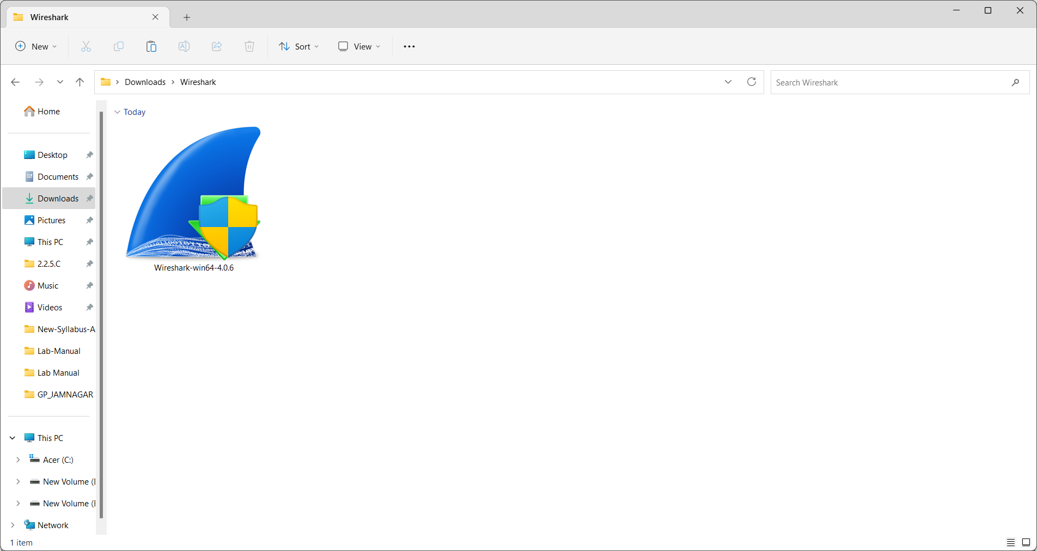

* 1. It will prompt for the confirmation to make changes to your system. Click on Yes.

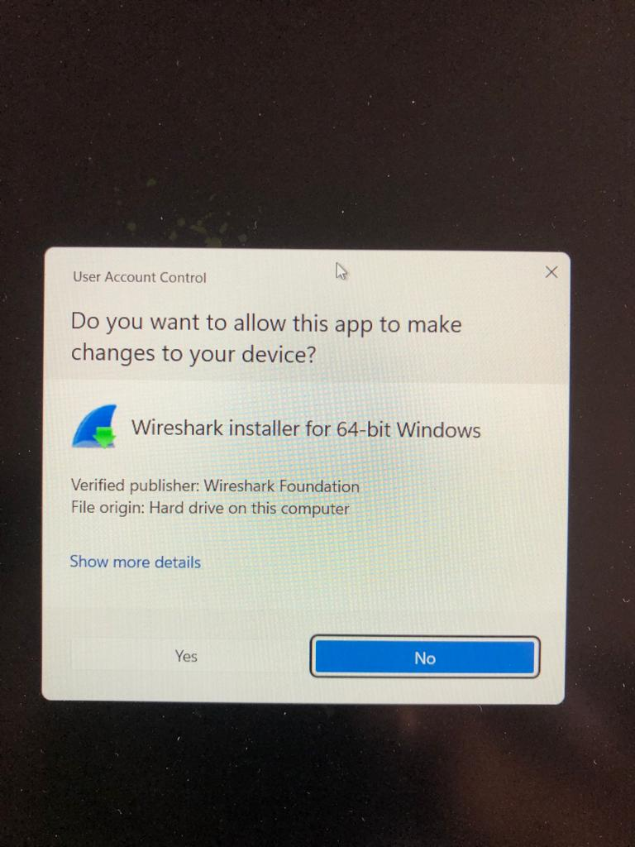

* 1. Setup screen will appear, click on Next.

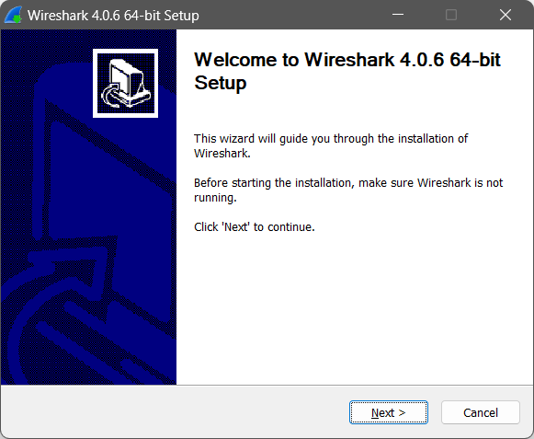

* 1. The next screen will be of License Agreement, click on Noted.

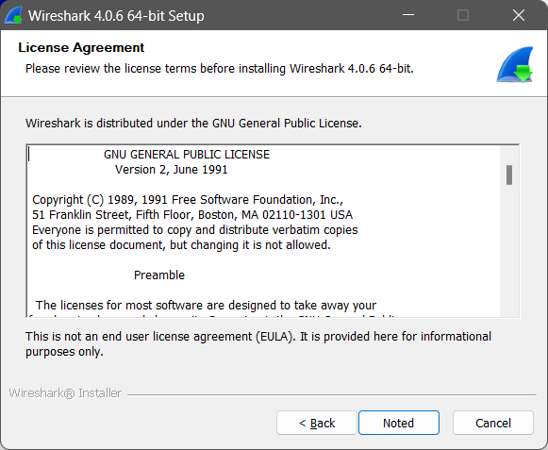

* 1. The next screen will be donation related. Click next.

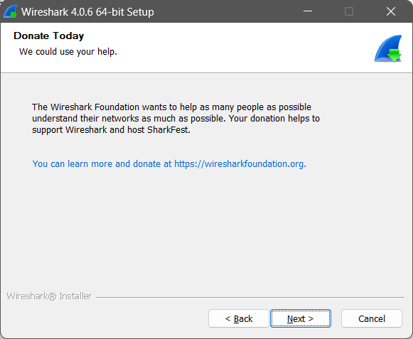

* 1. This screen is for choosing components, all components are already marked so don’t change anything just click on the Next button.

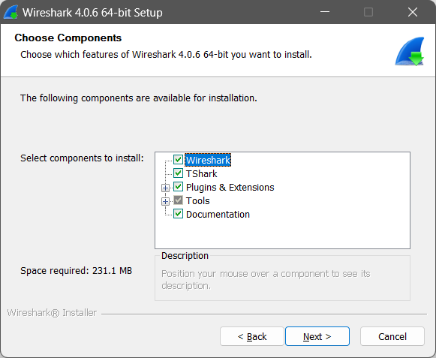

* 1. This screen is of choosing shortcuts like start menu or desktop icon along with file extensions which can be intercepted by Wireshark, tick all boxes, and click on Next button.

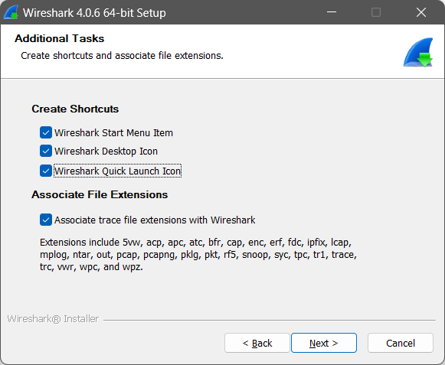

* 1. The next screen will be of installing location so choose the drive which will have sufficient memory space for installation. It needed only a memory space of 231.1 MB.(Size may be different)

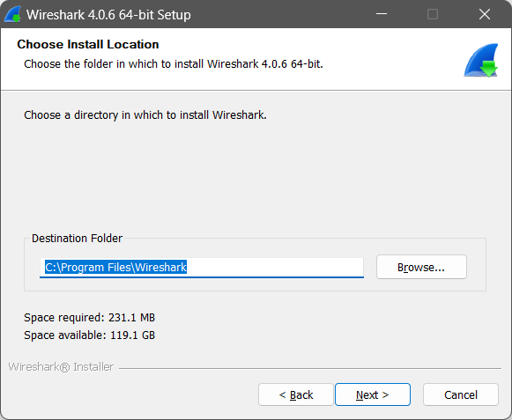

* 1. Next screen has an option to install Npcap which is used with Wireshark to capture packets pcap means packet capture so the install option is already checked (If not, then do check it) don’t change anything and click the next button.

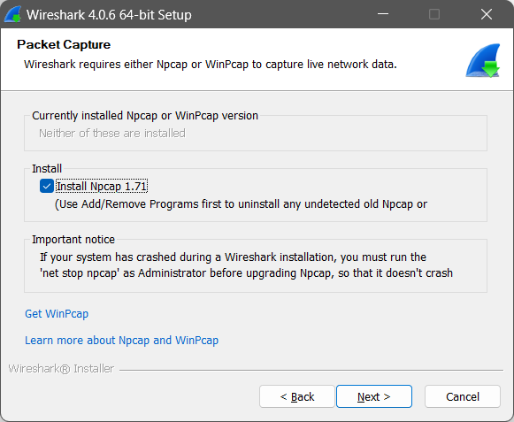

* 1. Next screen is about USB network capturing so it is one’s choice to use it or not, click on Install.

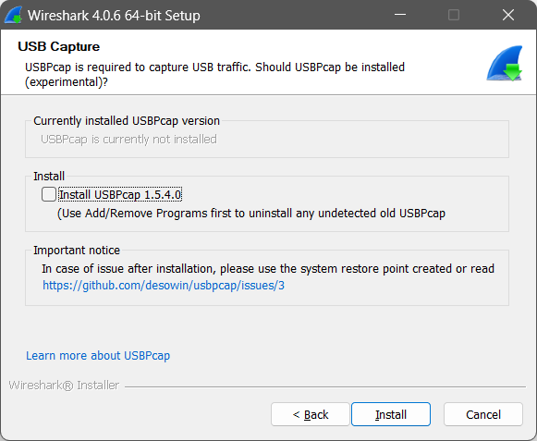

* 1. After this installation process will start.

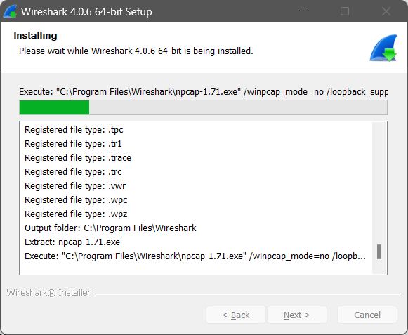

* 1. This installation will prompt for Npcap installation as already checked so the license agreement of Npcap will appear to click on the I Agree button.

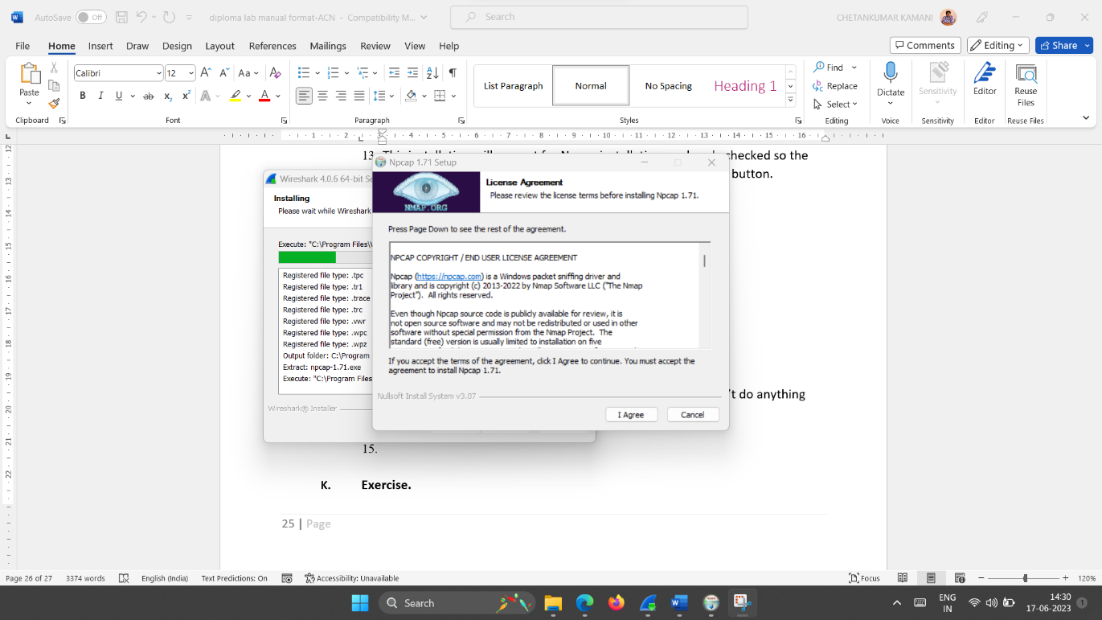

* 1. Next screen is about different installing options of npcap, don’t do anything click on Install.

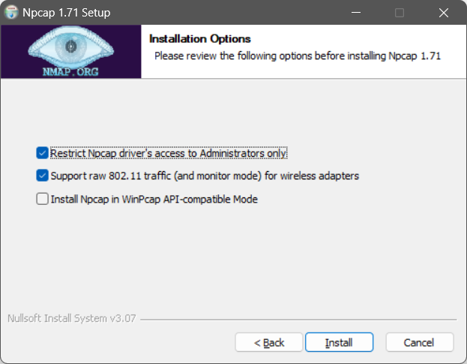

* 1. After this installation process will start, which will take only a minute.

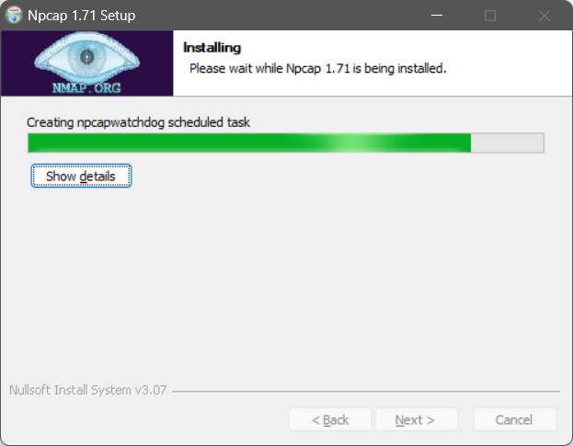

* 1. After this installation process will complete click on the Next button.

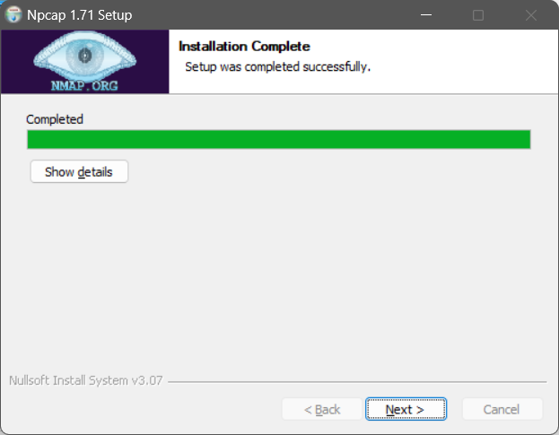

* 1. Click on Finish after the installation process is complete.

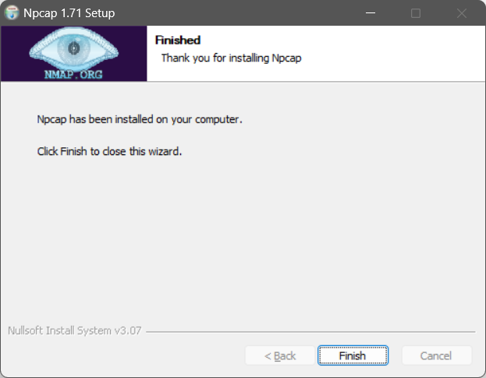

* 1. After this installation process of Wireshark will complete click on the Next button.

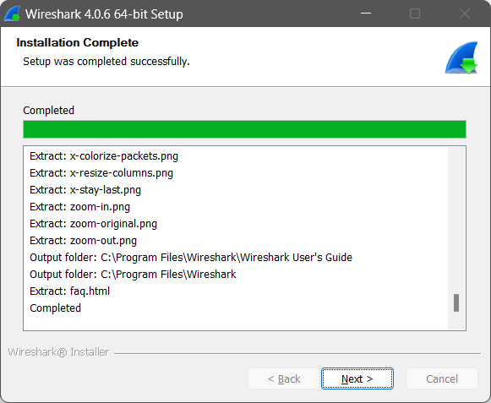

* 1. Click on Finish after the installation process of Wireshark is complete.

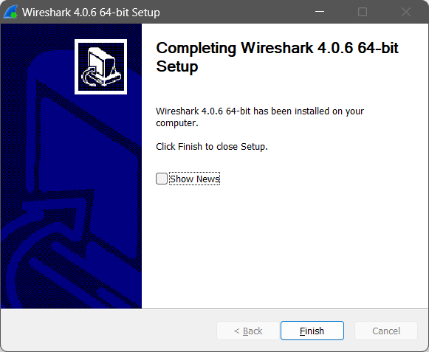

1. Start your web browser and clear the browser’s cache memory, but do not access any site yet**.**
2. Start Wireshark (Run as administrator) and you will get the following screen.

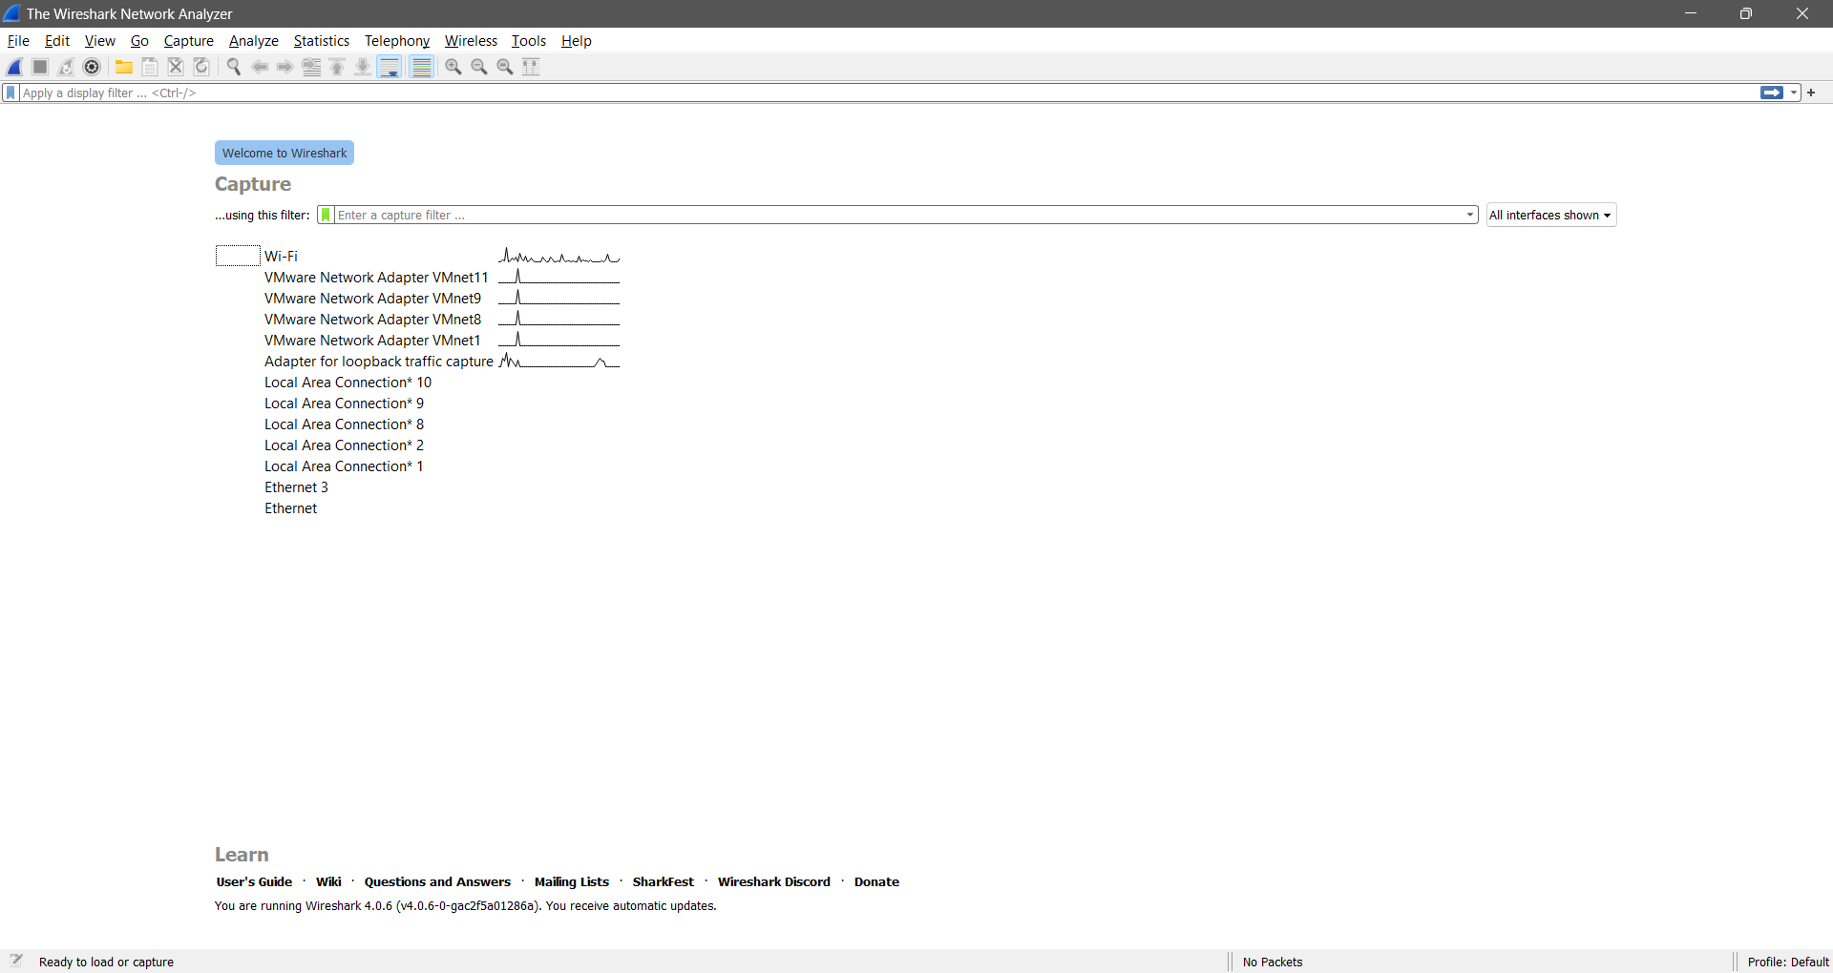

1. Go to capture menu and select options. Once you select options, you will get following dialog box.

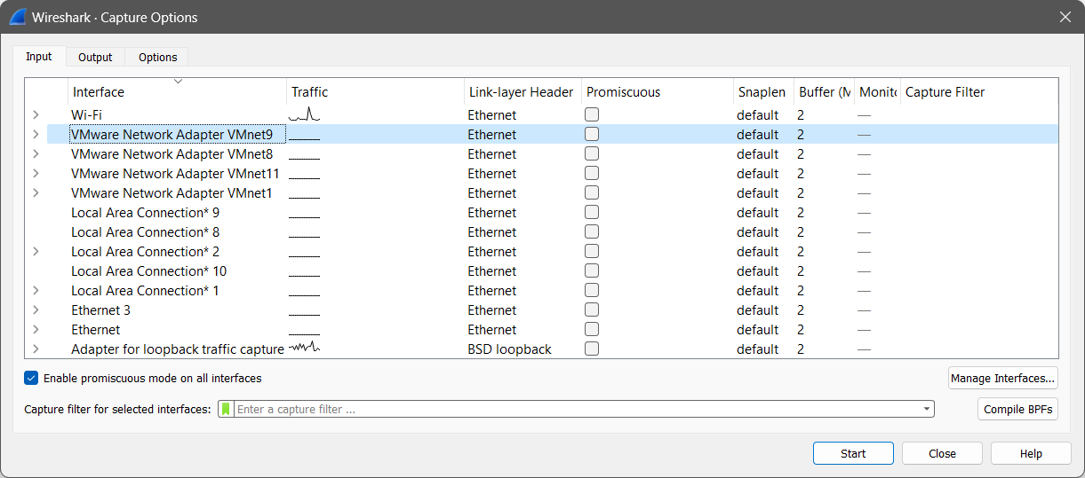

1. Check promiscuous for the interface on which you want to capture the packet and select it (Make sure the interface which you select must be connected to the internet) Then close the dialog box. (Here the Wi-Fi interface is selected)

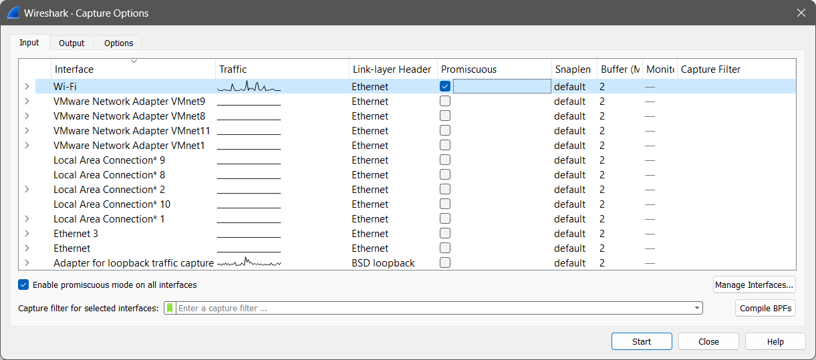

1. Go to capture menu and select start. Once you select it, Wireshark will start capturing the packets from the selected interface.

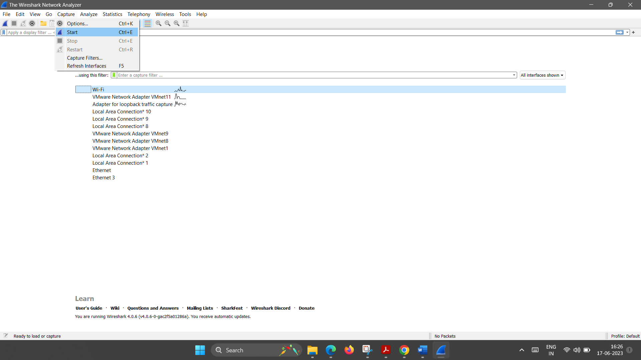

1. Go back to your web browser and retrieve any file from a site or surf any website. Wireshark starts capturing packets.

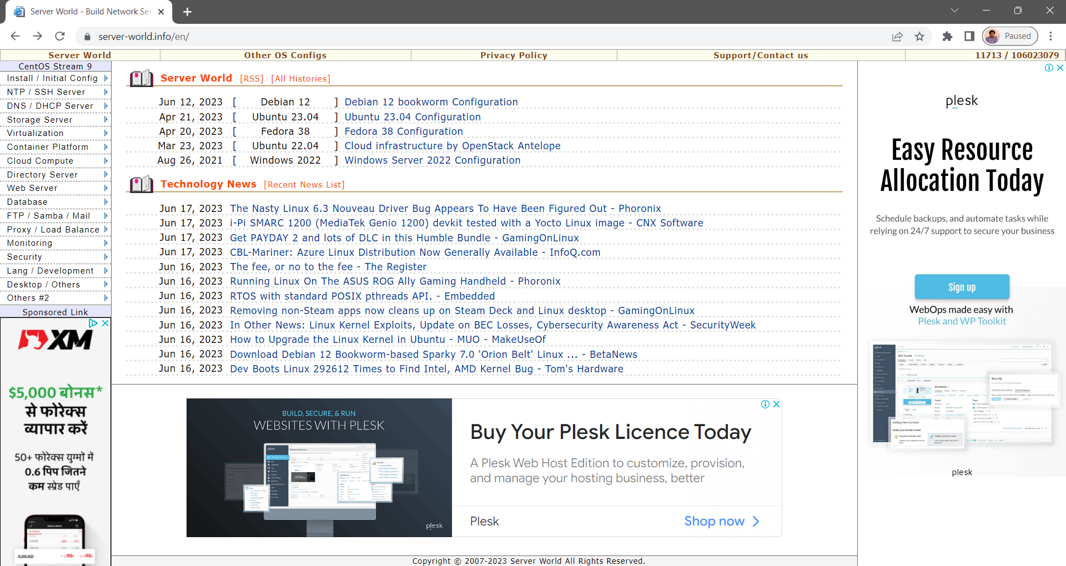

1. After enough packets have been captured, stop Wireshark for capturing the packet as shown below.

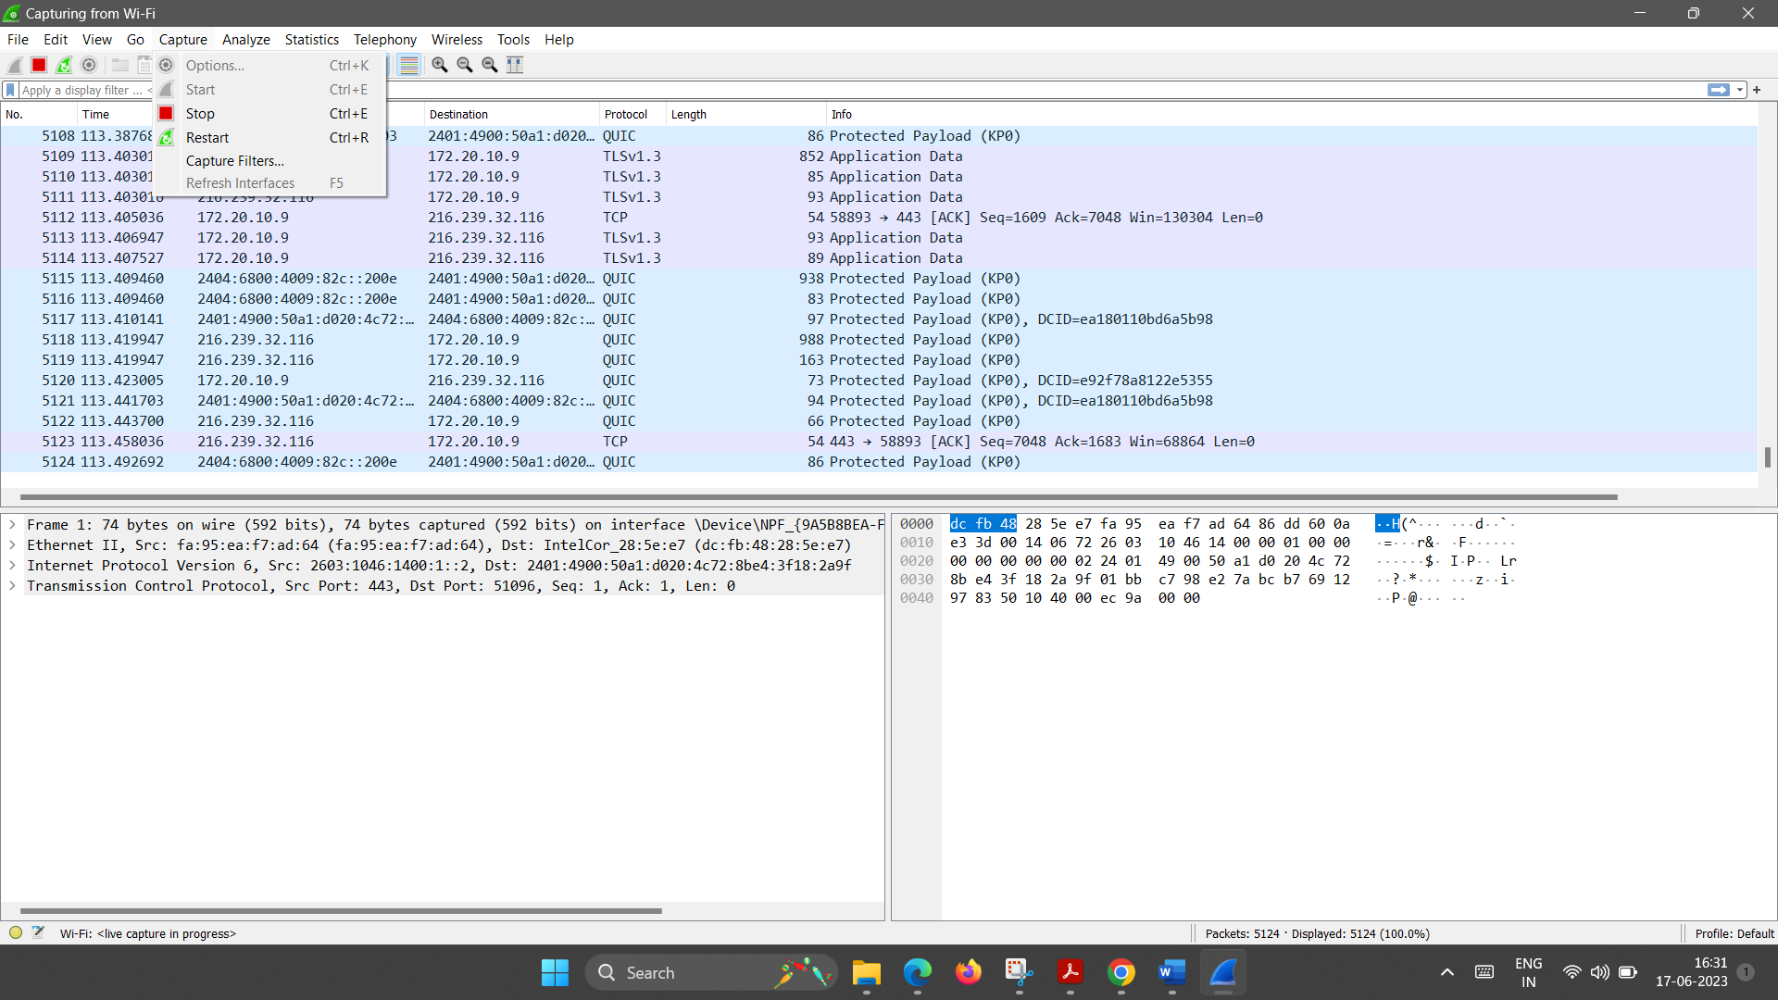

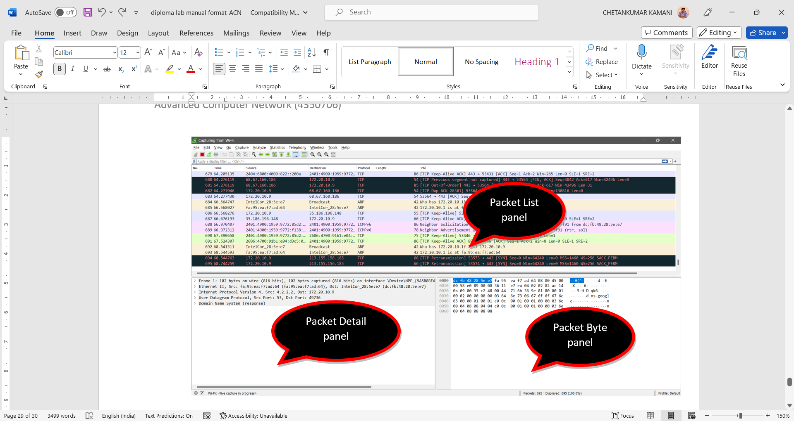

1. In the packet list pane, select any packet. In the packet detail pane, select the Internet Protocol. The hex dump of the IP header will be highlighted in the packet byte lane as shown below.

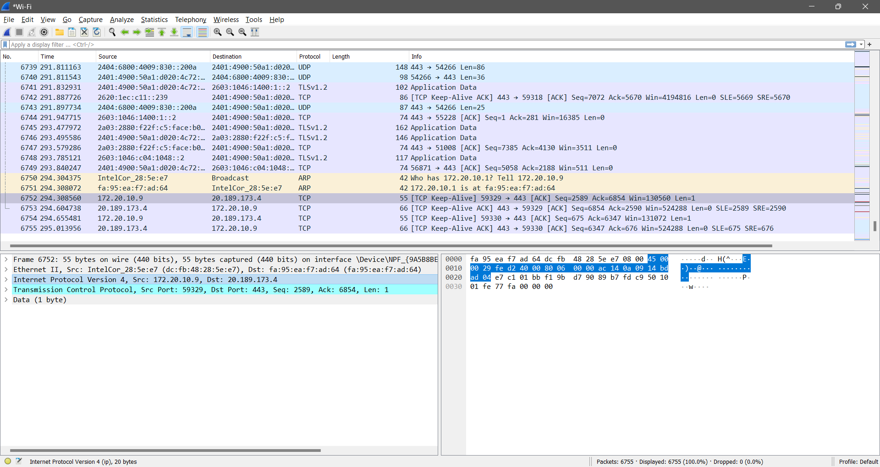

1. Based on the hex dump, fill the details in the table which is given in the exercise section of this experiment. (Packet-1 Analysis, Packet-2 Analysis)
2. **Exercise.**

**Packet -1 Analysis**

|  |  |  |
| --- | --- | --- |
| HEX dump: | | |
| 1 | a. IP version: | b. Header length  Number of bytes in the header: |
| c. Service type: | d. Total length: |
| e. Identification: | f. Flags: |
| g. Fragmentation offset | h. TTL: |
| i. Upper layer protocol: | j. Checksum: |
| k. Source IP address: | l. Destination IP address |
| 2 | Are answers to question 1 verified by the information in the packet detail pane of the Wireshark? | |
| 3 | If the checksum in the packet detail pane is marked correct, can we conclude that the IP payload is not corrupted?  Explain. | |
| 4 | Is the datagram fragmented?  Explain. | |
| 5 | Does source or destination address belong to one of the special addresses?  If yes which one? | |
| 6 | Number of bytes of data in the IP payload: | |

**Packet -2 Analysis**

|  |  |  |
| --- | --- | --- |
| HEX dump: | | |
| 1 | a. IP version: | b. Header length  Number of bytes in the header: |
| c. Service type: | d. Total length: |
| e. Identification: | f. Flags: |
| g. Fragmentation offset | h. TTL: |
| i. Upper layer protocol: | j. Checksum: |
| k. Source IP address: | l. Destination IP address |
| 2 | Are answers to question 1 verified by the information in the packet detail pane of the Wireshark? | |
| 3 | If the checksum in the packet detail pane is marked correct, can we conclude that the IP payload is not corrupted?  Explain. | |
| 4 | Is the datagram fragmented?  Explain. | |
| 5 | Does source or destination address belong to one of the special addresses?  If yes which one? | |
| 6 | Number of bytes of data in the IP payload: | |

1. **An IP datagram has arrived with the following partial information in the header (in hexadecimal): 45000054 00030000 2006...**
2. What is the header size?
3. Are there any options in the packet?
4. What is the size of data?
5. Is the packet fragmented?
6. How many more routers can the packet travel to?
7. What it the protocol number of the payload being carried by the packet?
8. **References**

* <https://www.geeksforgeeks.org/introduction-and-ipv4-datagram-header/>
* <https://networklessons.com/cisco/ccna-routing-switching-icnd1-100-105/ipv4-packet-header>
* <https://www.gatevidyalay.com/ipv4-ipv4-header-ipv4-header-format/>
* <https://www.youtube.com/watch?v=LQNwGM_TCRU>
* <https://www.youtube.com/watch?v=hGV8wsiCF28>

1. **Assessment-Rubrics**

|  |  |  |  |  |  |  |  |
| --- | --- | --- | --- | --- | --- | --- | --- |
| **Rubric ID** | **Task** | **Criteria** | **%** | **Good** | **Average** | **Poor** | **Mark** |
| **RB1** | Completion of the given task | The student completes all of the tasks required by the assignment. | 30% | All tasks are completed correctly and on time. **(Mark - 3)** | All tasks are completed, but some may be late or incorrect. **(Mark - 2)** | Some tasks are not completed, or they are completed incorrectly or late. **(Mark 1 or 0)** |  |
| **RB2** | Correctness of the given task | The student's work is correct and free of errors. | 30% | All work is correct and free of errors. **(Mark - 3)** | Most work is correct, but there may be a few minor errors. **(Mark - 2)** | There are many errors in the work. **(Mark 1 or 0)** |  |
| **RB3** | Question answers | The student answers all of the questions correctly. | 20% | All questions are answered correctly. **(Mark - 2)** | Most questions are answered correctly, but there may be a few incorrect answers. **(Mark - 1)** | All questions are answered incorrectly. **(Mark - 0)** |  |
| **RB4** | Regularity of the report submission | The student submits the report on time and in the correct format. | 20% | The report is submitted on time and in the correct format. **(Mark - 2)** | The report is submitted on time, but it is not in the correct format. **(Mark - 1)** | The report is late or not submitted at all. **(Mark - 0)** |  |

**Signature With Date**

**Date: ……………**

**Practical No.3:**

Capture and study ICMPv4 packets generated by other utility programs such as ping and traceroute using relevant software.

1. **Objectives:**

* To capture and study ICMPv4 packets generated by ping and traceroute commands of any network interface (Ex. Ethernet, Wi-Fi) on the computer.

1. **Expected Program Outcomes (POs):** PO1, PO2, PO3, PO4, PO5, PO6, PO7
2. **Expected Skills to be developed based on competency:**

* To capture and study ICMPv4 packets.

1. **Expected Course Outcomes (COs):** CO1
2. **Practical Outcomes (PROs)**

The students will be able …

* To use PING and TRACERT commands.
* To capture and study ICMPv4 packets generated by PING and TRACERT commands.

1. **Expected Affective domain Outcome (ADOs)**

* Practice good housekeeping.
* Follow standard configuration.
* Follow ethical practices.

1. **Prerequisite Theory:**

* Introduction to Wireshark and its application.
* How does Wireshark work?
* Introduction to packet capturing in Wireshark.
* How to capture ICMPv4 packets using Wireshark?
* Introduction to PING utility.
* Introduction to TRACEROUTE utility.
* ICMP packet structure (Echo request and Echo reply)

1. **Resources required.**

|  |  |
| --- | --- |
| **S. No.** | **Equipment Name with Broad Specifications** |
| 1 | Computer System with basic configuration and connected with LAN and Internet. |
| 2 | Wireshark software to capture and investigate packets. |

1. **Safety and necessary Precautions**

* Shut down the computer properly after using it.
* Do not unplug the computer's power cable while it is on.

1. **Procedure**

**Section-I Capture and study ICMPv4 packets generated by ping utility program.**

* In this section of the experiment, we use the ping utility to capture ICMPv4 query packets:
  + echo request
  + echo reply.
* The ping utility is, in fact, a client-server program. The client program, which needs to be invoked at the command prompt, triggers an echo request packets; the server program, which is running at the background all the time, waits for a signal from an echo request message, and triggers an echo reply message.
* The ping program, however, does not insert a message in the ICMPv4 packets, it just simply triggers its creation and provides the values for identification and the sequence number fields.
* This section is divided into two parts**: Ping-Part I and Ping-Part II.**
* In **Ping-Part I**, we want to see the messages exchanged at the ping level.
* In **Ping-part II**, we want to capture frames carrying ICMPv4 packet, which are encapsulated in an IPv4 packet.

***Ping-Part-I: Analyzing ping.***

1. Open the Wireshark and start packet capturing. Although, we are not using these frames in Part I, we will use them in Part II.

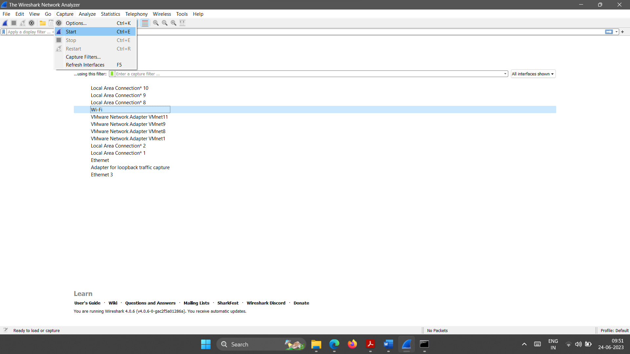

1. Open Command Prompt and type ping hostname. The hostname can be the domain name or the IP address of a site you know (be sure that there is no firewall to filter out the packets). An example of the result of the ping command in the Command Prompt window looks as shown in Figure below.

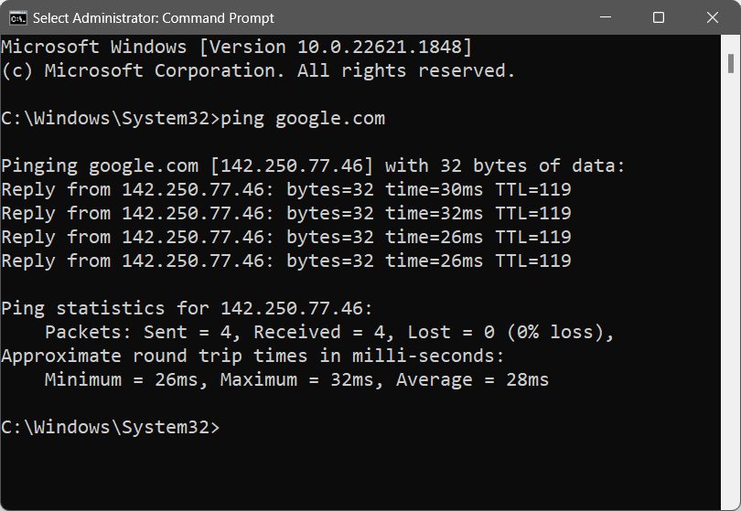

1. Return to the Wireshark window, stop packet capturing, and save the captured file.

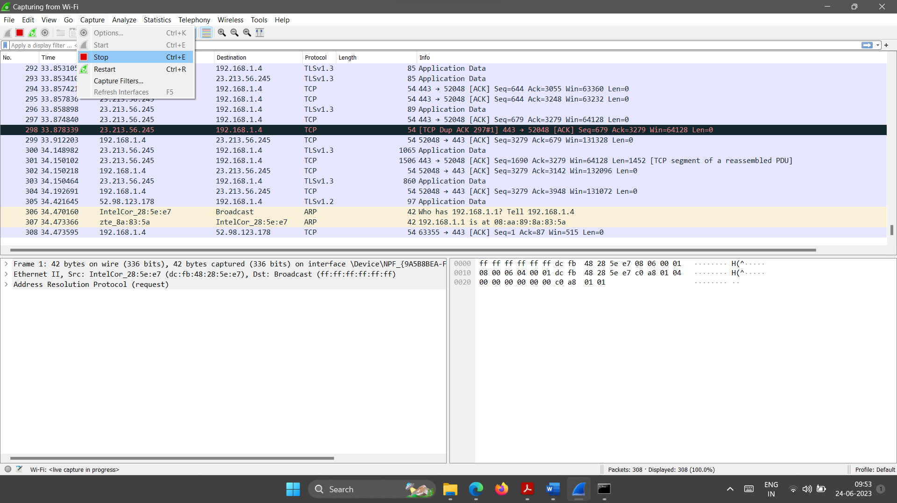

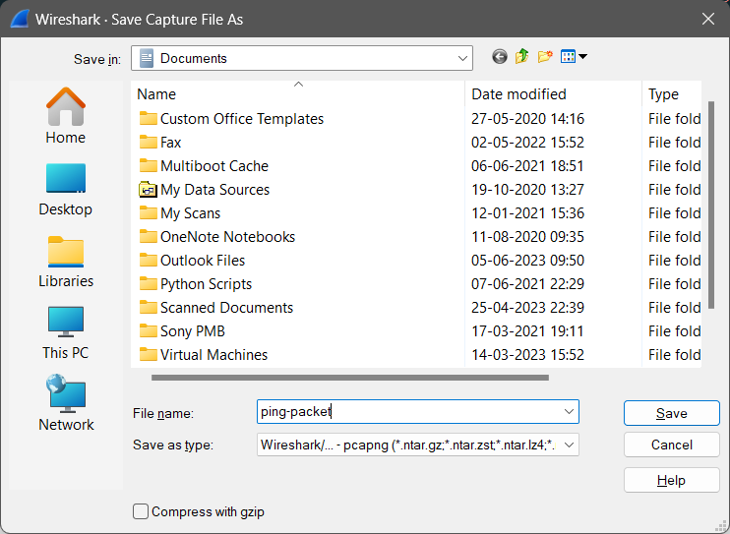

Using the result of the ping command in the Command Prompt window, answer the questions given in the Ping-part-1 of practical related quiz.

***Ping-Part II: Wireshark Capture of Ping Commands***

1. Open the file you captured in Part I.

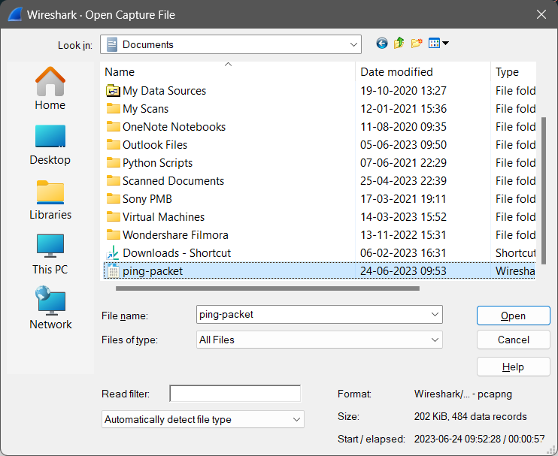

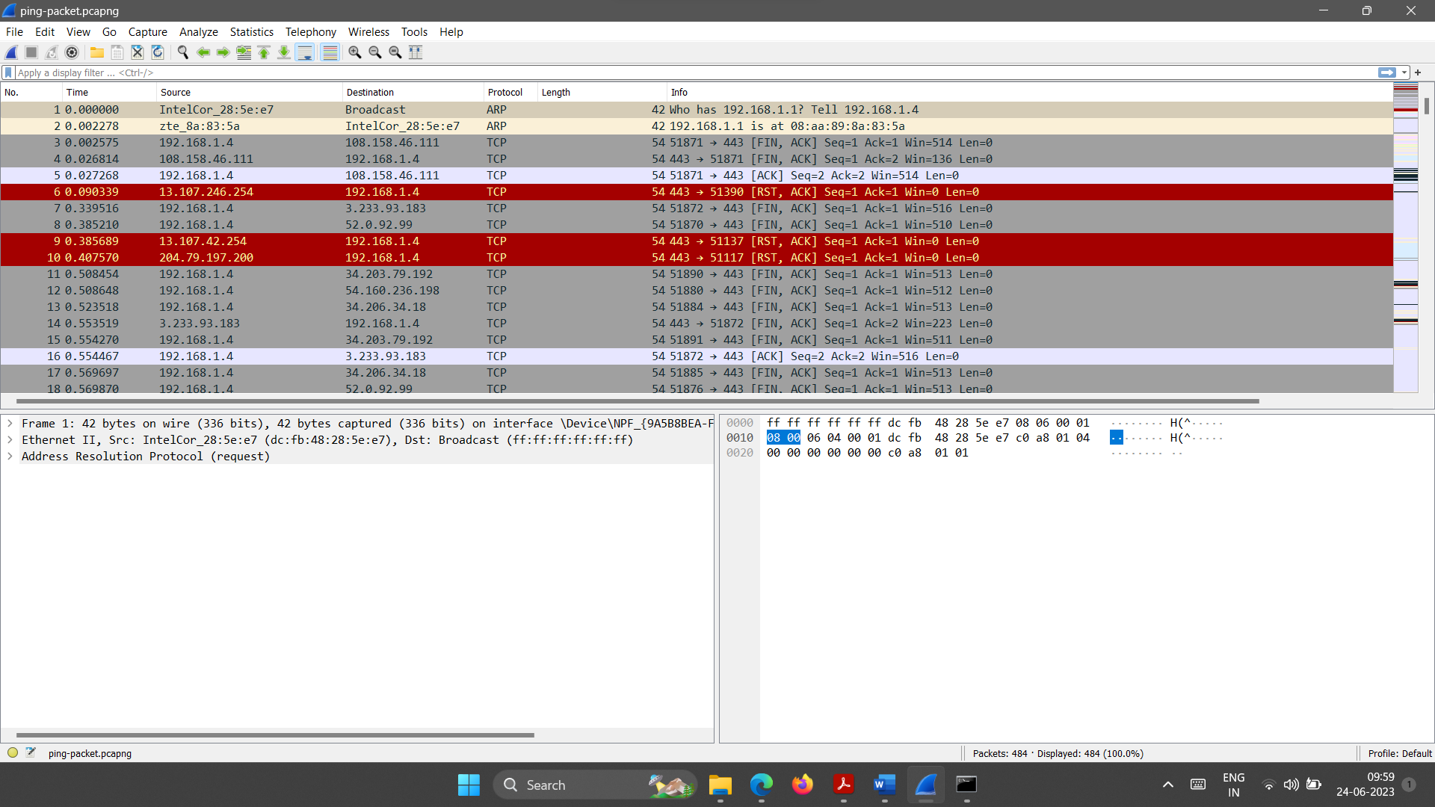

1. In the Filter field of the Wireshark window type icmp (lower case) and press the enter

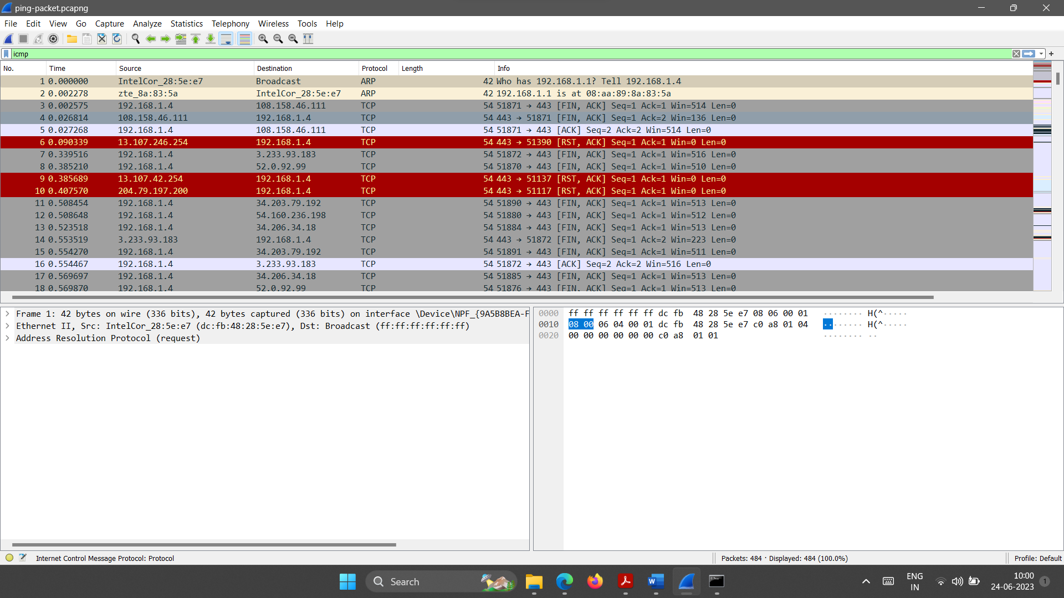

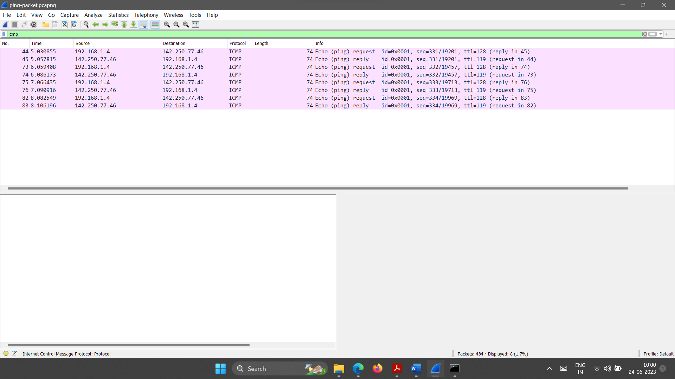

Using the result of the ping command in the Command Prompt window, answer the questions given in the Ping-part-2 of practical related quiz.

**Section-II Capture and study ICMPv4 packets generated by tracert utility program.**

* To capture some ICMPv4 error-reporting packets, we can use either the traceroute utility (in Unix-like environment) or the tracert utility (in the Windows environment).
* The traceroute utility is a client-server at the application layer that uses the services of UDP; the tracert utility is a client-server program that uses the services of IP.
* In this assignment, we use tracert, but the assignment can be easily changed to use traceroute if Unix-like environment is available.
* The tracert utility in Windows is different from the traceroute utility in Unix.
* In this case, instead of sending UDP with an unavailable port number, tracert sends (n +1) ICMP echo messages encapsulated in IP datagrams with TTL values 1, 2, 3, and so on.
* When a router receives one of these packets, it decrements the value of the TTL field and sends a time-exceeded message when the TTL value becomes zero.
* When undropped echo message reaches the destination host, an echo response message is sent back to the source host.
* We have divided this section into two parts: Tracert-Part I and Tracert-Part II.
* In Tracert-Part I, we want to see the messages exchanged at the tracert level.
* In Tracert-Part II, we want to capture frames carrying ICMPv4 packets, which are encapsulated in an IPv4 packet.

***Tracert-Part I: Analyzing tracert***

1. Open the Wireshark and start packet capturing. Although, we are not using the captured frames in Tracert-Part I, we will use them in Tracert-Part II.

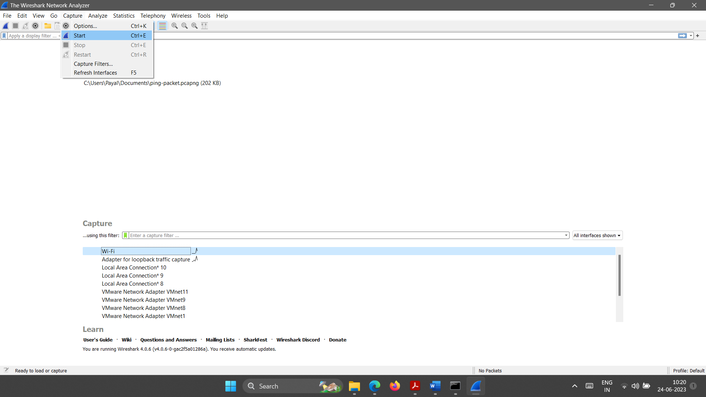

1. Open Command Prompt and type tracert −d hostname. The hostname can be the domain name or the IP address of a site you know. The −d option prevents tracert from resolving the IP addresses to their names and slowing down the process of displaying information. The result of the tracert command in the Command Prompt window looks as shown in the image below.

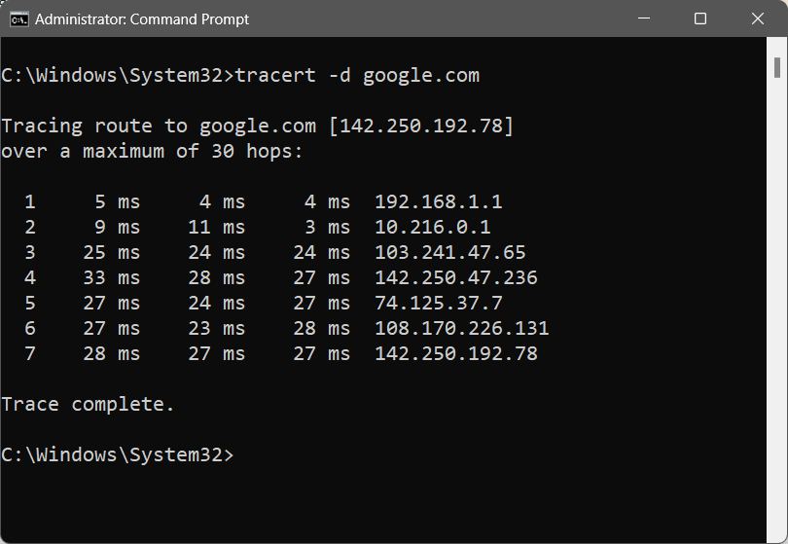

1. Return to the Wireshark window, stop packet capturing, and save the captured file.

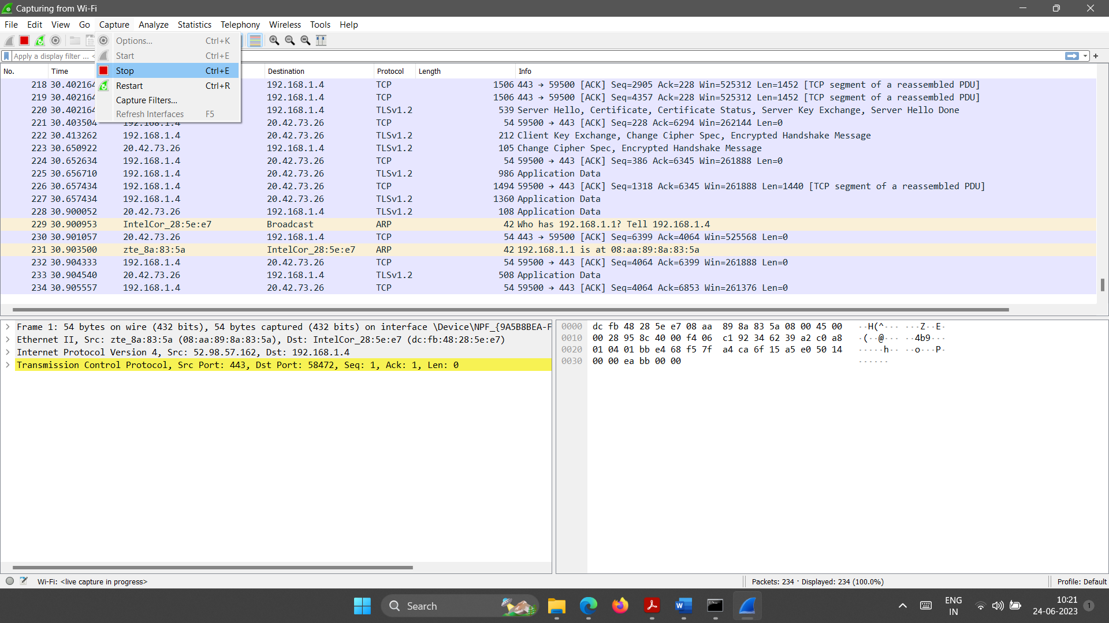

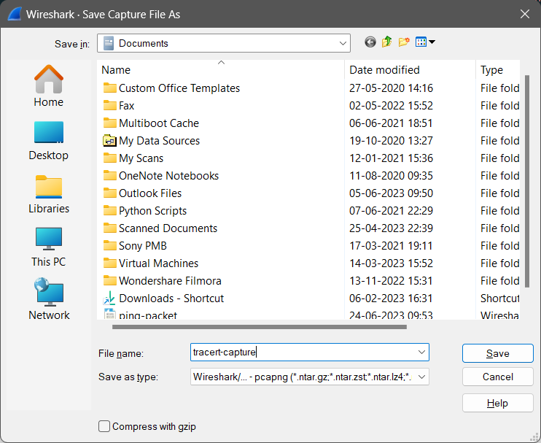

Using the result of the traceroute command, answer the questions in given the tracert-part-1 of practical related quiz.

***Tracert-Part II: Wireshark Capture of tracert***

1. Open the file you captured in Tracert-Part I.

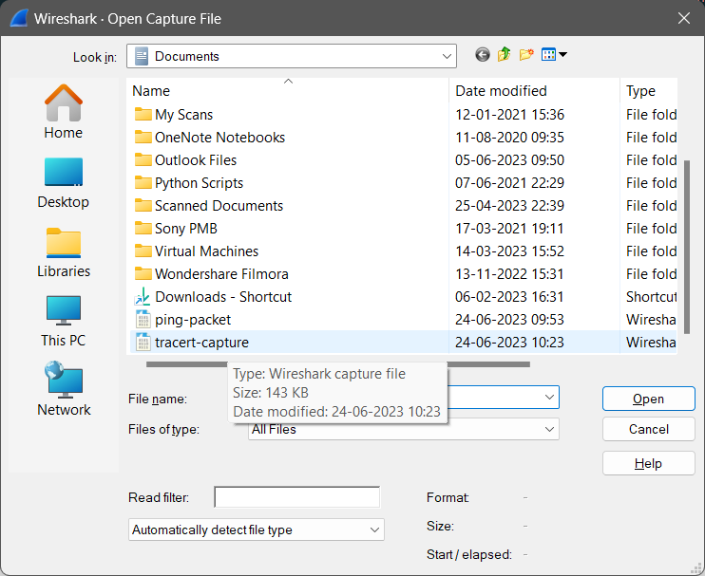

1. In the Filter field of the Wireshark window type icmp (lower case) and hit the enter.

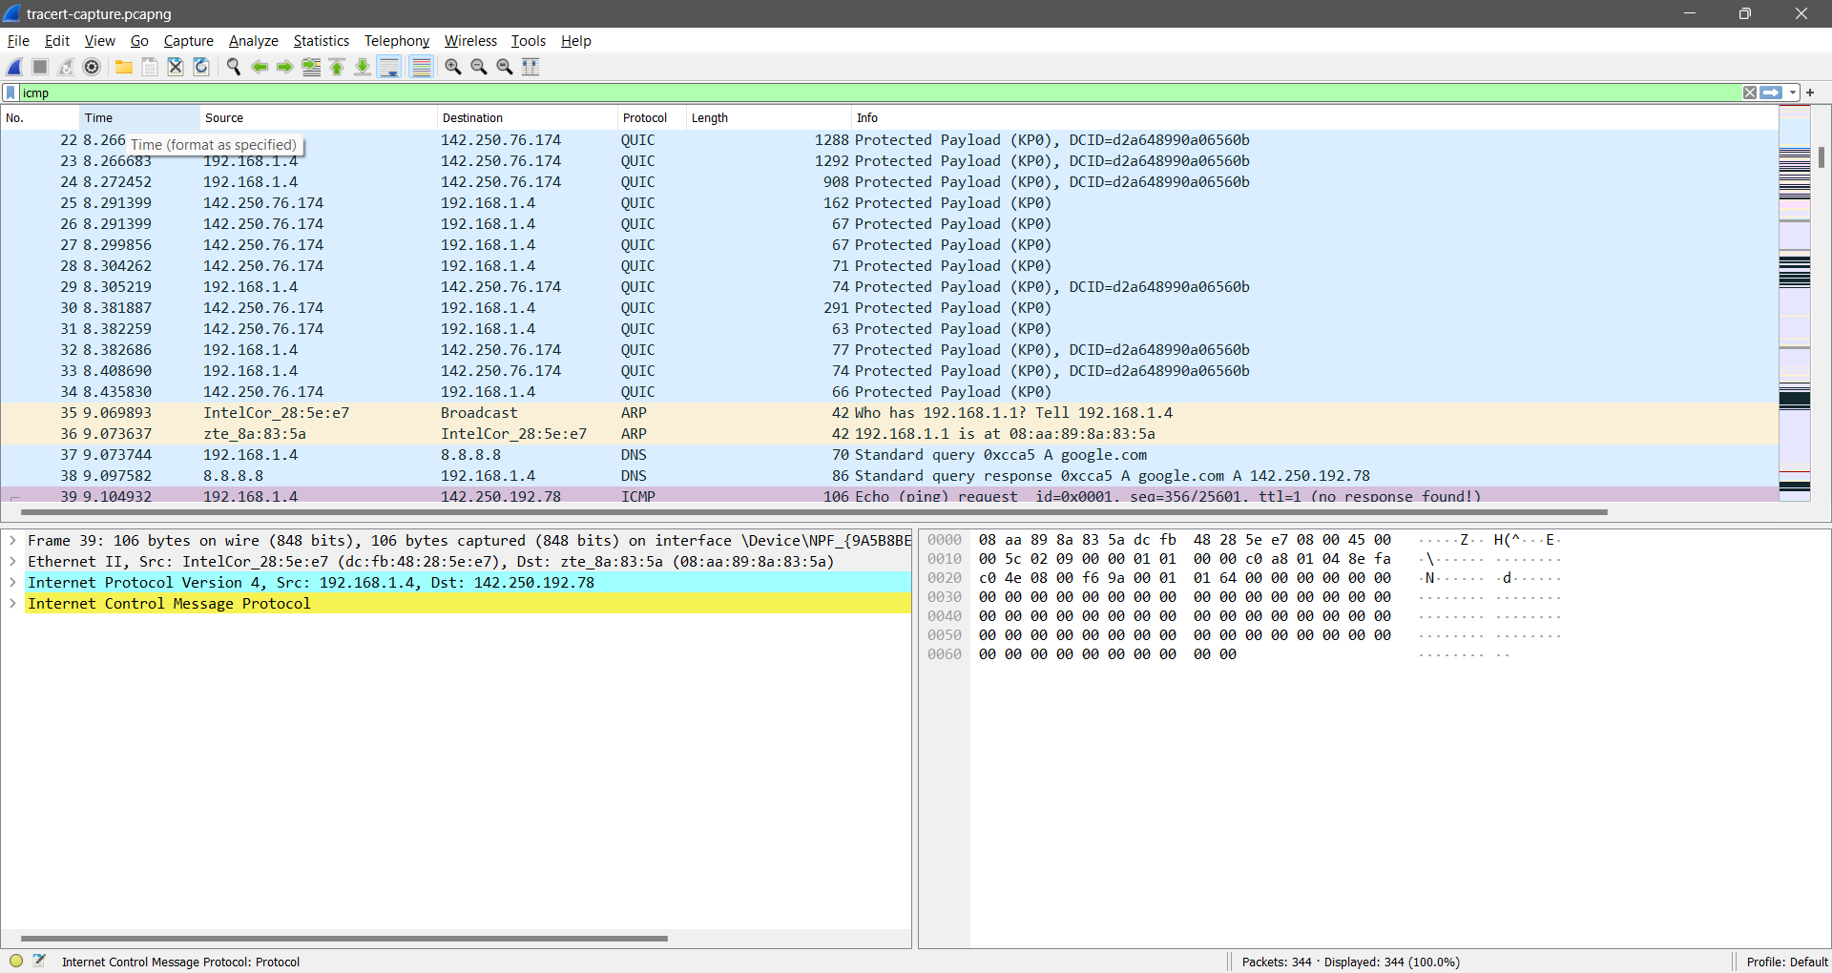

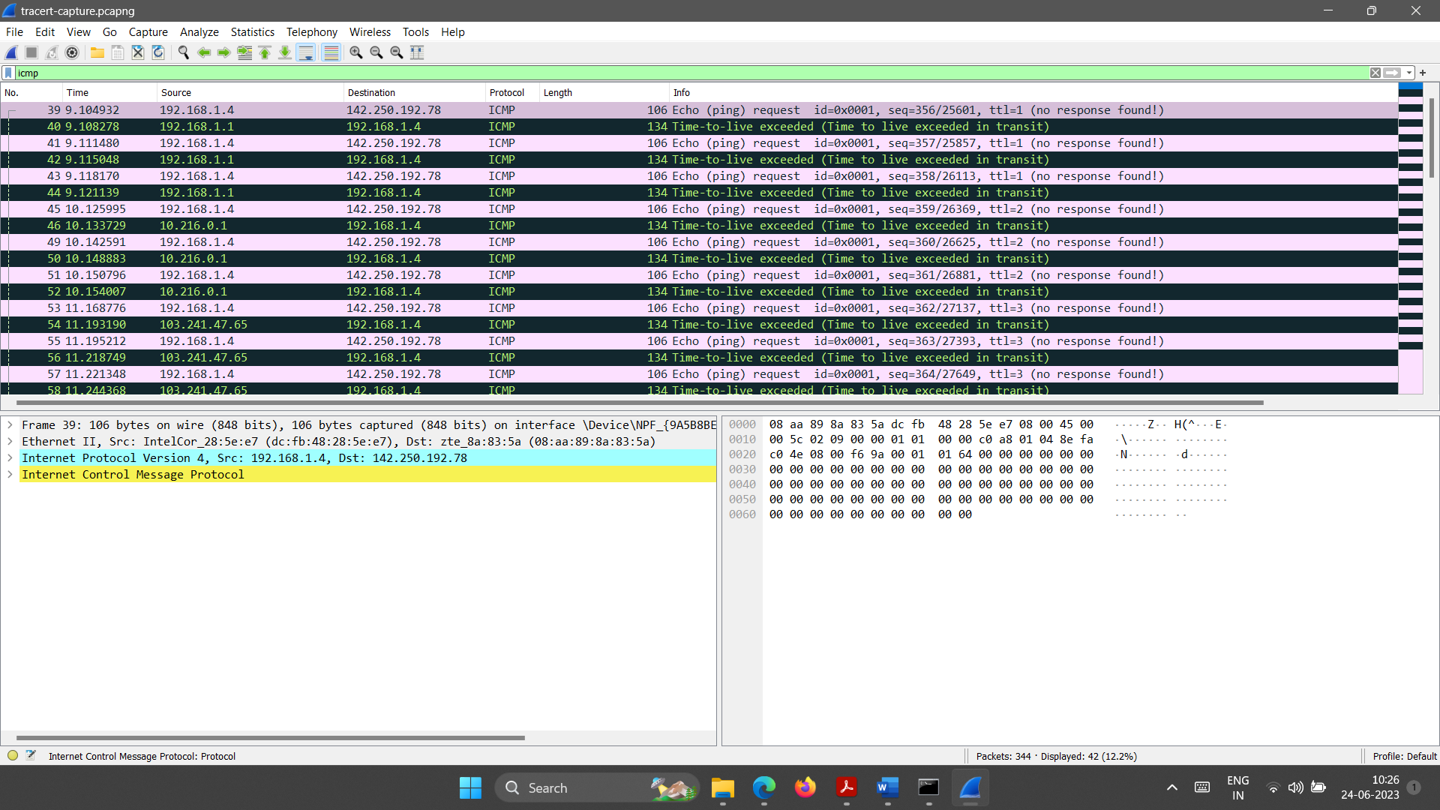

Using the result of the captured packets, answer the questions in given the tracert-part-2 of practical related quiz.

1. **Practical Quiz**

|  |  |
| --- | --- |
| **Ping - Part I** | |
| 1 | Destination IP address: |
| 2 | Number ping messages sent: |
| 3 | Number of bytes of data sends with each ping message: |
| 4 | The round-trip time for each packet: |
| 5 | Minimum round-trip: Average round-trip: Maximum round-trip: |

|  |  |
| --- | --- |
| **Ping - Part II** | |
| 1 | Destination IP address of Echo request ICMP messages:  Does the result agree with the information in Part I of the lab? |
| 2 | Number of Echo request ICMP packet: Number of Echo reply ICMP:  Does the result agree with the information in Part I of the lab? |
| 3 | Number bytes of data are carried by each ICMP packet:  Does the result agree with the information in Part I of the lab? |
| 4 | Difference between the time the first Echo message was sent and the first reply message was received:  Does the result agree with the information in Part I of the lab? |
| 5 | a. Fields that are the same in Echo request and Echo reply: Reason:  a. Fields that are different in Echo request and Echo reply: Reason: |
| 6 | a. Fields that are the same in Echo requests: Reason:  a. Fields that are different in Echo request: Reason: |

|  |  |
| --- | --- |
| **Tracert - Part I** | |
| 1 | Number of probe packets for each TTL value: |
| 2 | IP address of the default router: |
| 3 | How many routers are in between the source and destination? |
| 4 | IP address of the destination: |

|  |  |
| --- | --- |
| **Tracert - Part II** | |
| 1 | Number of ICMP packets in the packet list pane: |
| 2 | Relation between the number of ICMP packets to the number of network visited in the traceroute: |
| 3 | Content of Echo request ICMP packet:  Content of Time-to-live exceeded ICMP packet:  How the content of the Time-to-live exceeded ICMP packet is related to the content of the Echo request ICMP packet? |
| 4 | TTL value of the last echo request ICMP packets:  The number of routers between the host and destination: |
| 5 | Source IP address of the echo reply ICMP packets:  Which entity does this address define? |

1. **References**

* <http://www.tcpipguide.com/free/t_ICMPv4EchoRequestandEchoReplyMessages-2.htm>
* <https://www.geeksforgeeks.org/internet-control-message-protocol-icmp/>
* <https://www.wireshark.org/docs/wsug_html_chunked/ChCapCapturingSection.html>
* <https://en.wikipedia.org/wiki/Internet_Control_Message_Protocol>
* <https://en.wikipedia.org/wiki/Ping_(networking_utility)>
* <https://en.wikipedia.org/wiki/Traceroute>
* <https://www.youtube.com/watch?v=4HAO_7E64MQ>
* <https://www.youtube.com/watch?v=mg98Ufm9tEY>
* <https://www.youtube.com/watch?v=6X5TwvGXHP0>

1. **Assessment-Rubrics**

|  |  |  |  |  |  |  |  |
| --- | --- | --- | --- | --- | --- | --- | --- |
| **Rubric ID** | **Task** | **Criteria** | **%** | **Good** | **Average** | **Poor** | **Mark** |
| **RB1** | Completion of the given task | The student completes all of the tasks required by the assignment. | 30% | All tasks are completed correctly and on time. **(Mark - 3)** | All tasks are completed, but some may be late or incorrect. **(Mark - 2)** | Some tasks are not completed, or they are completed incorrectly or late. **(Mark 1 or 0)** |  |
| **RB2** | Correctness of the given task | The student's work is correct and free of errors. | 30% | All work is correct and free of errors. **(Mark - 3)** | Most work is correct, but there may be a few minor errors. **(Mark - 2)** | There are many errors in the work. **(Mark 1 or 0)** |  |
| **RB3** | Question answers | The student answers all of the questions correctly. | 20% | All questions are answered correctly. **(Mark - 2)** | Most questions are answered correctly, but there may be a few incorrect answers. **(Mark - 1)** | All questions are answered incorrectly. **(Mark - 0)** |  |
| **RB4** | Regularity of the report submission | The student submits the report on time and in the correct format. | 20% | The report is submitted on time and in the correct format. **(Mark - 2)** | The report is submitted on time, but it is not in the correct format. **(Mark - 1)** | The report is late or not submitted at all. **(Mark - 0)** |  |

**Signature With Date**

**Date: ……………**

**Practical No.4:**

Create a small IPv4 static routing network using relevant software.

1. **Objectives:**

* To create a small static routing network using Cisco packet tracer.
* To configure routers in the network with static routes
* To verify that static routes are working correctly.

1. **Expected Program Outcomes (POs):** PO1, PO2, PO3, PO4, PO5, PO6, PO7
2. **Expected Skills to be developed based on competency:**

* The students will learn how to create a small IPv4 static routing network using cisco packet tracer. And it will help them to apply the learned concepts in the real time network.

1. **Expected Course Outcomes (COs):** CO1
2. **Practical Outcomes (PROs)**

The students will be able …

* To create a small IPv4 static routing network using cisco packet tracer.
* To learn cisco commands which are required to configure IPv4 static network.
* To configure the routers in the network with static routes.
* To verify that the static routes are working correctly.
* To apply the knowledge and skills learned in this experiment to real-world networking scenarios.

1. **Expected Affective domain Outcome (ADOs)**

* Practice good housekeeping.
* Follow standard configuration.
* Follow ethical practices.

1. **Prerequisite Theory:**

* Introduction to Cisco Packet Tracer.
* Introduction to various Cisco commands to configure router.
* IPv4 Addressing
* Use of network devices such as network switch, routers.
* Use of different cables for the connections among devices such as copper straight cable, copper cross over cables.
* IPv4 address configuration in the Desktop Computers.
* Introduction to static routing.
* Use of PING and TRACERT commands.

1. **Resources required.**

|  |  |
| --- | --- |
| **S. No.** | **Equipment Name with Broad Specifications** |
| 1 | Computer System with basic configuration. |
| 2 | Cisco Packet Tracer Software |

1. **Safety and necessary Precautions**

* Shut down the computer properly after using it.
* Do not unplug the computer's power cable while it is on.

1. **Procedure**

**To configure the IPv4 network, Follow the steps given below.**

1. **Download and install cisco packet tracer.**

Link to download cisco packet tracer. (<https://www.netacad.com/portal/resources/file/692e524f-12f9-46ef-9417-f03be70a2f77>)

1. **Arrange different network devices and connect them using appropriate network cable as shown in the diagram below.**

The details of no of network devices and connection among them (with interfaces) are given below.

* The devices details are as follows
  + No of PCs :- 4
  + No of Network Switches(2960-24TT):- 2
  + No of Network Routers (ISR4331):- 3
* The connection with interface details are as follows.
  + The connection between PC1 (FastEthernet0) and Swtich1(FastEthernet0/1) is done using copper straight cable.
  + The connection between PC2 (FastEthernet0) and Swtich1(FastEthernet0/2) is done using copper straight cable.
  + The connection between Switch1 (GigabitEthernet 0/1) and Router0(GigabitEthernet 0/0/0) is done using copper straight cable.
  + The connection between Router0(GigabitEthernet 0/0/1) and Router1(GigabitEthernet 0/0/0) is done using copper cross over cable.
  + The connection between Router1(GigabitEthernet 0/0/1) and Router2(GigabitEthernet 0/0/0) is done using copper cross over cable.
  + The connection between Router2(GigabitEthernet 0/0/1) and Switch2(GigabitEthernet 0/1) is done using copper straight cable.
  + The connection between PC3 (FastEthernet0) and Swtich2(FastEthernet0/1) is done using straight cable.
  + The connection between PC4 (FastEthernet0) and Swtich2(FastEthernet0/2) is done using straight cable.

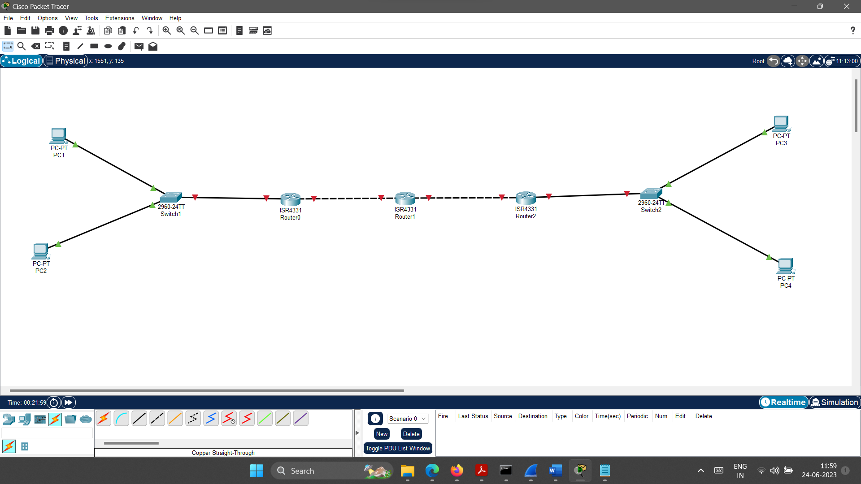

1. **Configure IP address, Subnet Mask and Default Gateway of PC1 as follows.**
   1. IP address: 192.168.1.2
   2. Subnet Mask : 255.255.255.0
   3. Default Gateway: 192.168.1.1
2. **Configure IP address, Subnet Mask and Default Gateway of PC2 as follows.**
   1. IP address: 192.168.1.3
   2. Subnet Mask : 255.255.255.0
   3. Default Gateway: 192.168.1.1
3. **Configure Router0 using CLI as specified below.**

*--- System Configuration Dialog ---*

*Would you like to enter the initial configuration dialog? [yes/no]: no*

*Press RETURN to get started!*

*Router>****enable***

*Router#****configure terminal***

*Enter configuration commands, one per line. End with CNTL/Z.*

*Router(config)#****interface gigabitEthernet 0/0/0***

*Router(config-if)#****ip address 192.168.1.1 255.255.255.0***

*Router(config-if)#****no shutdown***

*Router(config-if)#*

*%LINK-5-CHANGED: Interface GigabitEthernet0/0/0, changed state to up*

*%LINEPROTO-5-UPDOWN: Line protocol on Interface GigabitEthernet0/0/0, changed state to up*

*Router(config-if)#****exit***

*Router(config)#****interface gigabitEthernet 0/0/1***

*Router(config-if)#****ip address 192.168.2.1 255.255.255.0***

*Router(config-if)#****no shutdown***

*Router(config-if)#*

*%LINK-5-CHANGED: Interface GigabitEthernet0/0/1, changed state to up*

*Router(config-if)#****exit***

*Router(config)#****ip route 192.168.3.0 255.255.255.0 192.168.2.2***

*Router(config)#****ip route 192.168.4.0 255.255.255.0 192.168.2.2***

*Router(config)#****exit***

1. **Configure Router1 using CLI as specified below.**

*--- System Configuration Dialog ---*

*Would you like to enter the initial configuration dialog? [yes/no]: no*

*Press RETURN to get started!*

*Router>****enable***

*Router#****configure terminal***

*Enter configuration commands, one per line. End with CNTL/Z.*

*Router(config)#****interface gigabitEthernet 0/0/0***

*Router(config-if)#****ip address 192.168.2.2 255.255.255.0***

*Router(config-if)#****no shutdown***

*Router(config-if)#*

*%LINK-5-CHANGED: Interface GigabitEthernet0/0/0, changed state to up*

*%LINEPROTO-5-UPDOWN: Line protocol on Interface GigabitEthernet0/0/0, changed state to up*

*Router(config-if)#****exit***

*Router(config)#****interface gigabitEthernet 0/0/1***

*Router(config-if)#****ip address 192.168.3.1 255.255.255.0***

*Router(config-if)#****no shutdown***

*Router(config-if)#*

*%LINK-5-CHANGED: Interface GigabitEthernet0/0/1, changed state to up*

*Router(config-if)#****exit***

*Router(config)#****ip route 192.168.1.0 255.255.255.0 192.168.2.1***

*Router(config)#****ip route 192.168.4.0 255.255.255.0 192.168.3.2***

*Router(config)#****exit***

1. **Configure Router2 using CLI as specified below.**

*--- System Configuration Dialog ---*

*Would you like to enter the initial configuration dialog? [yes/no]: no*

*Press RETURN to get started!*

*Router>****enable***

*Router#****configure terminal***

*Enter configuration commands, one per line. End with CNTL/Z.*

*Router(config)#****interface gigabitEthernet 0/0/0***

*Router(config-if)#****ip address 192.168.3.2 255.255.255.0***

*Router(config-if)#****no shutdown***

*Router(config-if)#*

*%LINK-5-CHANGED: Interface GigabitEthernet0/0/0, changed state to up*

*%LINEPROTO-5-UPDOWN: Line protocol on Interface GigabitEthernet0/0/0, changed state to up*

*Router(config-if)#****exit***

*Router(config)#****interface gigabitEthernet 0/0/1***

*Router(config-if)#****ip address 192.168.4.1 255.255.255.0***

*Router(config-if)#****no shutdown***

*Router(config-if)#*

*%LINK-5-CHANGED: Interface GigabitEthernet0/0/1, changed state to up*

*%LINEPROTO-5-UPDOWN: Line protocol on Interface GigabitEthernet0/0/1, changed state to up*

*Router(config-if)#****exit***

*Router(config)#****ip route 192.168.1.0 255.255.255.0 192.168.3.1***

*Router(config)#****ip route 192.168.2.0 255.255.255.0 192.168.3.1***

*Router(config)#****exit***

1. **Configure IP address, Subnet Mask and Default Gateway of PC3 as follows.**
   1. IP address: 192.168.4.2
   2. Subnet Mask : 255.255.255.0
   3. Default Gateway: 192.168.4.1
2. **Configure IP address, Subnet Mask and Default Gateway of PC4 as follows.**
3. IP address: 192.168.4.3
4. Subnet Mask : 255.255.255.0
5. Default Gateway: 192.168.4.1

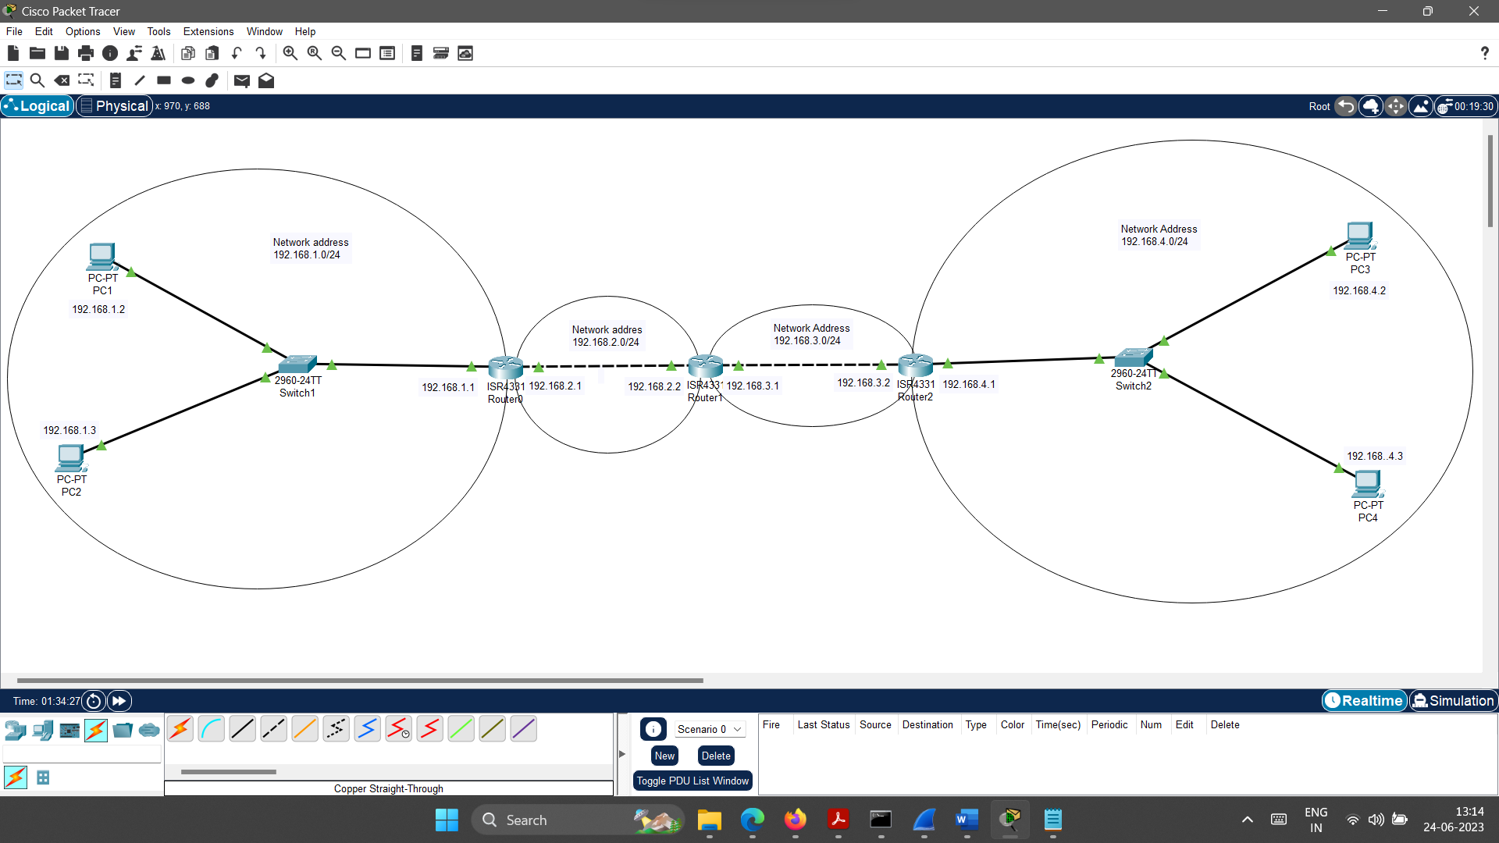

The configuration part done. Now perform the given operations in the practical quiz section.

1. **Practical Quiz**
2. Screenshot of configured IPv4 network. [Paste here the screenshot of the configured network.]
3. Execute ***ping 192.168.4.2*** command in the command prompt of the PC1. [Paste here the output screenshot of the command prompt]
4. Execute **tracert 192.168.4.3** command in the command prompt of the PC2. [Paste here the output screenshot of the command prompt]
5. Execute **ping 192.168.1.2** command in the command prompt of the PC3. [Paste here the output screenshot of the command prompt]
6. Execute **tracert 192.168.1.3** command in the command prompt of the PC4. [Paste here the output screenshot of the command prompt]
7. **References**

* <https://en.wikipedia.org/wiki/Packet_Tracer>
* <https://www.cisco.com/c/en/us/td/docs/ios/fundamentals/command/reference/cf_book.pdf>
* <https://www.cisco.com/c/en/us/td/docs/routers/access/800M/software/800MSCG/routconf.pdf>
* <https://www.networkstraining.com/basic-cisco-router-configuration-steps/>
* <https://www.cisco.com/c/en/us/td/docs/wireless/mwam/user/guide/mwam1/CLI.pdf>
* <https://en.wikipedia.org/wiki/Network_switch>
* <https://www.cisco.com/c/en/us/solutions/small-business/resource-center/networking/understanding-the-different-types-of-network-switches.html>
* <https://www.geeksforgeeks.org/what-is-a-network-switch-and-how-does-it-work/>
* <https://en.wikipedia.org/wiki/Router_(computing)>
* <https://www.cisco.com/c/en/us/solutions/small-business/resource-center/networking/what-is-a-router.html>
* <https://www.geeksforgeeks.org/introduction-of-a-router/>
* <https://www.cables-solutions.com/difference-between-straight-through-and-crossover-cable.html>
* <https://incentre.net/ethernet-cable-color-coding-diagram/>

1. **Assessment-Rubrics**

|  |  |  |  |  |  |  |  |
| --- | --- | --- | --- | --- | --- | --- | --- |
| **Rubric ID** | **Task** | **Criteria** | **%** | **Good** | **Average** | **Poor** | **Mark** |
| **RB1** | Completion of the given task | The student completes all of the tasks required by the assignment. | 30% | All tasks are completed correctly and on time. **(Mark - 3)** | All tasks are completed, but some may be late or incorrect. **(Mark - 2)** | Some tasks are not completed, or they are completed incorrectly or late. **(Mark 1 or 0)** |  |
| **RB2** | Correctness of the given task | The student's work is correct and free of errors. | 30% | All work is correct and free of errors. **(Mark - 3)** | Most work is correct, but there may be a few minor errors. **(Mark - 2)** | There are many errors in the work. **(Mark 1 or 0)** |  |
| **RB3** | Question answers | The student answers all of the questions correctly. | 20% | All questions are answered correctly. **(Mark - 2)** | Most questions are answered correctly, but there may be a few incorrect answers. **(Mark - 1)** | All questions are answered incorrectly. **(Mark - 0)** |  |
| **RB4** | Regularity of the report submission | The student submits the report on time and in the correct format. | 20% | The report is submitted on time and in the correct format. **(Mark - 2)** | The report is submitted on time, but it is not in the correct format. **(Mark - 1)** | The report is late or not submitted at all. **(Mark - 0)** |  |

**Signature With Date**

**Date: ……………**

**Practical No.5:**

Create a small IPv6 network using any relevant software.

1. **Objectives:**

* Configure IPv6 addressing on a router.
* Configure IPv6 addressing on a host.
* Ping between hosts in the IPv6 network.

1. **Expected Program Outcomes (POs):** PO1, PO2, PO3, PO4, PO6, PO7
2. **Expected Skills to be developed based on competency:**

* The students will learn how to create a small IPv6 network using cisco packet tracer. And it will help them to apply the learned concepts in the real time network.

1. **Expected Course Outcomes (COs):** CO2
2. **Practical Outcomes (PROs)**

The students will be able …

* To enable IPv6 globally on the router, configure IPv6 addressing on an interface and verify IPv6 addressing on the router.
* To configure link-local address on the host, configure a global unicast address on the host and verify IPv6 addressing on the host.
* To ping one host to another host using their IPv6 addresses and verify that ping was successful.

1. **Expected Affective domain Outcome (ADOs)**

* Practice good housekeeping.
* Follow standard configuration.
* Follow ethical practices.

1. **Prerequisite Theory:**

* Introduction to Cisco Packet Tracer.
* Introduction to various Cisco commands to configure router.
* Characteristics of IPv6 address.
* Various IPv6 addresses such as Global Unicast, Link-Local.
* Autoconfiguration facility in IPv6 addressing.
* Use of network devices such as network switch, routers.
* Use of different cables for the connections among devices such as copper straight cable, copper cross over cables.
* IPv6 address configuration in the Desktop Computers.
* Introduction to static routing.
* Use of PING and TRACERT commands.

1. **Resources required.**

|  |  |
| --- | --- |
| **S. No.** | **Equipment Name with Broad Specifications** |
| 1 | Computer System with basic configuration and connected with LAN and Internet. |
| 2 | Cisco Packet Tracer Software |

1. **Safety and necessary Precautions**

* Shut down the computer properly after using it.
* Do not unplug the computer's power cable while it is on.

1. **Procedure**

**To configure the IPv6 network, Follow the steps given below.**

1. **Open cisco packet tracer. Arrange different network devices and connect them using appropriate network cable as shown in the diagram below.**

The details of no of network devices and connection among them (with interfaces) are given below.

* The devices details are as follows
  + No of PCs :- 4
  + No of Network Switches(2960-24TT):- 2
  + No of Network Routers (2911):- 1
* The connection with interface details are as follows.
  + The connection between PC1 (FastEthernet0) and Swtich0(FastEthernet0/1) is done using copper straight cable.
  + The connection between PC2 (FastEthernet0) and Swtich0(FastEthernet0/2) is done using copper straight cable.
  + The connection between Switch0 (GigabitEthernet 0/1) and Router0(GigabitEthernet 0/0) is done using copper straight cable.
  + The connection between Router0(GigabitEthernet 0/1) and Switch1(GigabitEthernet 0/1) is done using copper straight cable.
  + The connection between PC3 (FastEthernet0) and Swtich1(FastEthernet0/1) is done using straight cable.
  + The connection between PC4 (FastEthernet0) and Swtich1(FastEthernet0/2) is done using straight cable.

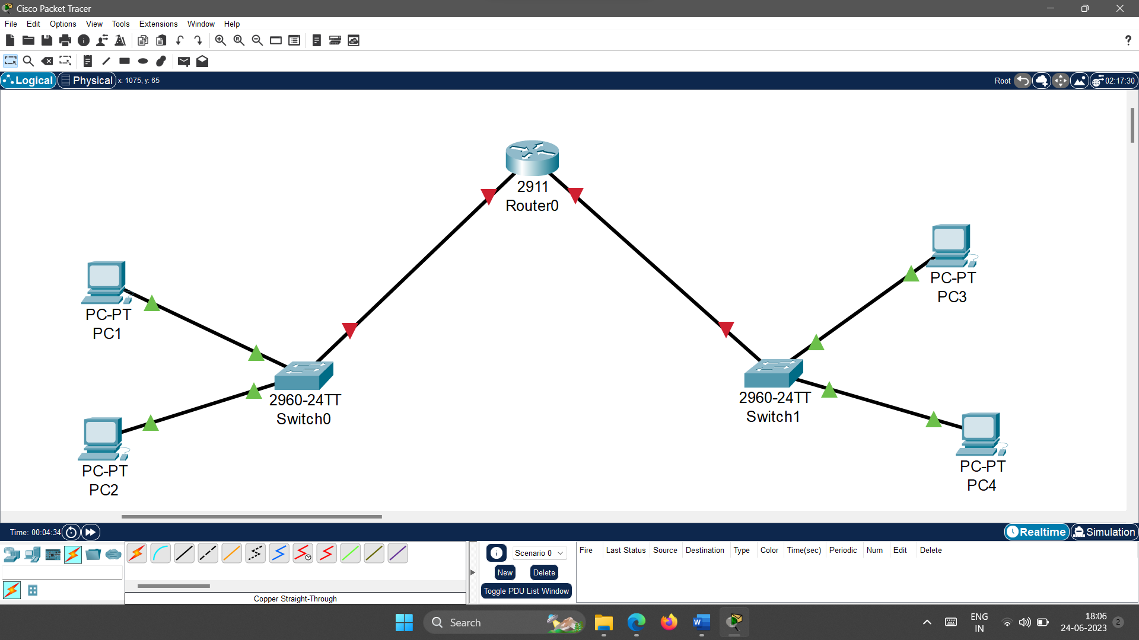

1. **Configure the Router0 as specified below.**

*--- System Configuration Dialog ---*

*Would you like to enter the initial configuration dialog? [yes/no]: no*

*Press RETURN to get started!*

*Router>****enable***

*Router#****configure terminal***

*Enter configuration commands, one per line. End with CNTL/Z.*

*Router(config)#****ipv6 unicast-routing***

*Router(config)#****interface gigabitEthernet 0/0***

*Router(config-if)#****ipv6 address FE80::1 link-local***

*Router(config-if)#****no shutdown***

*Router(config-if)#*

*%LINK-5-CHANGED: Interface GigabitEthernet0/0, changed state to up*

*%LINEPROTO-5-UPDOWN: Line protocol on Interface GigabitEthernet0/0, changed state to up*

*Router(config-if)#****exit***

*Router(config)#****interface gigabitEthernet 0/1***

*Router(config-if)#****ipv6 address FE80::1 link-local***

*Router(config-if)#****no shutdown***

*Router(config-if)#*

*%LINK-5-CHANGED: Interface GigabitEthernet0/1, changed state to up*

*%LINEPROTO-5-UPDOWN: Line protocol on Interface GigabitEthernet0/1, changed state to up*

*Router(config-if)#****exit***

*Router(config)#****interface gigabitEthernet 0/0***

*Router(config-if)#****ipv6 address 2000:DB8:1:A::1/64***

*Router(config-if)#****no shutdown***

*Router(config-if)#****exit***

*Router(config)#****interface gigabitEthernet 0/1***

*Router(config-if)#****ipv6 address 2000:DB8:1:B::1/64***

*Router(config-if)#****no shutdown***

*Router(config-if)#****exit***

*Router(config)#****exit***

*Router#*

1. **Configure PC1 as follows:**

Double click on PC1->Desktop->IP configuration->IPv6 Configuration-> Select Automatic

1. **Configure PC2 as follows:**

Double click on PC1->Desktop->IP configuration->IPv6 Configuration-> Select Automatic

1. **Configure PC3 as follows:**

Double click on PC1->Desktop->IP configuration->IPv6 Configuration-> Select Automatic

1. **Configure PC4 as follows:**

Double click on PC1->Desktop->IP configuration->IPv6 Configuration-> Select Automatic

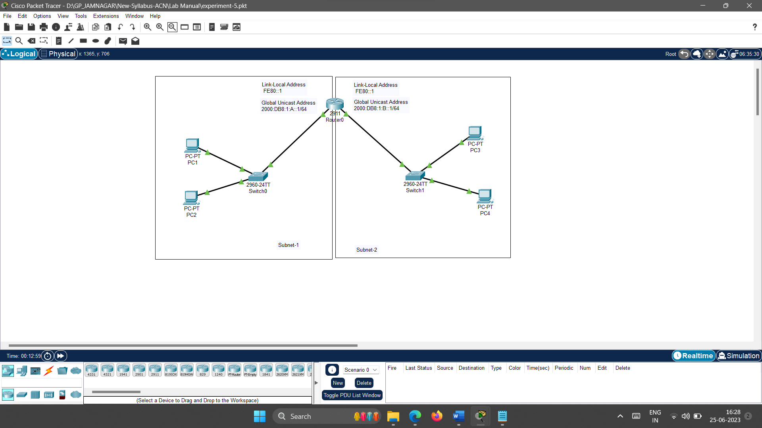

The configuration part done. Now perform the given operations in the practical quiz section.

1. **Practical Quiz**
2. Screenshot of your configured network. [Paste here the output screenshot of the command prompt]
3. Check connectivity from PC1 to PC3 using ping command. [Paste here the output screenshot of the command prompt]
4. Traceroute from PC2 to PC4 using tracert command. [Paste here the output screenshot of the command prompt]
5. Traceroute from PC3 to PC4 using ping command. [Paste here the output screenshot of the command prompt]
6. Check connectivity from PC4 to PC2 using ping command. [Paste here the output screenshot of the command prompt]
7. Find the content of the inbound and outbound packet at the router when you check the connectivity from PC1 to PC3 using ping command. (Use simulation mode)[ [Paste here the output screenshot of the content of the inbound and outbound packet].
8. **References**

* <https://www.geeksforgeeks.org/how-to-configure-ipv6-on-cisco-router/>
* <https://ipcisco.com/lesson/ipv6-configuration-on-cisco-packet-tracer/>
* <https://www.youtube.com/watch?v=FVf-GvUVm5U>
* <https://en.wikipedia.org/wiki/IPv6_address>

1. **Assessment-Rubrics**

|  |  |  |  |  |  |  |  |
| --- | --- | --- | --- | --- | --- | --- | --- |
| **Rubric ID** | **Task** | **Criteria** | **%** | **Good** | **Average** | **Poor** | **Mark** |
| **RB1** | Completion of the given task | The student completes all of the tasks required by the assignment. | 30% | All tasks are completed correctly and on time. **(Mark - 3)** | All tasks are completed, but some may be late or incorrect. **(Mark - 2)** | Some tasks are not completed, or they are completed incorrectly or late. **(Mark 1 or 0)** |  |
| **RB2** | Correctness of the given task | The student's work is correct and free of errors. | 30% | All work is correct and free of errors. **(Mark - 3)** | Most work is correct, but there may be a few minor errors. **(Mark - 2)** | There are many errors in the work. **(Mark 1 or 0)** |  |
| **RB3** | Question answers | The student answers all of the questions correctly. | 20% | All questions are answered correctly. **(Mark - 2)** | Most questions are answered correctly, but there may be a few incorrect answers. **(Mark - 1)** | All questions are answered incorrectly. **(Mark - 0)** |  |
| **RB4** | Regularity of the report submission | The student submits the report on time and in the correct format. | 20% | The report is submitted on time and in the correct format. **(Mark - 2)** | The report is submitted on time, but it is not in the correct format. **(Mark - 1)** | The report is late or not submitted at all. **(Mark - 0)** |  |

**Signature With Date**

**Date: ……………**

**Practical No.6:**

Configure RIP routing protocol using relevant software.

1. **Objectives:**

* To understand the RIP routing protocol.
* To be able to configure RIP on a router.

1. **Expected Program Outcomes (POs):** PO1, PO2, PO3, PO4, PO6, PO7
2. **Expected Skills to be developed based on competency:**

* The students will learn how to configure RIP routing protocol in the network using cisco packet tracer. And it will help them to apply the learned concepts in the real time network.

1. **Expected Course Outcomes (COs):** CO3
2. **Practical Outcomes (PROs)**

The students will be able …

* To configure RIP routing protocol using Cisco Packet Tracer.
* To verify RIP is configured correctly.
* To troubleshoot RIP problems.
* To learn various CISCO router configuration commands related to RIP.

1. **Expected Affective domain Outcome (ADOs)**

* Practice good housekeeping.
* Follow standard configuration.
* Follow ethical practices.

1. **Prerequisite Theory:**

* Introduction to Cisco Packet Tracer.
* Introduction to various Cisco commands to configure router.
* Introduction to RIP protocol.
* How does RIP work?
* IPv4 Addressing
* Use of network devices such as network switch, routers.
* Use of different cables for the connections among devices such as copper straight cable, copper cross over cables.
* IPv4 address configuration in the Desktop Computers.
* Introduction to dynamic routing.
* Use of PING and TRACERT commands.

1. **Resources required.**

|  |  |
| --- | --- |
| **S. No.** | **Equipment Name with Broad Specifications** |
| 1 | Computer System with basic configuration and connected with LAN and Internet. |
| 2 | Cisco Packet Tracer Software |

1. **Safety and necessary Precautions**

* Shut down the computer properly after using it.
* Do not unplug the computer's power cable while it is on.

1. **Procedure**

**To configure the RIP protocol, Follow the steps given below.**

1. **Open cisco packet tracer. Arrange different network devices and connect them using appropriate network cable as shown in the diagram below.**

The details of no of network devices and connection among them (with interfaces) are given below.

* The devices details are as follows
  + No of PCs :- 3
  + No of Network Switches(2960-24TT):- 3
  + No of Network Routers (2911):- 3
* The connection with interface details are as follows.
  + The connection between PC1 (FastEthernet0) and Swtich0(FastEthernet0/1) is done using copper straight cable.
  + The connection between PC2 (FastEthernet0) and Swtich1(FastEthernet0/1) is done using copper straight cable.
  + The connection between PC3 (FastEthernet0) and Swtich2(FastEthernet0/1) is done using copper straight cable.
  + The connection between Switch0 (GigabitEthernet 0/1) and Router6(GigabitEthernet 0/0) is done using copper straight cable.
  + The connection between Switch1 (GigabitEthernet 0/1) and Router8(GigabitEthernet 0/1) is done using copper straight cable.
  + The connection between Switch2 (GigabitEthernet 0/1) and Router9(GigabitEthernet 0/1) is done using copper straight cable.
  + The connection between Router6(GigabitEthernet 0/1)and Router8(GigabitEthernet 0/1) is done using copper cross over cable.
  + The connection between Router8(GigabitEthernet 0/2)and Router9(GigabitEthernet 0/0) is done using copper cross over cable.

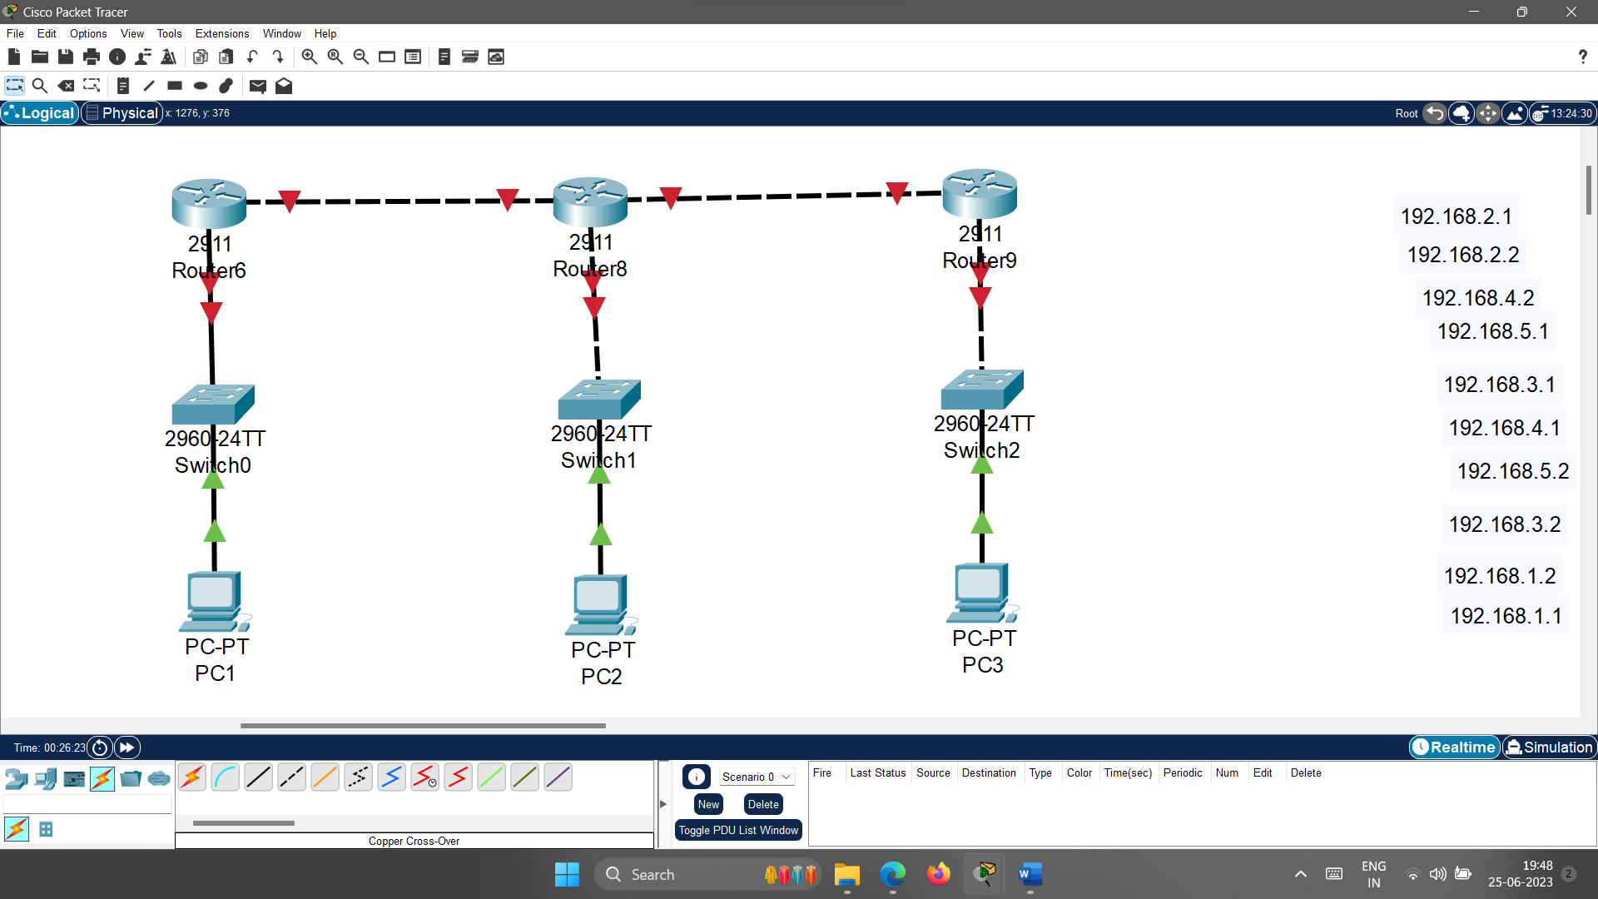

1. **Configure IP address, Subnet Mask and Default Gateway of PC1 as follows.**
   1. IP address: 192.168.1.2
   2. Subnet Mask: 255.255.255.0
   3. Default Gateway: 192.168.1.1
2. **Configure the Router6 as specified below.**

*--- System Configuration Dialog ---*

*Would you like to enter the initial configuration dialog? [yes/no]: no*

*Press RETURN to get started!*

*Router>****enable***

*Router#****configure terminal***

*Enter configuration commands, one per line. End with CNTL/Z.*

*Router(config)#****interface gigabitEthernet 0/0***

*Router(config-if)#****ip address 192.168.1.1 255.255.255.0***

*Router(config-if)#****no shutdown***

*Router(config-if)#*

*%LINK-5-CHANGED: Interface GigabitEthernet0/0, changed state to up*

*%LINEPROTO-5-UPDOWN: Line protocol on Interface GigabitEthernet0/0, changed state to up*

*Router(config-if)#****exit***

*Router(config)#****interface gigabitEthernet 0/1***

*Router(config-if)#****ip address 192.168.2.1 255.255.255.0***

*Router(config-if)#****no shutdown***

*Router(config-if)#*

*%LINK-5-CHANGED: Interface GigabitEthernet0/1, changed state to up*

*Router(config-if)#****exit***

*Router(config)#****router rip***

*Router(config-router)#****network 192.168.1.0***

*Router(config-router)#****network 192.168.2.0***

*Router(config-router)#****exit***

*Router(config)#****exit***

*Router#*

1. **Configure the Router8 as specified below.**

*--- System Configuration Dialog ---*

*Would you like to enter the initial configuration dialog? [yes/no]: no*

*Press RETURN to get started!*

*Router>****enable***

*Router#****configure terminal***

*Enter configuration commands, one per line. End with CNTL/Z.*

*Router(config)#****interface gigabitEthernet 0/0***

*Router(config-if)#****ip address 192.168.2.2 255.255.255.0***

*Router(config-if)#****no shutdown***

*Router(config-if)#*

*%LINK-5-CHANGED: Interface GigabitEthernet0/0, changed state to up*

*%LINEPROTO-5-UPDOWN: Line protocol on Interface GigabitEthernet0/0, changed state to up*

*Router(config-if)#****exit***

*Router(config)#****interface gigabitEthernet 0/1***

*Router(config-if)#****ip address 192.168.3.1 255.255.255.0***

*Router(config-if)#****no shutdown***

*Router(config-if)#*

*%LINK-5-CHANGED: Interface GigabitEthernet0/1, changed state to up*

*%LINEPROTO-5-UPDOWN: Line protocol on Interface GigabitEthernet0/1, changed state to up*

*Router(config-if)#****exit***

*Router(config)#*

*Router(config)#****interface gigabitEthernet 0/2***

*Router(config-if)#****ip address 192.168.4.1 255.255.255.0***

*Router(config-if)#****no shutdown***

*Router(config-if)#*

*%LINK-5-CHANGED: Interface GigabitEthernet0/2, changed state to up*

*%LINEPROTO-5-UPDOWN: Line protocol on Interface GigabitEthernet0/2, changed state to up*

*Router(config-if)#****exit***

*Router(config)#****router rip***

*Router(config-router)#****network 192.168.2.0***

*Router(config-router)#****network 192.168.3.0***

*Router(config-router)#****network 192.168.4.0***

*Router(config-router)#****exit***

*Router(config)#****exit***

*Router#*

1. **Configure IP address, Subnet Mask and Default Gateway of PC1 as follows.**
   1. IP address: 192.168.3.2
   2. Subnet Mask : 255.255.255.0
   3. Default Gateway: 192.168.3.1
2. **Configure the Router9 as specified below.**

*--- System Configuration Dialog ---*

*Would you like to enter the initial configuration dialog? [yes/no]: no*

*Press RETURN to get started!*

*Router>****enable***

*Router#****configure terminal***

*Enter configuration commands, one per line. End with CNTL/Z.*

*Router(config)#****interface gigabitEthernet 0/0***

*Router(config-if)#****ip address 192.168.4.2 255.255.255.0***

*Router(config-if)#****no shutdown***

*Router(config-if)#*

*%LINK-5-CHANGED: Interface GigabitEthernet0/0, changed state to up*

*%LINEPROTO-5-UPDOWN: Line protocol on Interface GigabitEthernet0/0, changed state to up*

*Router(config-if)#****exit***

*Router(config)#****interface gigabitEthernet 0/1***

*Router(config-if)#****ip address 192.168.5.1 255.255.255.0***

*Router(config-if)#****no shutdown***

*Router(config-if)#*

*%LINK-5-CHANGED: Interface GigabitEthernet0/1, changed state to up*

*%LINEPROTO-5-UPDOWN: Line protocol on Interface GigabitEthernet0/1, changed state to up*

*Router(config-if)#****exit***

*Router(config)#****router rip***

*Router(config-router)#****network 192.168.4.0***

*Router(config-router)#****network 192.168.5.0***

*Router(config-router)#****exit***

*Router(config)#****exit***

*Router#*

1. **Configure IP address, Subnet Mask and Default Gateway of PC1 as follows.**
2. IP address: 192.168.5.2
3. Subnet Mask : 255.255.255.0
4. Default Gateway: 192.168.5.1

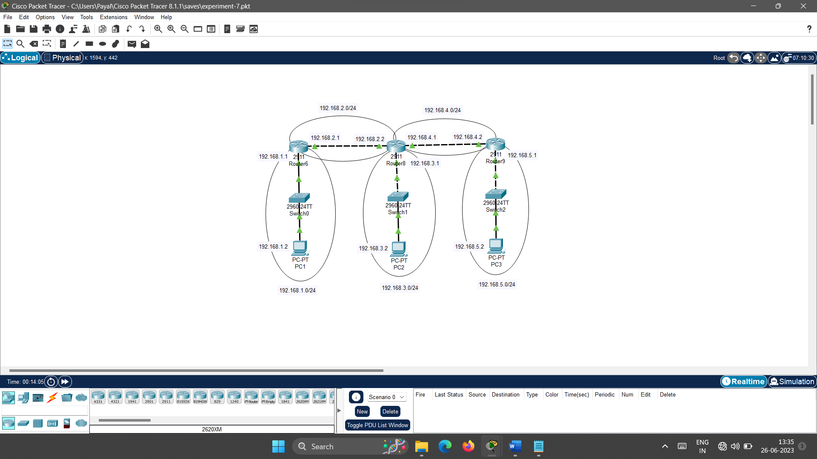

The configuration part done. Now perform the given operations in the practical quiz section.

1. **Practical Quiz**
2. Screenshot of your configured network.
3. Check connectivity from PC1 to PC2 using ping command. [Paste here the output screenshot of the command prompt]
4. Traceroute from PC1 to PC3 using tracert command. [Paste here the output screenshot of the command prompt]
5. Show IP route of the router6 [Paste here the screen shot of the router CLI]
6. Show IP route of the router8 [Paste here the screen shot of the router CLI]
7. Show IP route of the router9 [Paste here the screen shot of the router CLI]
8. **References**

* <https://en.wikipedia.org/wiki/Routing_Information_Protocol>
* <https://www.geeksforgeeks.org/rip-routing-configuration-using-3-routers-in-cisco-packet-tracer/>
* <https://www.youtube.com/watch?v=krM9GprN6qA>
* <https://www.geeksforgeeks.org/routing-information-protocol-rip/>
* <https://www.cisco.com/c/en/us/td/docs/ios/iproute_rip/command/reference/irr_book/irr_rip.html>

1. **Assessment-Rubrics**

|  |  |  |  |  |  |  |  |
| --- | --- | --- | --- | --- | --- | --- | --- |
| **Rubric ID** | **Task** | **Criteria** | **%** | **Good** | **Average** | **Poor** | **Mark** |
| **RB1** | Completion of the given task | The student completes all of the tasks required by the assignment. | 30% | All tasks are completed correctly and on time. **(Mark - 3)** | All tasks are completed, but some may be late or incorrect. **(Mark - 2)** | Some tasks are not completed, or they are completed incorrectly or late. **(Mark 1 or 0)** |  |
| **RB2** | Correctness of the given task | The student's work is correct and free of errors. | 30% | All work is correct and free of errors. **(Mark - 3)** | Most work is correct, but there may be a few minor errors. **(Mark - 2)** | There are many errors in the work. **(Mark 1 or 0)** |  |
| **RB3** | Question answers | The student answers all of the questions correctly. | 20% | All questions are answered correctly. **(Mark - 2)** | Most questions are answered correctly, but there may be a few incorrect answers. **(Mark - 1)** | All questions are answered incorrectly. **(Mark - 0)** |  |
| **RB4** | Regularity of the report submission | The student submits the report on time and in the correct format. | 20% | The report is submitted on time and in the correct format. **(Mark - 2)** | The report is submitted on time, but it is not in the correct format. **(Mark - 1)** | The report is late or not submitted at all. **(Mark - 0)** |  |

**Signature with Date**

**Date: ……………**

**Practical No.7:**

Configure OSPF routing protocol using relevant software.

1. **Objectives:**

* To understand the OSPF routing protocol.
* To be able to configure OSPF on a router.

1. **Expected Program Outcomes (POs):** PO1, PO2, PO3, PO4, PO6, PO7
2. **Expected Skills to be developed based on competency:**

* The students will learn how to configure OSPF routing protocol in the network using cisco packet tracer. And it will help them to apply the learned concepts in the real time network.

1. **Expected Course Outcomes (COs):** CO3
2. **Practical Outcomes (PROs)**

The students will be able …

* To configure OSPF routing protocol using Cisco Packet Tracer.
* To verify OSPF is configured correctly.
* To troubleshoot OSPF problems.
* To learn various CISCO router configuration commands related to OSPF.

1. **Expected Affective domain Outcome (ADOs)**

* Practice good housekeeping.
* Follow standard configuration.
* Follow ethical practices.

1. **Prerequisite Theory:**

* Introduction to Cisco Packet Tracer.
* Introduction to various Cisco commands to configure router.
* Introduction to OSPF protocol.
* How does OSPF work?
* IPv4 Addressing
* Use of network devices such as network switch, routers.
* Use of different cables for the connections among devices such as copper straight cable, copper cross over cables.
* IPv4 address configuration in the Desktop Computers.
* Introduction to dynamic routing.
* Use of PING and TRACERT commands.

1. **Resources required.**

|  |  |
| --- | --- |
| **S. No.** | **Equipment Name with Broad Specifications** |
| 1 | Computer System with basic configuration and connected with LAN and Internet. |
| 2 | Cisco Packet Tracer Software |

1. **Safety and necessary Precautions**

* Shut down the computer properly after using it.
* Do not unplug the computer's power cable while it is on.

1. **Procedure**

**To configure the OSPF protocol, Follow the steps given below.**

1. Open cisco packet tracer. Arrange different network devices and connect them using appropriate network cable as shown in the diagram below.

The details of no of network devices and connection among them (with interfaces) are given below.

* The devices details are as follows
  + No of PCs :- 3
  + No of Network Switches(2960-24TT):- 3
  + No of Network Routers (2911):- 3
* The connection with interface details are as follows.
  + The connection between PC1 (FastEthernet0) and Swtich0(FastEthernet0/1) is done using copper straight cable.
  + The connection between Switch0 (GigabitEthernet 0/1) and Router0(GigabitEthernet 0/0) is done using copper straight cable.
  + The connection between Router0(GigabitEthernet 0/1)and Router1(GigabitEthernet 0/1) is done using copper cross over cable.
  + The connection between Router0(GigabitEthernet 0/2)and Router2(GigabitEthernet 0/0) is done using copper cross over cable.
  + The connection between Router1(GigabitEthernet 0/1)and Router2(GigabitEthernet 0/1) is done using copper cross over cable.
  + The connection between Switch1 (GigabitEthernet 0/1) and Router2(GigabitEthernet 0/2) is done using copper straight cable.
  + The connection between PC2 (FastEthernet0) and Swtich1(FastEthernet0/1) is done using copper straight cable.

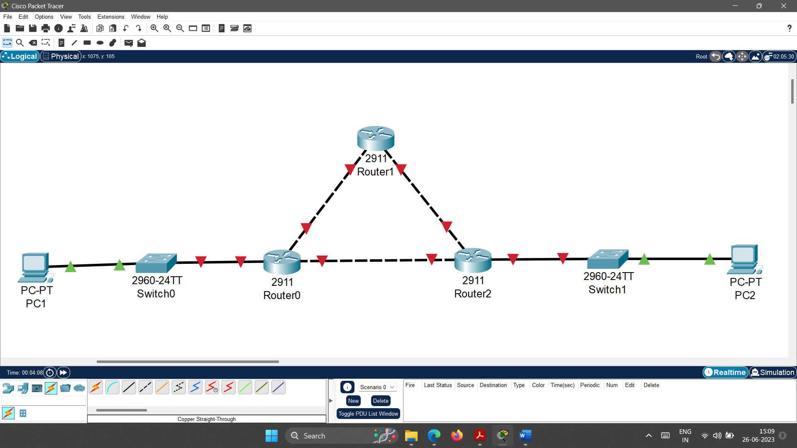

1. **Configure IP address, Subnet Mask and Default Gateway of PC1 as follows.**
   1. IP address: 192.168.1.2
   2. Subnet Mask: 255.255.255.0
   3. Default Gateway: 192.168.1.1
2. **Configure the Router0 as specified below.**

*--- System Configuration Dialog ---*

*Would you like to enter the initial configuration dialog? [yes/no]: no*

*Press RETURN to get started!*

*Router>****enable***

*Router#****configure terminal***

*Enter configuration commands, one per line. End with CNTL/Z.*

*Router(config)#****interface gigabitEthernet 0/0***

*Router(config-if)#****ip address 192.168.1.1 255.255.255.0***

*Router(config-if)#****no shutdown***

*Router(config-if)#*

*%LINK-5-CHANGED: Interface GigabitEthernet0/0, changed state to up*

*%LINEPROTO-5-UPDOWN: Line protocol on Interface GigabitEthernet0/0, changed state to up*

*Router(config-if)#****exit***

*Router(config)#****interface gigabitEthernet 0/1***

*Router(config-if)#****ip address 192.168.2.1 255.255.255.0***

*Router(config-if)#****no shutdown***

*Router(config-if)#*

*%LINK-5-CHANGED: Interface GigabitEthernet0/1, changed state to up*

*%LINEPROTO-5-UPDOWN: Line protocol on Interface GigabitEthernet0/1, changed state to up*

*Router(config-if)#****exit***

*Router(config)#****interface gigabitEthernet 0/2***

*Router(config-if)#****ip address 192.168.3.1 255.255.255.0***

*Router(config-if)#****no shutdown***

*Router(config-if)#*

*%LINK-5-CHANGED: Interface GigabitEthernet0/2, changed state to up*

*Router(config-if)#****exit***

*Router(config)#****router ospf 1***

*Router(config-router)#****network 192.168.1.0 0.0.0.255 area 0***

*Router(config-router)#****network 192.168.2.0 0.0.0.255 area 0***

*Router(config-router)#****network 192.168.3.0 0.0.0.255 area 0***

*Router(config-router)#****exit***

*Router(config)#****exit***

*Router#*

1. Configure the Router1 as specified below.

*--- System Configuration Dialog ---*

*Would you like to enter the initial configuration dialog? [yes/no]:*

*Press RETURN to get started!*

*Router>****enable***

*Router#****configure terminal***

*Enter configuration commands, one per line. End with CNTL/Z.*

*Router(config)#****interface gigabitEthernet 0/0***

*Router(config-if)#****ip address 192.168.2.2 255.255.255.0***

*Router(config-if)#****no shutdown***

*Router(config-if)#*

*%LINK-5-CHANGED: Interface GigabitEthernet0/0, changed state to up*

*Router(config-if)#****exit***

*Router(config)#****interface gigabitEthernet 0/1***

*Router(config-if)#****ip address 192.168.4.1 255.255.255.0***

*Router(config-if)#****no shutdown***

*Router(config-if)#*

*%LINK-5-CHANGED: Interface GigabitEthernet0/1, changed state to up*

*Router(config-if)#****exit***

*Router(config)#****router ospf 1***

*Router(config-router)#****network 192.168.2.0 0.0.0.255 area 0***

*Router(config-router)#****network 192.168.4.0 0.0.0.255 area 0***

*Router(config-router)#****exit***

*Router(config)#****exit***

*Router#*

1. **Configure the Router2 as specified below.**

*--- System Configuration Dialog ---*

*Would you like to enter the initial configuration dialog? [yes/no]: no*

*Press RETURN to get started!*

*Router>****enable***

*Router#****configure terminal***

*Enter configuration commands, one per line. End with CNTL/Z.*

*Router(config)#****interface gigabitEthernet 0/0***

*Router(config-if)#****ip address 192.168.3.2 255.255.255.0***

*Router(config-if)#****no shutdown***

*Router(config-if)#*

*%LINK-5-CHANGED: Interface GigabitEthernet0/0, changed state to up*

*%LINEPROTO-5-UPDOWN: Line protocol on Interface GigabitEthernet0/0, changed state to up*

*Router(config-if)#****exit***

*Router(config)#****interface gigabitEthernet 0/1***

*Router(config-if)#****ip address 192.168.4.2 255.255.255.0***

*Router(config-if)#****no shutdown***

*Router(config-if)#*

*%LINK-5-CHANGED: Interface GigabitEthernet0/1, changed state to up*

*%LINEPROTO-5-UPDOWN: Line protocol on Interface GigabitEthernet0/1, changed state to up*

*Router(config-if)#****exit***

*Router(config)#****interface gigabitEthernet 0/2***

*Router(config-if)#****ip address 192.168.5.1 255.255.255.0***

*Router(config-if)#****no shutdown***

*Router(config-if)#*

*%LINK-5-CHANGED: Interface GigabitEthernet0/2, changed state to up*

*%LINEPROTO-5-UPDOWN: Line protocol on Interface GigabitEthernet0/2, changed state to up*

*Router(config-if)#****exit***

*Router(config)#****router ospf 1***

*Router(config-router)#****network 192.168.4.0 0.0.0.255 area 0***

*Router(config-router)#****network 192.168.5.0 0.0.0.255 area 0***

*Router(config-router)#****network 192.168.3.0 0.0.0.255 area 0***

*Router(config-router)#****exit***

*Router(config)#****exit***

*Router#*

1. **Configure IP address, Subnet Mask and Default Gateway of PC2 as follows.**
   1. IP address: 192.168.5.2
   2. Subnet Mask : 255.255.255.0
   3. Default Gateway: 192.168.5.1

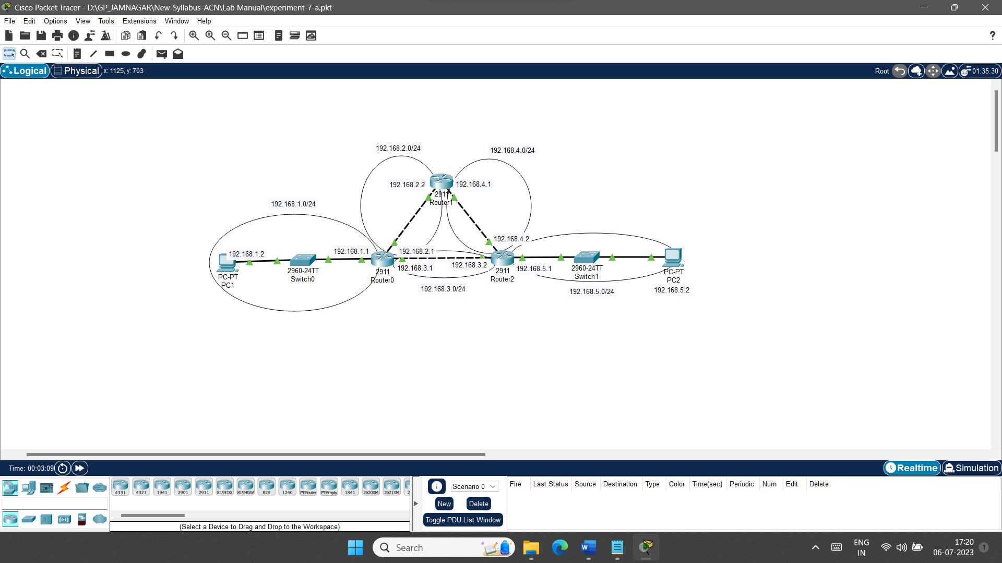

The configuration part done. Now perform the given operations in the practical quiz section.

1. **Practical Quiz**
2. Screenshot of your configured network.
3. Check connectivity from PC1 to PC2 using ping command. [Paste here the output screenshot of the command prompt].
4. Traceroute from PC1 to PC2 using tracert command. [Paste here the output screenshot of the command prompt]
5. Show IP route of the router0 [Paste here the screen shot of the router CLI]
6. Show IP route of the router1 [Paste here the screen shot of the router CLI]
7. Show IP route of the router2 [Paste here the screen shot of the router CLI]
8. **References**

* <https://www.youtube.com/watch?v=PQJzPkwPlhk>
* <https://www.youtube.com/watch?v=UtleMgkvp3o>
* <https://www.javatpoint.com/ospf-protocol>
* <https://www.nwkings.com/what-is-ospf-protocol-in-networking>
* <https://www.cisco.com/c/en/us/support/docs/ip/open-shortest-path-first-ospf/7039-1.html>

1. **Assessment-Rubrics**

|  |  |  |  |  |  |  |  |
| --- | --- | --- | --- | --- | --- | --- | --- |
| **Rubric ID** | **Task** | **Criteria** | **%** | **Good** | **Average** | **Poor** | **Mark** |
| **RB1** | Completion of the given task | The student completes all of the tasks required by the assignment. | 30% | All tasks are completed correctly and on time. **(Mark - 3)** | All tasks are completed, but some may be late or incorrect. **(Mark - 2)** | Some tasks are not completed, or they are completed incorrectly or late. **(Mark 1 or 0)** |  |
| **RB2** | Correctness of the given task | The student's work is correct and free of errors. | 30% | All work is correct and free of errors. **(Mark - 3)** | Most work is correct, but there may be a few minor errors. **(Mark - 2)** | There are many errors in the work. **(Mark 1 or 0)** |  |
| **RB3** | Question answers | The student answers all of the questions correctly. | 20% | All questions are answered correctly. **(Mark - 2)** | Most questions are answered correctly, but there may be a few incorrect answers. **(Mark - 1)** | All questions are answered incorrectly. **(Mark - 0)** |  |
| **RB4** | Regularity of the report submission | The student submits the report on time and in the correct format. | 20% | The report is submitted on time and in the correct format. **(Mark - 2)** | The report is submitted on time, but it is not in the correct format. **(Mark - 1)** | The report is late or not submitted at all. **(Mark - 0)** |  |

**Signature With Date**

**Date: ……………**

**Practical No.8:**

Configure BGP routing protocol using relevant software.

1. **Objectives:**

* To understand the BGP routing protocol.
* To be able to configure BGP on a router.

1. **Expected Program Outcomes (POs):** PO1, PO2, PO3, PO4, PO6, PO7
2. **Expected Skills to be developed based on competency:**

* The students will learn how to configure BGP routing protocol in the network using cisco packet tracer. And it will help them to apply the learned concepts in the real time network.

1. **Expected Course Outcomes (COs):** CO3
2. **Practical Outcomes (PROs)**

The students will be able …

* To configure BGP routing protocol using Cisco Packet Tracer.
* To verify BGP is configured correctly.
* To troubleshoot BGP problems.
* To learn various CISCO router configuration commands related to BGP.

1. **Expected Affective domain Outcome (ADOs)**

* Practice good housekeeping.
* Follow standard configuration.
* Follow ethical practices.

1. **Prerequisite Theory:**

* Introduction to Cisco Packet Tracer.
* Introduction to various Cisco commands to configure router.
* Introduction to BGP protocol.
* How does BGP work?
* Introduction to Autonomous System.
* IPv4 Addressing
* Use of network devices such as network switch, routers.
* Use of different cables for the connections among devices such as copper straight cable, copper cross over cables.
* IPv4 address configuration in the Desktop Computers.
* Introduction to dynamic routing.
* Use of PING and TRACERT commands.

1. **Resources required.**

|  |  |
| --- | --- |
| **S. No.** | **Equipment Name with Broad Specifications** |
| 1 | Computer System with basic configuration and connected with LAN and Internet. |
| 2 | Cisco Packet Tracer Software |

1. **Safety and necessary Precautions**

* Shut down the computer properly after using it.
* Do not unplug the computer's power cable while it is on.

1. **Procedure**

**To configure the OSPF protocol, Follow the steps given below.**

1. Open cisco packet tracer. Arrange different network devices and connect them using appropriate network cable as shown in the diagram below.

The details of no of network devices and connection among them (with interfaces) are given below.

* The devices details are as follows
  + No of PCs :- 3
  + No of Network Routers (2911):- 3
* The connection with interface details are as follows.
  + The connection between PC1 (FastEthernet0) and Router0(GigabitEthernet 0/0) is done using copper cross over cable.
  + The connection between Router0(GigabitEthernet 0/1)and Router1(GigabitEthernet 0/1) is done using copper cross over cable.
  + The connection between PC2 (FastEthernet0) and Router1(GigabitEthernet 0/0) is done using copper cross over cable.
  + The connection between Router1(GigabitEthernet 0/2)and Router2(GigabitEthernet 0/1) is done using copper cross over cable.
  + The connection between PC3 (FastEthernet0) and Router2(GigabitEthernet 0/0) is done using copper cross over cable.

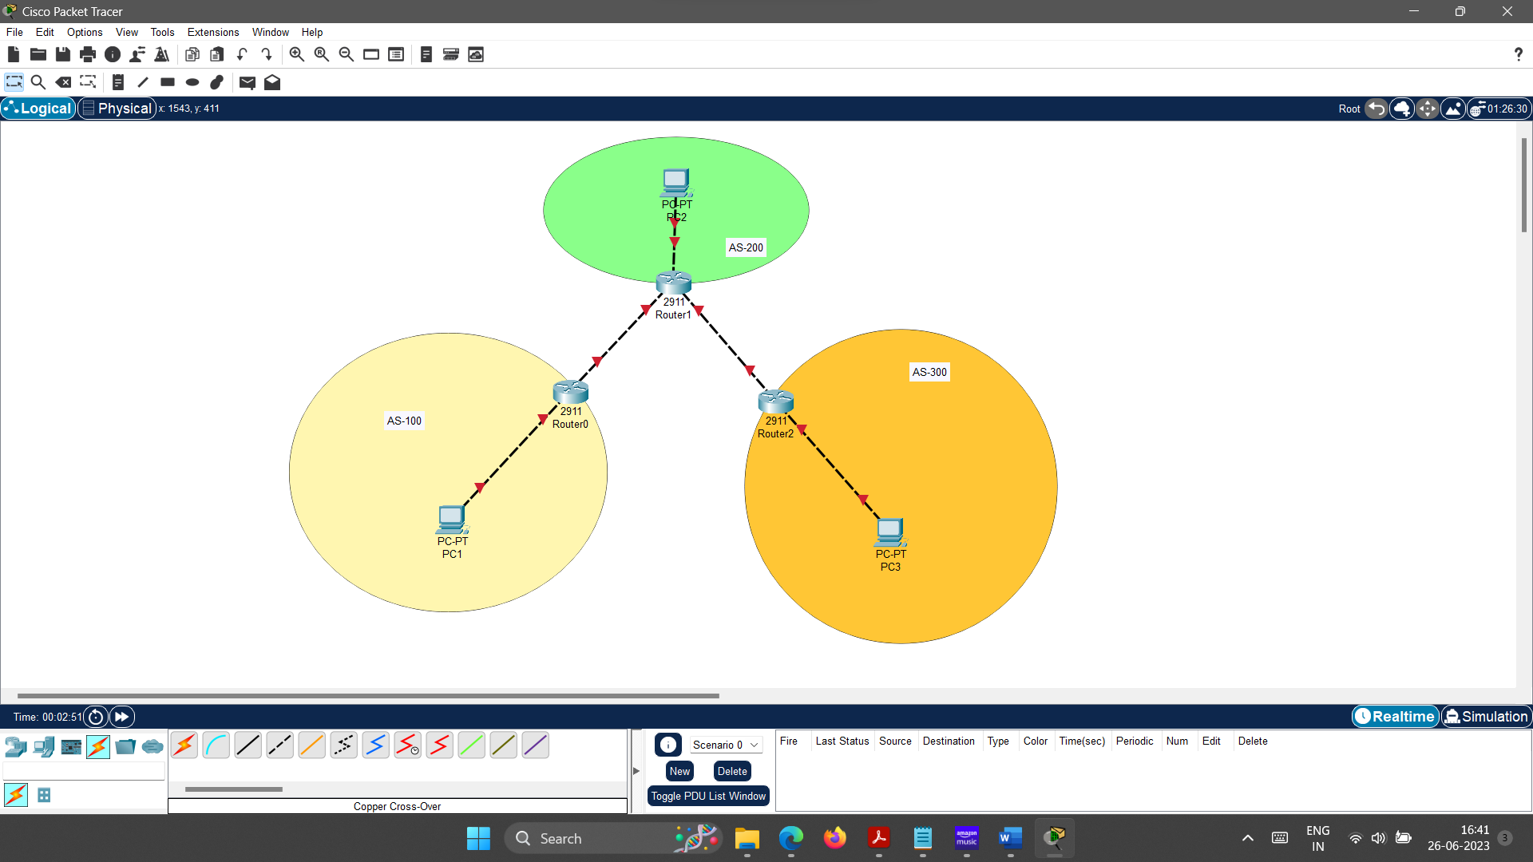

1. **Configure IP address, Subnet Mask and Default Gateway of PC1 as follows.**
   1. IP address: 192.168.1.2
   2. Subnet Mask: 255.255.255.0
   3. Default Gateway: 192.168.1.1
2. **Configure the Router0 as specified below.**

*--- System Configuration Dialog ---*

*Would you like to enter the initial configuration dialog? [yes/no]:*

*Press RETURN to get started!*

*Router>*

*Router>****enable***

*Router#****configure terminal***

*Enter configuration commands, one per line. End with CNTL/Z.*

*Router(config)#****interface gigabitEthernet 0/0***

*Router(config-if)#****ip address 192.168.1.1 255.255.255.0***

*Router(config-if)#****no shutdown***

*Router(config-if)#*

*%LINK-5-CHANGED: Interface GigabitEthernet0/0, changed state to up*

*%LINEPROTO-5-UPDOWN: Line protocol on Interface GigabitEthernet0/0, changed state to up*

*Router(config-if)#****exit***

*Router(config)#****interface gigabitEthernet 0/1***

*Router(config-if)#****ip address 10.0.0.1 255.255.255.0***

*Router(config-if)#****no shutdown***

*Router(config-if)#*

*%LINK-5-CHANGED: Interface GigabitEthernet0/1, changed state to up*

*Router(config-if)#****exit***

*Router(config)#****router bgp 100***

*Router(config-router)#****network 192.168.1.0 mask 255.255.255.0***

*Router(config-router)#****network 10.0.0.0 mask 255.255.255.0***

*Router(config-router)#****neighbor 10.0.0.2 remote-as 200***

*Router(config-router)#****exit***

*Router(config)#****exit***

*Router#*

1. **Configure the Router1 as specified below.**

*--- System Configuration Dialog ---*

*Would you like to enter the initial configuration dialog? [yes/no]: no*

*Press RETURN to get started!*

*Router>****enable***

*Router#****configure terminal***

*Router(config)#****interface gigabitEthernet 0/0***

*Router(config-if)#****ip address 192.168.2.1 255.255.255.0***

*Router(config-if)#****no shutdown***

*Router(config-if)#*

*%LINK-5-CHANGED: Interface GigabitEthernet0/0, changed state to up*

*%LINEPROTO-5-UPDOWN: Line protocol on Interface GigabitEthernet0/0, changed state to up*

*Router(config-if)#****exit***

*Router(config)#****interface gigabitEthernet 0/1***

*Router(config-if)#****ip address 10.0.0.2 255.255.255.0***

*Router(config-if)#****no shutdown***

*Router(config-if)#*

*%LINK-5-CHANGED: Interface GigabitEthernet0/1, changed state to up*

*%LINEPROTO-5-UPDOWN: Line protocol on Interface GigabitEthernet0/1, changed state to up*

*Router(config-if)#****exit***

*Router(config)#****interface gigabitEthernet 0/2***

*Router(config-if)#****ip address 20.0.0.2 255.255.255.0***

*Router(config-if)#****no shutdown***

*Router(config-if)#*

*%LINK-5-CHANGED: Interface GigabitEthernet0/2, changed state to up*

*Router(config-if)#****exit***

*Router(config)#****router bgp 200***

*Router(config-router)#****network 10.0.0.0 mask 255.255.255.0***

*Router(config-router)#****network 20.0.0.0 mask 255.255.255.0***

*Router(config-router)#****network 192.168.2.0 mask 255.255.255.0***

*Router(config-router)#****neighbor 10.0.0.1 remote-as 100***

*Router(config-router)#%BGP-5-ADJCHANGE: neighbor 10.0.0.1 Up*

*Router(config-router)#****neighbor 20.0.0.1 remote-as 200***

*Router(config-router)#*

*%Cisco Packet Tracer does not support internal BGP in this version. Only external neighbors are supported.*

*Router(config-router)#****neighbor 20.0.0.1 remote-as 300***

*Router(config-router)#****exit***

*Router(config)#****exit***

*Router#*

1. **Configure the Router2 as specified below.**

*--- System Configuration Dialog ---*

*Would you like to enter the initial configuration dialog? [yes/no]: no*

*Press RETURN to get started!*

*Router>****enable***

*Router#****configure terminal***

*Enter configuration commands, one per line. End with CNTL/Z.*

*Router(config)#****interface gigabitEthernet 0/0***

*Router(config-if)#****ip address 192.168.3.1 255.255.255.0***

*Router(config-if)#****no shutdown***

*Router(config-if)#*

*%LINK-5-CHANGED: Interface GigabitEthernet0/0, changed state to up*

*%LINEPROTO-5-UPDOWN: Line protocol on Interface GigabitEthernet0/0, changed state to up*

*Router(config-if)#****exit***

*Router(config)#****interface gigabitEthernet 0/1***

*Router(config-if)#****ip address 20.0.0.1 255.255.255.0***

*Router(config-if)#*

*%LINK-5-CHANGED: Interface GigabitEthernet0/1, changed state to up*

*%LINEPROTO-5-UPDOWN: Line protocol on Interface GigabitEthernet0/1, changed state to up*

*Router(config-if)#****exit***

*Router(config)#****router bgp 300***

*Router(config-router)#****network 20.0.0.0 mask 255.255.255.0***

*Router(config-router)#****network 192.168.3.0 mask 255.255.255.0***

*Router(config-router)#****neighbor 20.0.0.2 remote-as 200***

*Router(config-router)#%BGP-5-ADJCHANGE: neighbor 20.0.0.2 Up*

*Router(config-router)#****exit***

*Router(config)#****exit***

*Router#*

1. **Configure IP address, Subnet Mask and Default Gateway of PC2 as follows.**
   1. IP address: 192.168.2.2
   2. Subnet Mask : 255.255.255.0
   3. Default Gateway: 192.168.2.1
2. **Configure IP address, Subnet Mask and Default Gateway of PC3 as follows.**
   1. IP address: 192.168.3.2
   2. Subnet Mask : 255.255.255.0
   3. Default Gateway: 192.168.3.1

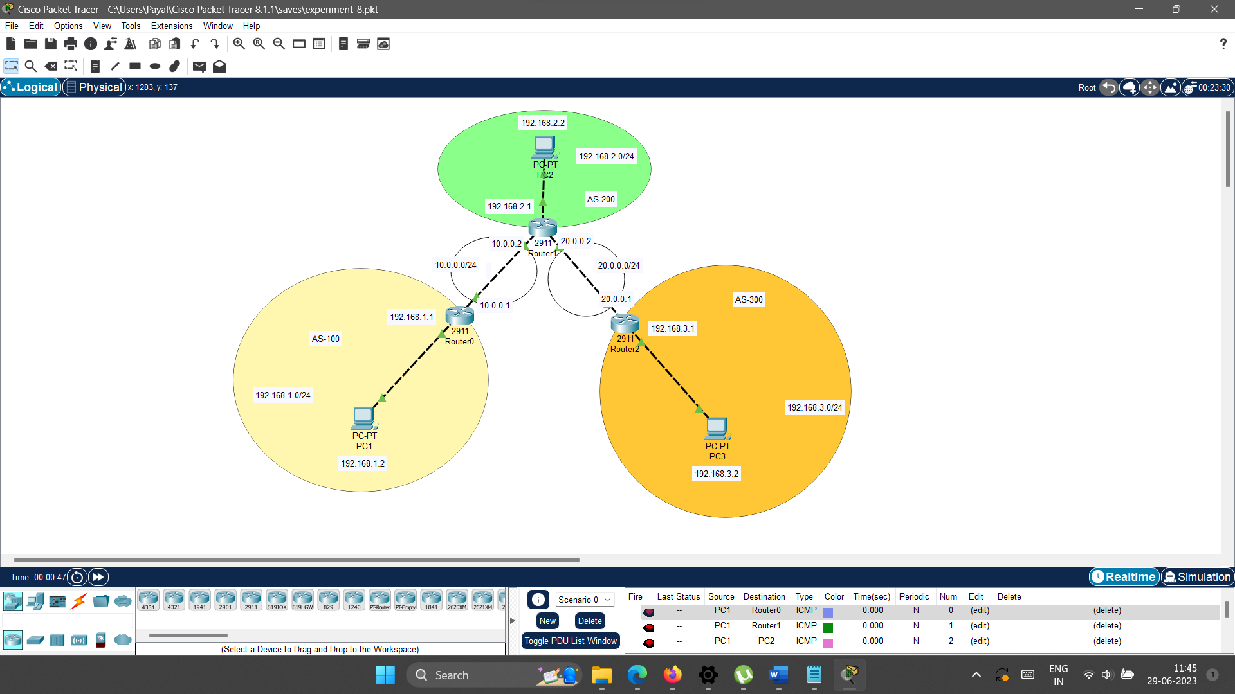

The configuration part done. Now perform the given operations in the practical quiz section.

1. **Practical Quiz**
2. Screenshot of your configured network.
3. Check connectivity from PC1 to PC2 using ping command. [Paste here the output screenshot of the command prompt]
4. Traceroute from PC1 to PC3 using tracert command. [Paste here the output screenshot of the command prompt]
5. Show IP route of the router0 [Paste here the screen shot of the router CLI]
6. Show IP route of the router1 [Paste here the screen shot of the router CLI]
7. Show IP route of the router2 [Paste here the screen shot of the router CLI]
8. **References**

* <https://datatracker.ietf.org/doc/html/rfc1105>
* <https://en.wikipedia.org/wiki/Border_Gateway_Protocol>
* <https://www.cloudflare.com/learning/security/glossary/what-is-bgp/>
* <https://www.youtube.com/watch?v=n66ZN8yULLw>
* <https://www.youtube.com/watch?v=A1KXPpqlNZ4>
* <https://www.youtube.com/watch?v=Y71DK9pP8u>0

1. **Assessment-Rubrics**

|  |  |  |  |  |  |  |  |
| --- | --- | --- | --- | --- | --- | --- | --- |
| **Rubric ID** | **Task** | **Criteria** | **%** | **Good** | **Average** | **Poor** | **Mark** |
| **RB1** | Completion of the given task | The student completes all of the tasks required by the assignment. | 30% | All tasks are completed correctly and on time. **(Mark - 3)** | All tasks are completed, but some may be late or incorrect. **(Mark - 2)** | Some tasks are not completed, or they are completed incorrectly or late. **(Mark 1 or 0)** |  |
| **RB2** | Correctness of the given task | The student's work is correct and free of errors. | 30% | All work is correct and free of errors. **(Mark - 3)** | Most work is correct, but there may be a few minor errors. **(Mark - 2)** | There are many errors in the work. **(Mark 1 or 0)** |  |
| **RB3** | Question answers | The student answers all of the questions correctly. | 20% | All questions are answered correctly. **(Mark - 2)** | Most questions are answered correctly, but there may be a few incorrect answers. **(Mark - 1)** | All questions are answered incorrectly. **(Mark - 0)** |  |
| **RB4** | Regularity of the report submission | The student submits the report on time and in the correct format. | 20% | The report is submitted on time and in the correct format. **(Mark - 2)** | The report is submitted on time, but it is not in the correct format. **(Mark - 1)** | The report is late or not submitted at all. **(Mark - 0)** |  |

**Signature With Date**

**Date: ……………**

**Practical No.9:**

1. The following is a dump (contents) of a UDP header in hexadecimal format.

0045DF0000580000

* 1. What is the source port number?
  2. What is the destination port number?
  3. What is the total length of the user datagram?
  4. What is the length of the data?
  5. Is the packet directed from a client to a server or vice versa?
  6. What is the application-layer protocol?
  7. Has the sender calculated a checksum for this packet?

1. The following is part of a TCP header dump (contents) in hexadecimal format.

E293 0017 00000001 00000000 5002 07FF..

* 1. What is the source port number?
  2. What is the destination port number?
  3. What is the sequence number?
  4. What is the acknowledgment number?
  5. What is the length of the header?
  6. What is the type of the segment?
  7. What is the window size?

1. The following is a dump of an SCTP general header in hexadecimal format.

04320017 00000001 00000000

* 1. What is the source port number?
  2. What is the destination port number?
  3. What is the value of the verification tag?
  4. What is the value of the checksum?

1. **Objectives**
   * To identify different components of the TCP, UDP and SCTP header.
2. **Expected Program Outcomes (POs):** PO1, PO2, PO3, PO4, PO6, PO7
3. **Expected Skills to be developed based on competency:**

* The students will be able to understand the binary representation and its meaning of the TCP, UDP and SCTP header data. And it will help them to apply the learned concepts in the real time network.

1. **Expected Course Outcomes (COs) :** CO4
2. **Practical Outcomes (PROs)**

The students will be able …

* To understand binary representation of TCP, UDP and SCTP header data.
* To identify the different fields of TCP, UDP and SCTP header.

1. **Expected Affective domain Outcome (ADOs)**

* Follow ethical practices.
* Follow standard configuration.

1. **Prerequisite Theory:**

* Number Conversion from Binary to Decimal.
* Number Conversion from Decimal to Binary.
* Basics of IPv4 address.
* Classful IPv4 addressing.
* Classless IPv4 addressing.
* CIDR notation.
* Subnetting of IPv4 address.

1. **Exercise.**
2. **The following is a dump (contents) of a UDP header in hexadecimal format.**

**0045DF0000580000**

* 1. **What is the source port number?**
  2. **What is the destination port number?**
  3. **What is the total length of the user datagram?**
  4. **What is the length of the data?**
  5. **Is the packet directed from a client to a server or vice versa?**
  6. **What is the application-layer protocol?**
  7. **Has the sender calculated a checksum for this packet?**

1. **The following is part of a TCP header dump (contents) in hexadecimal format.**

**E293 0017 00000001 00000000 5002 07FF..**

* 1. **What is the source port number?**
  2. **What is the destination port number?**
  3. **What is the sequence number?**
  4. **What is the acknowledgment number?**
  5. **What is the length of the header?**
  6. **What is the type of the segment?**
  7. **What is the window size?**

1. **The following is a dump of an SCTP general header in hexadecimal format.**

**04320017 00000001 00000000**

* 1. **What is the source port number?**
  2. **What is the destination port number?**
  3. **What is the value of the verification tag?**
  4. **What is the value of the checksum?**

1. **References**

* <https://datatracker.ietf.org/doc/html/rfc9293>
* <https://en.wikipedia.org/wiki/Transmission_Control_Protocol>
* <https://www.geeksforgeeks.org/services-and-segment-structure-in-tcp/>
* <https://www.gatevidyalay.com/transmission-control-protocol-tcp-header/>
* <https://www.youtube.com/watch?v=pfU_IgdEzMs>
* <https://datatracker.ietf.org/doc/html/rfc768>
* <https://en.wikipedia.org/wiki/User_Datagram_Protocol>
* <https://www.geeksforgeeks.org/user-datagram-protocol-udp/>
* <https://www.gatevidyalay.com/udp-protocol-udp-header-udp/>
* <https://datatracker.ietf.org/doc/html/rfc4960>
* <https://www.youtube.com/watch?v=HF_znV8x9a0>
* <https://www.geeksforgeeks.org/sctp-packet-structure/>
* <https://en.wikipedia.org/wiki/SCTP_packet_structure>
* <https://www.youtube.com/watch?v=TwBH14AWtqw>

1. **Assessment-Rubrics**

|  |  |  |  |  |  |  |  |
| --- | --- | --- | --- | --- | --- | --- | --- |
| **Rubric ID** | **Task** | **Criteria** | **%** | **Good** | **Average** | **Poor** | **Mark** |
| **RB1** | Completion of the given task | The student completes all of the tasks required by the assignment. | 30% | All tasks are completed correctly and on time. **(Mark - 3)** | All tasks are completed, but some may be late or incorrect. **(Mark - 2)** | Some tasks are not completed, or they are completed incorrectly or late. **(Mark 1 or 0)** |  |
| **RB2** | Correctness of the given task | The student's work is correct and free of errors. | 30% | All work is correct and free of errors. **(Mark - 3)** | Most work is correct, but there may be a few minor errors. **(Mark - 2)** | There are many errors in the work. **(Mark 1 or 0)** |  |
| **RB3** | Question answers | The student answers all of the questions correctly. | 20% | All questions are answered correctly. **(Mark - 2)** | Most questions are answered correctly, but there may be a few incorrect answers. **(Mark - 1)** | All questions are answered incorrectly. **(Mark - 0)** |  |
| **RB4** | Regularity of the report submission | The student submits the report on time and in the correct format. | 20% | The report is submitted on time and in the correct format. **(Mark - 2)** | The report is submitted on time, but it is not in the correct format. **(Mark - 1)** | The report is late or not submitted at all. **(Mark - 0)** |  |

**Signature With Date**

**Date: ……………**

**Practical No.10:**

Capture and Study TCP and UDP Packets using relevant software.

1. **Objectives**
   * To capture and study TCP and UCP packets of any network interface (Ex. Ethernet, Wi-Fi) on the computer using Wireshark.
2. **Expected Program Outcomes (POs):** PO1, PO2, PO3, PO4, PO6, PO7
3. **Expected Skills to be developed based on competency:**

* The students will be able to understand the binary representation and its meaning of the TCP, UDP and SCTP header data. And it will help them to apply the learned concepts in the real time network.

1. **Expected Course Outcomes (COs) :** CO4
2. **Practical Outcomes (PROs)**

The students will be able …

* To capture TCP and UDP packets.
* To understand binary representation of TCP, UDP and SCTP header data.
* To identify the different fields of TCP, UDP and SCTP header.
* To

1. **Expected Affective domain Outcome (ADOs)**

* Follow ethical practices.
* Follow standard configuration.

1. **Prerequisite Theory:**

* Introduction to Wireshark and its application.
* How does Wireshark work?
* Introduction to packet capturing in Wireshark.
* How to capture TCP and UDP packets Wireshark?
* TCP header format.
* UDP header format.
* How do TCP and UDP work?
* How to identify the different fields in TCP and UDP packets?

1. **Resources required.**

|  |  |
| --- | --- |
| **S. No.** | **Equipment Name with Broad Specifications** |
| 1 | Computer System with basic configuration and connected with LAN and Internet. |
| 2 | Wireshark software to capture and investigate packets. |

1. **Safety and necessary Precautions**

* Shut down the computer properly after using it.
* Do not unplug the computer's power cable while it is on.

1. **Procedure**

**This lab experiment is divided into two sections: Section-I (UDP analysis) and Section-II(TCP Analysis)**

**Section-I Capture and study UDP packets.**

* In this lab, we use Wireshark to capture and study UDP packets.
* We find the values of different fields of a UDP user datagram header.
* Using the values in these fields, we also find all the information about a user datagram and verify that the value in total length field matches with the total number of bytes in the user datagram (header and data).
* We also check to see whether a checksum has been calculated for the packet.
* UDP is a connectionless protocol; no connection-establishment and connection termination packets are issued by UDP.
* This means that UDP cannot be a source or sink protocol in a captured frame.
* To analyze UDP headers, we need to use a source or sink protocol at the application layer that uses the services of UDP.
* DNS is a good candidate. DNS packets can be encapsulated in either UDP or TCP packets (depending on the size).
* We need to be careful to select only those DNS packets that use the service of UDP. Since any client-server application program (except DNS itself) uses DNS as the first step, we can open any application to capture DNS packets.
* We recommend to access your favourite website for this purpose.

***Analysis of UDP.***

1. Start your web browser and clear the browser's cache memory, but do not access any website yet.
2. Open the Wireshark and start packet capturing. (Select only that interface which is connected with the internet. In this example, Wi-Fi interface is selected).



1. Go back to your web browser and retrieve any file from a website. Wireshark starts capturing packets.



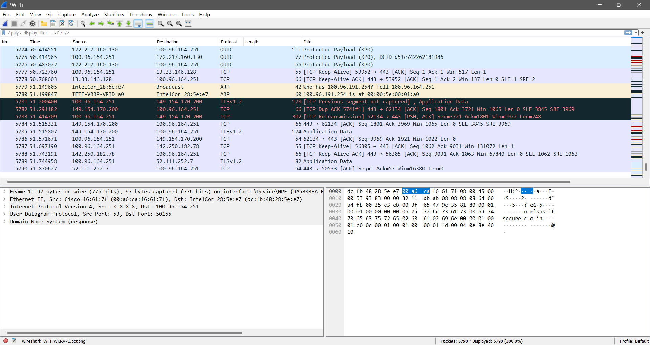

1. After enough packets have been captured, stop Wireshark and save the captured file.

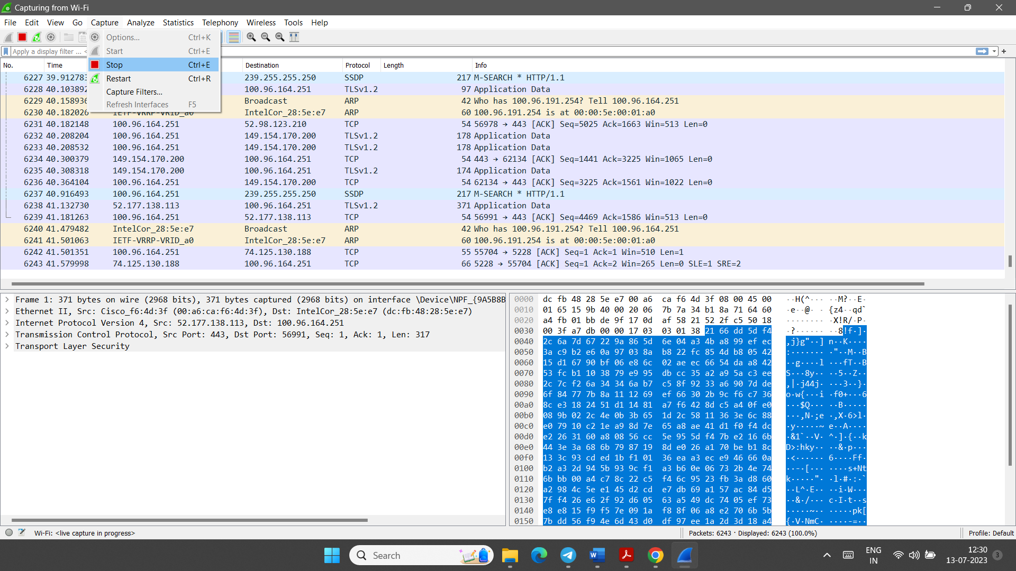

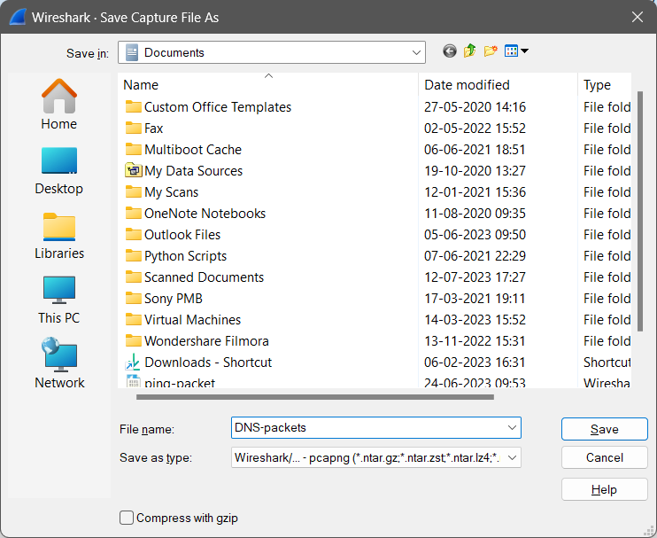

1. Using the captured file, select only those DNS packets that use the service of UDP. Type udp (lowercase) in the filter field and click Apply. The packet list pane of the Wireshark window should now display a bunch of DNS messages. Each DNS message is carried in a UDP packet.

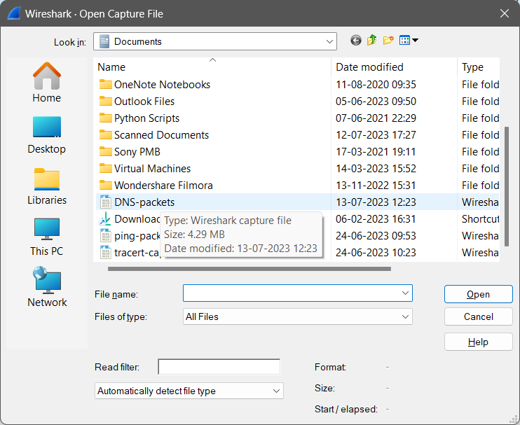

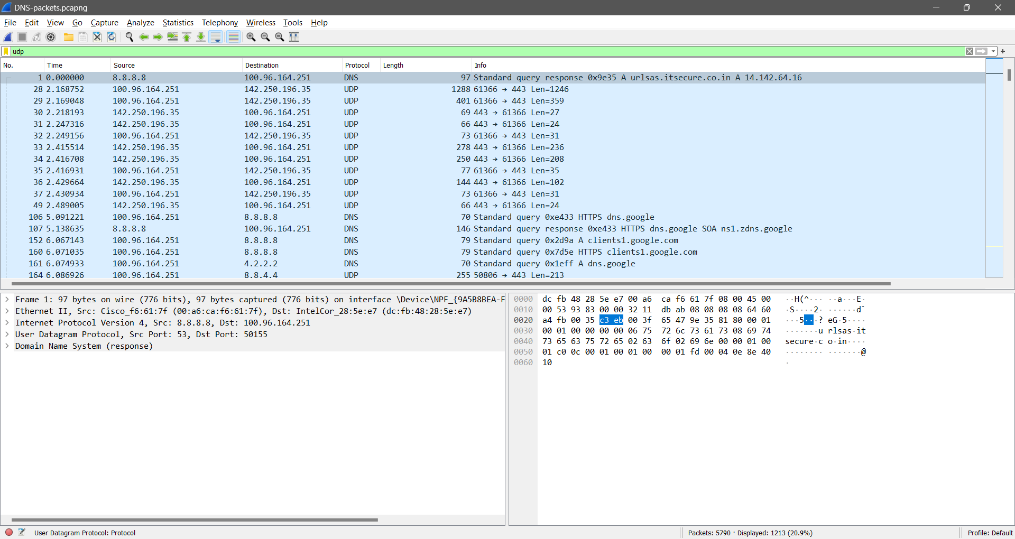

1. In the packet list pane, select the first DNS packet. In the packet detail pane, select the User Datagram Protocol. The UDP hexdump will be highlighted in the packet byte lane. Using the hexdump, answer the questions given in the UDP report of practical related quiz.

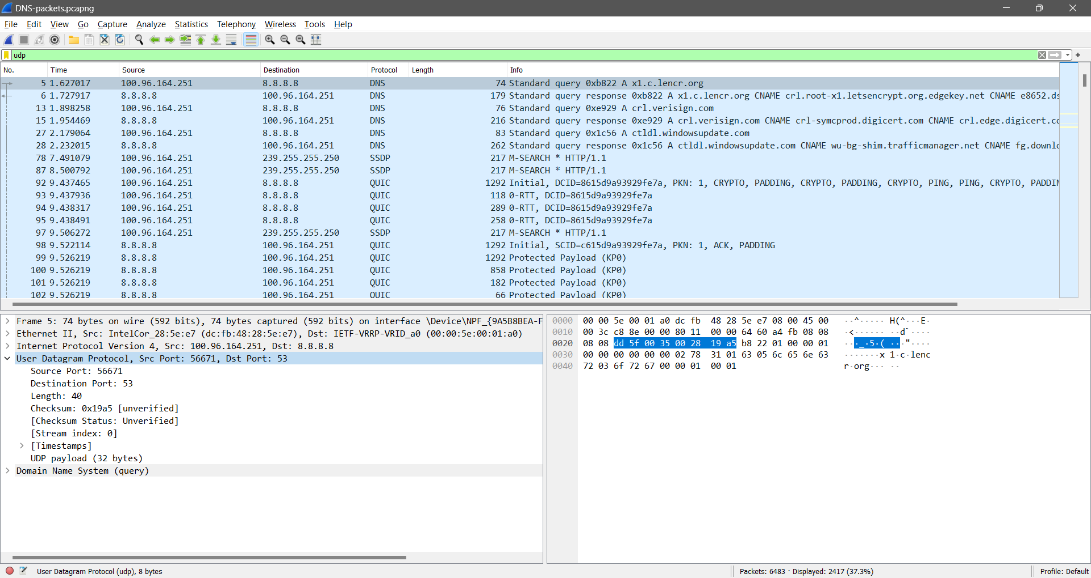

**Section-II Capture and study TCP packets.**

* In this lab, we use Wireshark to capture TCP packets to study many features of TCP protocol.
* Many applications such as HTTP, SMTP, TELNET, and FTP use the service of TCP.
* For this lab, we use HTTP application to download a rather long file.
* The situation of TCP is different from UDP. TCP is a connection-oriented protocol; it uses packets for connection establishment, connection termination, and data transfer.
* This means that we can capture packets that use TCP as source or sink protocol as well as packets that use an application-layer protocol as the source or sink, but use TCP as the intermediate protocol.
* In this lab assignment, we capture both types of packets and distinguish between them.

Analysis of TCP

1. Start your web browser and clear the browser's cache memory, but do not access any website yet.
2. Open the Wireshark and start packet capturing. (Select only that interface which is connected with the internet. In this example, Wi-Fi interface is selected).



1. Go back to your web browser and retrieve any file from a website. Wireshark starts capturing packets.

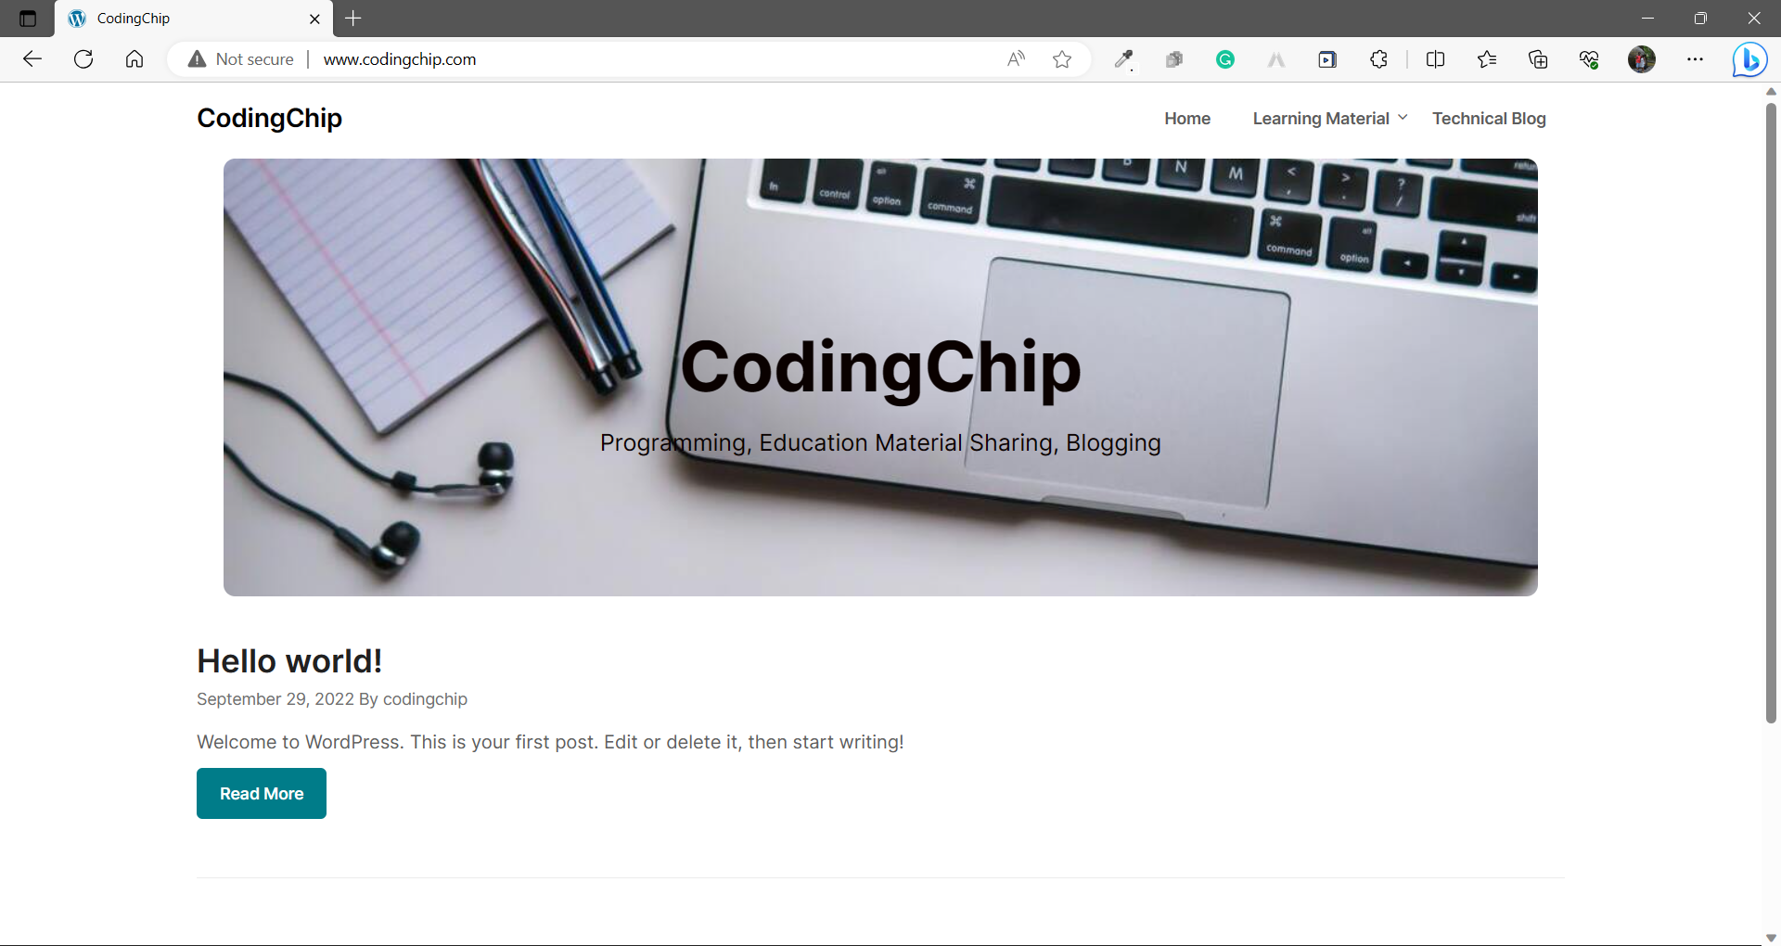



1. After enough packets have been captured, stop Wireshark and save the captured file.



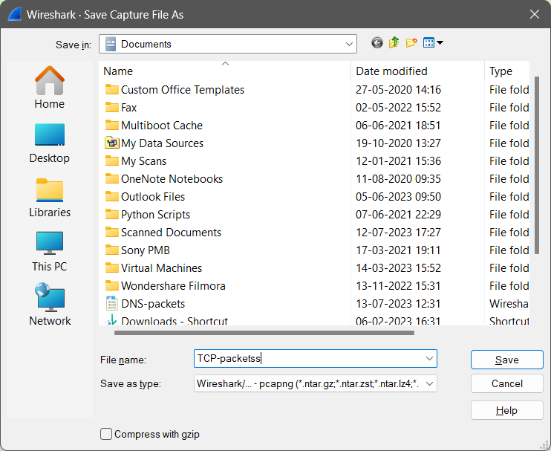

1. Using the captured file, select only those packets that use the service of TCP. For this purpose, type “tcp && ip.addr==”IP ADDRESS”(lowercase) in the filter field and press Apply. The packet list pane of the Wireshark window should now display a bunch of packets. (Here the IP address must be of the website you have searched. Otherwise you will be confused to the related data.)

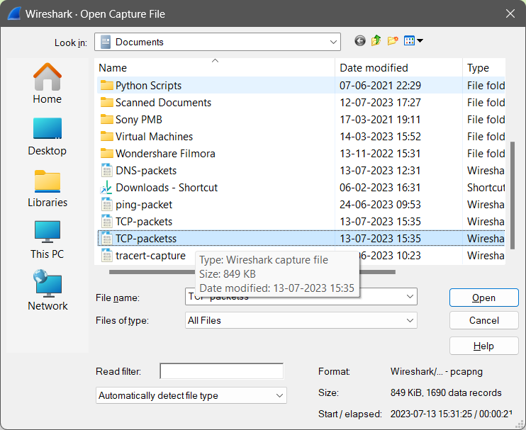

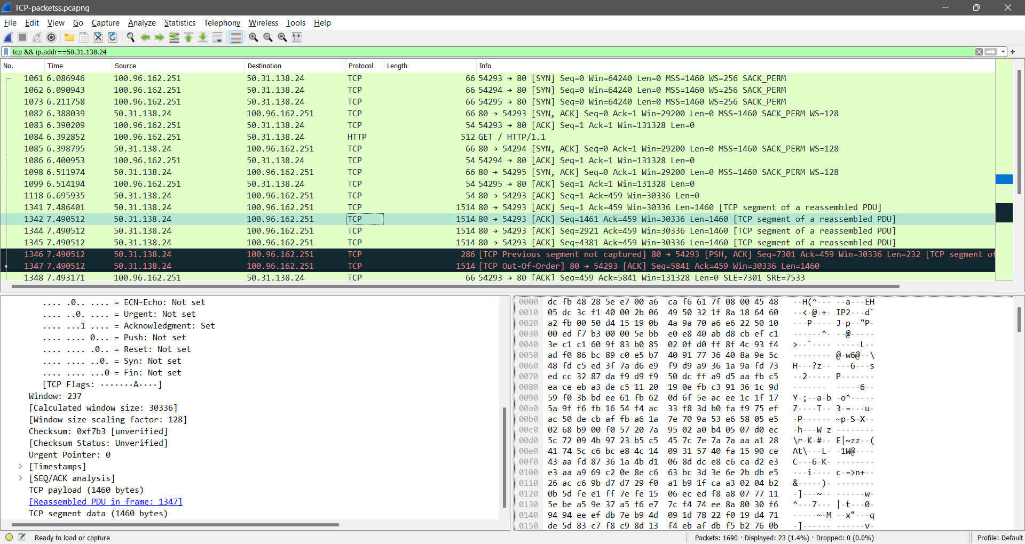

Using the above information of packets, answer the questions given in the TCP Part-I, Part-II, Part-III and Part-IV report of practical related quiz.

1. **Problem Quiz**

|  |  |  |
| --- | --- | --- |
| **UDP PART** | | |
| 1 | a. Source port number: | b. Destination port number: |
| c. Total length of user diagram | d. Length of data |
| e. Is the packet from client or server? | f. Application layer protocol |
|  | g. Is checksum calculated? | |
| 2 | Are answer in number 1 are verified by the information in the detail pane lane? | |
| 3 | Source and destination IP addresses in the query message:  Source and destination IP addresses in the response) message:  Relation between IP addresses: | |
| 4 | Source and destination port number in the query message:  Source and destination port number in the response message:  Relation between port numbers:  Which port number is well-known? | |
| 5 | The length of the first UDP packet:  How many bytes of payload are carried by the first UDP packet? | |
| 6 | Number of bytes in the DNS message:  Does the count agree with the answer to question 5? | |
| 7 | Is the checksum calculated for the first UDP packet?  Value of the checksum: | |

|  |  |
| --- | --- |
| **TCP - Part I: Connection-Establishment Phase**  Identify the TCP packets used for connection establishment. Note that the last packet used for connection establish may have the application-layer as the source protocol. | |
| 1 | Socket addresses: |
| 2 | Set flags: |
| 3 | Sequence number and acknowledgement number: |
| 4 | Window size: |

|  |  |
| --- | --- |
| **TCP - Part II Data-Transfer Phase**  The data-transfer phase starts with an HTTP GET request message and ends with an HTTP OK message. | |
| 1 | Set flag in HTTP GET message: |
| 2 | Number of bytes transmitted by the HTTP GET message: |
| 3 | Acknowledgement frequency:  Corresponding rule: |
| 4 | Number of bytes transmitted by each packet:  Relation to sequence and acknowledgement Number: |
| 5 | Original window sizes:  Are these numbers expected?  How window sizes change? |
| 6 | How the window size is used in flow control? |
| 7 | Purpose of the HTTP OK message: |

|  |  |
| --- | --- |
| **TCP - Part III** **Connection Termination Phase**  The data-transfer phase is followed by the connection termination phase. Note that some packets used in the connection-termination phase may have the source or sink protocol at the application layer. Find the packets used for connection termination. | |
| 1 | Number of TCP segments exchanged for connection termination: |
| 1 | Which end point started the connection termination phase? |
| 2 | Flags sets in each of the segments used for connection termination: |

|  |  |  |
| --- | --- | --- |
| **TCP - Part IV: General**  Write detail of any one TCP packet. | | |
| 1 | a. Source port number: | b. Destination port number: |
| c. Sequence number | d. Acknowledgement number |
| e. Heather length: | f. Set flags: |
| g. Window size: | h. Urgent pointer: |
| 2 | Are answer in the question number 1 verified by the information in the detail pane lane? | |
| 3 | Does any of the TCP packet headers carry options?  Explain | |
| 4 | Size of a TCP packet with no option:  Size of a TCP packet with options: | |
| 5 | Is window size in any of the TCP packet zero?  Explain: | |

1. **References**

* All the references specified in the practical number: 9
* <https://www.youtube.com/watch?v=nQlhUKbuwT4>
* <https://www.youtube.com/watch?v=Caq2GBki2Mc>
* <https://www.youtube.com/watch?v=ToLao3kSBFA>

1. **Assessment-Rubrics**

|  |  |  |  |  |  |  |  |
| --- | --- | --- | --- | --- | --- | --- | --- |
| **Rubric ID** | **Task** | **Criteria** | **%** | **Good** | **Average** | **Poor** | **Mark** |
| **RB1** | Completion of the given task | The student completes all of the tasks required by the assignment. | 30% | All tasks are completed correctly and on time. **(Mark - 3)** | All tasks are completed, but some may be late or incorrect. **(Mark - 2)** | Some tasks are not completed, or they are completed incorrectly or late. **(Mark 1 or 0)** |  |
| **RB2** | Correctness of the given task | The student's work is correct and free of errors. | 30% | All work is correct and free of errors. **(Mark - 3)** | Most work is correct, but there may be a few minor errors. **(Mark - 2)** | There are many errors in the work. **(Mark 1 or 0)** |  |
| **RB3** | Question answers | The student answers all of the questions correctly. | 20% | All questions are answered correctly. **(Mark - 2)** | Most questions are answered correctly, but there may be a few incorrect answers. **(Mark - 1)** | All questions are answered incorrectly. **(Mark - 0)** |  |
| **RB4** | Regularity of the report submission | The student submits the report on time and in the correct format. | 20% | The report is submitted on time and in the correct format. **(Mark - 2)** | The report is submitted on time, but it is not in the correct format. **(Mark - 1)** | The report is late or not submitted at all. **(Mark - 0)** |  |

**Signature With Date**

**Date: ……………**

**Practical No.11:**

Configure Dynamic Host Configuration Protocol using relevant software.

1. **Objectives:**

* To be able to configure DHCP in Cisco packet tracer.
* To be able to troubleshoot DHCP problems in Cisco Packet Tracer.

1. **Expected Program Outcomes (POs):** PO1, PO2, PO3, PO4, PO5, PO6, PO7
2. **Expected Skills to be developed based on competency:**

* The students will learn how to configure DHCP protocol in the network using cisco packet tracer. And it will help them to apply the learned concepts in the real time network.

1. **Expected Course Outcomes (COs):** CO5
2. **Practical Outcomes (PROs)**

The students will be able …

* To configure DHCP services on a server.
* To troubleshoot DHCP related problems.
* To understand the purpose of DHCP.
* To understand how DHCP works.

1. **Expected Affective domain Outcome (ADOs)**

* Practice good housekeeping.
* Follow standard configuration.
* Follow ethical practices.

1. **Prerequisite Theory:**

* Introduction to Cisco Packet Tracer.
* Introduction to various Cisco commands to configure router.
* Introduction to DHCP protocol.
* How does DHCP work?
* DORA process.
* Static IPv4 address and Dynamic IPv4 address.
* IPv4 Addressing
* Use of network devices such as network switch, routers, and servers.
* Use of different cables for the connections among devices such as copper straight cable, copper cross over cables.
* IPv4 address configuration in the Desktop Computers.
* Use of PING and TRACERT commands.

1. **Resources required.**

|  |  |
| --- | --- |
| **S. No.** | **Equipment Name with Broad Specifications** |
| 1 | Computer System with basic configuration. |
| 2 | Cisco Packet Tracer Software |

1. **Safety and necessary Precautions**

* Shut down the computer properly after using it.
* Do not unplug the computer's power cable while it is on.

1. **Procedure**

**To configure the Dynamic Host Configuration protocol, Follow the steps given below.**

1. **Open cisco packet tracer. Arrange different network devices and connect them using appropriate network cable as shown in the diagram below.**

The details of no of network devices and connection among them (with interfaces) are given below.

* The devices details are as follows
  + No of PCs :- 2
  + No of Servers :- 1
  + No of Network Switches(2960-24TT):- 1
* The connection with interface details are as follows.
  + The connection between PC1 (FastEthernet0) and Swtich0(FastEthernet0/1) is done using copper straight cable.
  + The connection between PC2 (FastEthernet0) and Swtich0(FastEthernet0/2) is done using copper straight cable.
  + The connection between DHCP Server (FastEthernet0) and Swtich0(FastEthernet0/24) is done using copper straight cable.

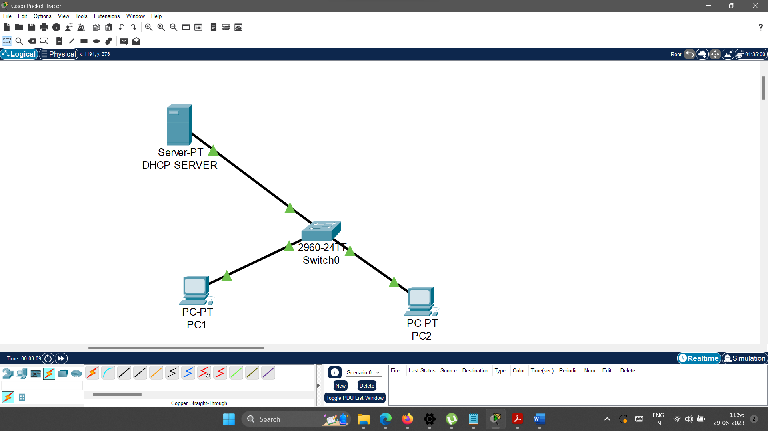

1. **Rename the server to “DHCP SERVER” as follows**

Click on the Server -> Go to Config -> Change Display name to “DHCP SERVER**”.**

1. **Configure the DHCP SERVER as specified below.**
   1. **Configure IP address, subnet mask and default gateway of the DHCP SERVER as specified follows.**
      1. IP address: 192.168.1.2
      2. Subnet Mask : 255.255.255.0
      3. Default Gateway: 192.168.1.1

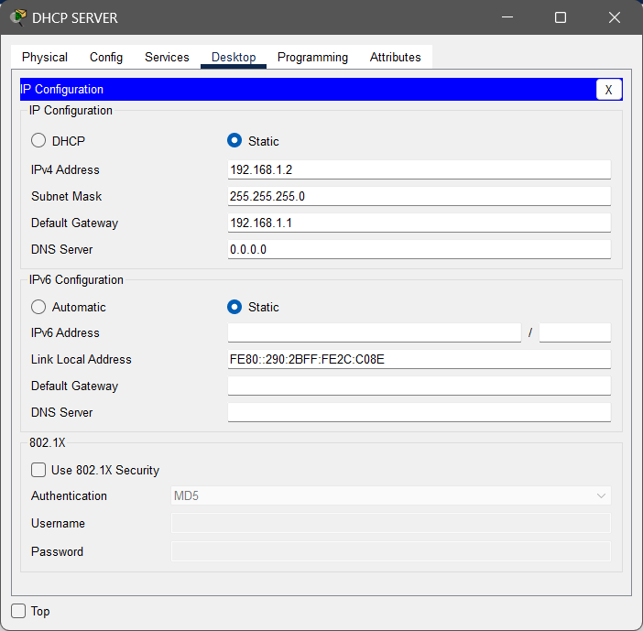

* 1. **Configure Services on the DHCP SERVER.**
     1. **Double click on the server and go to services tab.**

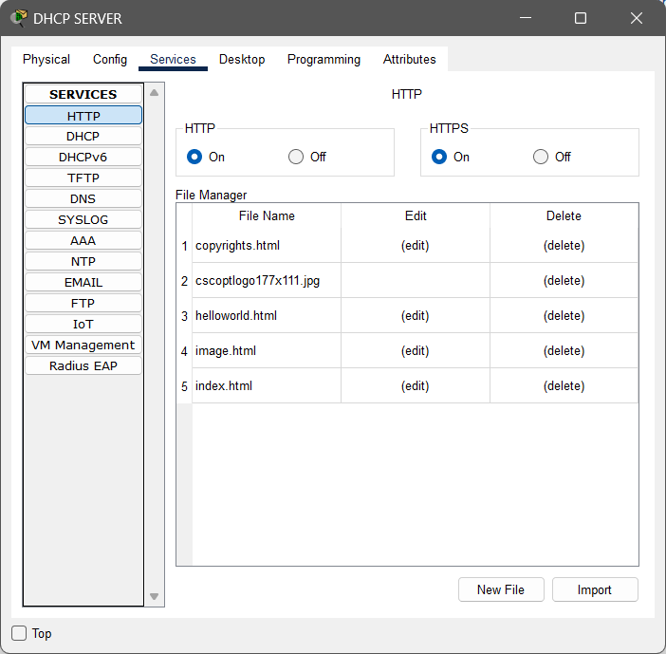

* + 1. **Select DHCP from the list of services.**

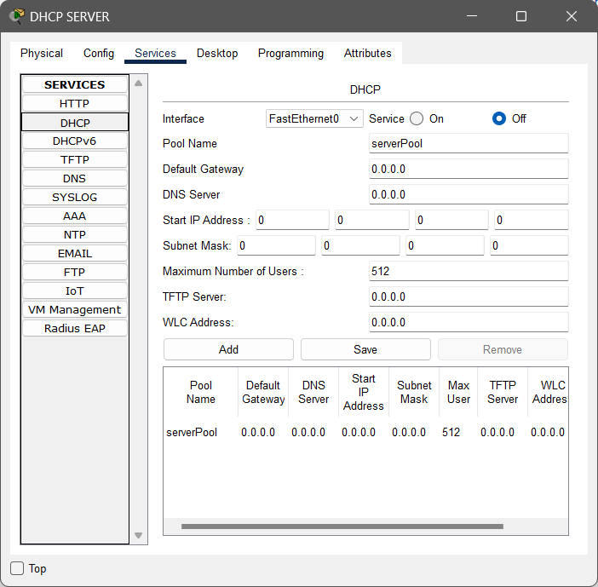

* + 1. **Select the serverPool from the given list and update the details as specified below.**

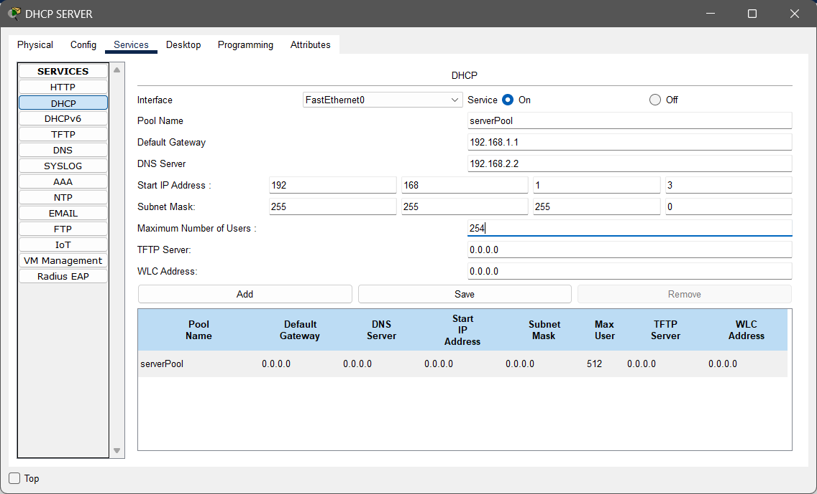

* + 1. **Click on the Save button and you will see the updated details in the pool list.**

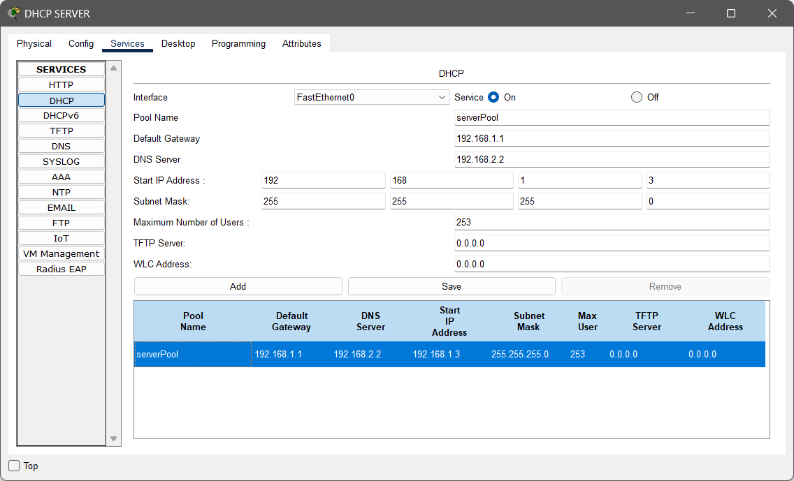

1. **Configure the PC1 as specified below.**

Double click on PC1 -> Go to Desktop tab -> Open IP configuration -> Select DHCP in the IP configuration part.

By doing the above process, PC1 will get the dynamic IP address of the from the DHCP server.

1. **Configure the PC2 as specified below.**

Double click on PC2 -> Go to Desktop tab -> Open IP configuration -> Select DHCP in the IP configuration part.

By doing the above process, PC2 will get the dynamic IP address of the from the DHCP server.

The configuration part done. Now perform the given operations in the practical quiz section.

1. **Practical Quiz**
2. Screenshot of your configured network.
3. Show the Dynamic IP of the PC1 [Paste here the screenshot of the IP configuration]
4. Show the Dynamic IP of the PC2 [Paste here the screenshot of the IP configuration]
5. Check connectivity from PC1 to PC2 using ping command. [Paste here the output screenshot of the command prompt]
6. **References**

* <https://en.wikipedia.org/wiki/Dynamic_Host_Configuration_Protocol>
* <https://www.youtube.com/watch?v=e6-TaH5bkjo>
* <https://www.youtube.com/watch?v=Oj3nFRphDgw>
* <https://www.youtube.com/watch?v=dyVXVQgos4Q>
* <https://datatracker.ietf.org/doc/html/rfc3456>
* <https://www.ietf.org/rfc/rfc2131.txt>

1. **Assessment-Rubrics**

|  |  |  |  |  |  |  |  |
| --- | --- | --- | --- | --- | --- | --- | --- |
| **Rubric ID** | **Task** | **Criteria** | **%** | **Good** | **Average** | **Poor** | **Mark** |
| **RB1** | Completion of the given task | The student completes all of the tasks required by the assignment. | 30% | All tasks are completed correctly and on time. **(Mark - 3)** | All tasks are completed, but some may be late or incorrect. **(Mark - 2)** | Some tasks are not completed, or they are completed incorrectly or late. **(Mark 1 or 0)** |  |
| **RB2** | Correctness of the given task | The student's work is correct and free of errors. | 30% | All work is correct and free of errors. **(Mark - 3)** | Most work is correct, but there may be a few minor errors. **(Mark - 2)** | There are many errors in the work. **(Mark 1 or 0)** |  |
| **RB3** | Question answers | The student answers all of the questions correctly. | 20% | All questions are answered correctly. **(Mark - 2)** | Most questions are answered correctly, but there may be a few incorrect answers. **(Mark - 1)** | All questions are answered incorrectly. **(Mark - 0)** |  |
| **RB4** | Regularity of the report submission | The student submits the report on time and in the correct format. | 20% | The report is submitted on time and in the correct format. **(Mark - 2)** | The report is submitted on time, but it is not in the correct format. **(Mark - 1)** | The report is late or not submitted at all. **(Mark - 0)** |  |

**Signature With Date**

**Date: ……………**

**Practical No.12:**

a) Configure Domain Name Server (DNS) using relevant software.

b) Configure Web Server using relevant software.

1. **Objectives:**

* To configure a DNS server in Cisco Packet Tracer.
* To configure Web server in Cisco Packet Tracer.

1. **Expected Program Outcomes (POs):** PO1, PO2, PO3, PO4, PO5, PO6, PO7
2. **Expected Skills to be developed based on competency:**

* The students will learn how to configure DNS and Web server using cisco packet tracer. And it will help them to apply the learned concepts in the real time network.

1. **Expected Course Outcomes (COs):** CO5
2. **Practical Outcomes (PROs)**

The students will be able …

* To configure DNS services on a server.
* To troubleshoot DNS related problems.
* To understand the purpose of DNS.
* To understand how DNS works.
* To configure Web services on a server.
* To troubleshoot web server related problems.
* To understand the purpose of web server.
* To understand how web server works.

1. **Expected Affective domain Outcome (ADOs)**

* Practice good housekeeping.
* Follow standard configuration.
* Follow ethical practices.

1. **Prerequisite Theory:**

* Introduction to Cisco Packet Tracer.
* Introduction to various Cisco commands to configure router.
* Introduction to DNS server.
* How DNS works?
* Introduction to resource records.
* Introduction to Web server.
* How web server works?
* IPv4 Addressing
* Use of network devices such as network switch, routers, and servers.
* Use of different cables for the connections among devices such as copper straight cable, copper cross over cables.
* IPv4 address configuration in the Desktop Computers.

1. **Resources required.**

|  |  |
| --- | --- |
| **S. No.** | **Equipment Name with Broad Specifications** |
| 1 | Computer System with basic configuration and connected with LAN and Internet. |
| 2 | Cisco Packet Tracer Software |

1. **Safety and necessary Precautions**

* Shut down the computer properly after using it.
* Do not unplug the computer's power cable while it is on.

1. **Procedure**

**To configure the Dynamic Host Configuration protocol, Follow the steps given below.**

1. **Open the network topology that you have prepared in the practical-11.**
2. **Update the network topology of the practical-11, as specified in the diagram below.**

* The devices details are as follows
  + No of PCs :- 2
  + No of Servers :- 3
  + No of Network Switches(2960-24TT):- 2
* The updated connection with interface details are as follows. Here I have not specified the connection details of practical-11.
  + The connection between Switch0 (GigabitEthernet0/1) and Router2(GigabitEthernet0/0) is done using copper straight cable.
  + The connection between Router2 (GigabitEthernet0/1) and Switch1(GigabitEthernet0/1) is done using copper straight cable.
  + The connection between DNS Server (FastEthernet0) and Swtich0(FastEthernet0/1) is done using copper straight cable.
  + The connection between WEB Server (FastEthernet0) and Swtich0(FastEthernet0/2) is done using copper straight cable.

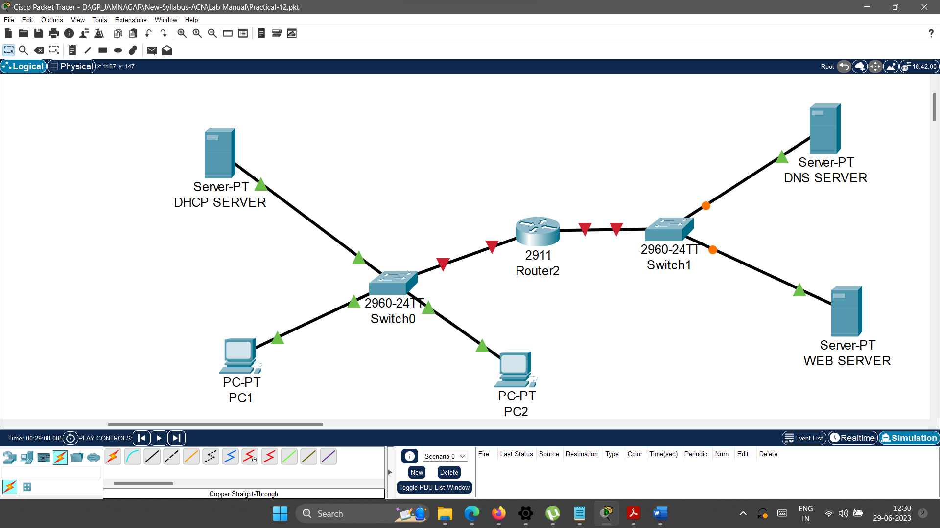

1. **Rename the First server to “DNS SERVER” as follows.**

Click on the Server -> Go to Config -> Change Display name to “DNS SERVER”.

1. **Rename the Second server to “WEB SERVER” as follows.**

Click on the Server -> Go to Config -> Change Display name to “DHCP SERVER”.

1. **Configure the Router2 as specified below.**

*--- System Configuration Dialog ---*

*Would you like to enter the initial configuration dialog? [yes/no]: n*

*Press RETURN to get started!*

*Router>****enable***

*Router#****configure terminal***

*Enter configuration commands, one per line. End with CNTL/Z.*

*Router(config)#****interface gigabitEthernet 0/0***

*Router(config-if)#****ip address 192.168.1.1 255.255.255.0***

*Router(config-if)#****no shutdown***

*Router(config-if)#*

*%LINK-5-CHANGED: Interface GigabitEthernet0/0, changed state to up*

*%LINEPROTO-5-UPDOWN: Line protocol on Interface GigabitEthernet0/0, changed state to up*

*Router(config-if)#****exit***

*Router(config)#****interface gigabitEthernet 0/1***

*Router(config-if)#****ip address 192.168.2.1 255.255.255.0***

*Router(config-if)#****no shutdown***

*Router(config-if)#*

*%LINK-5-CHANGED: Interface GigabitEthernet0/1, changed state to up*

*%LINEPROTO-5-UPDOWN: Line protocol on Interface GigabitEthernet0/1, changed state to up*

*Router(config-if)#****exit***

*Router(config)#****exit***

*Router#*

1. **Configure the DNS SERVER as specified below.**
   1. **Configure IP address, subnet mask and default gateway of the DHCP SERVER as specified follows.**
      1. IP address: 192.168.2.2
      2. Subnet Mask : 255.255.255.0
      3. Default Gateway: 192.168.2.1
      4. DNS Server: 192.168.2.2

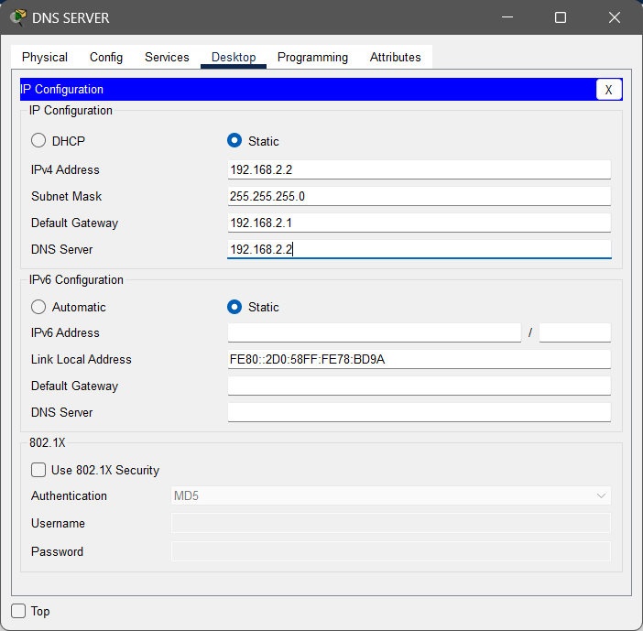

* 1. **Configure Services on the DNS SERVER.**
     1. **Double click on the server and go to services tab.**

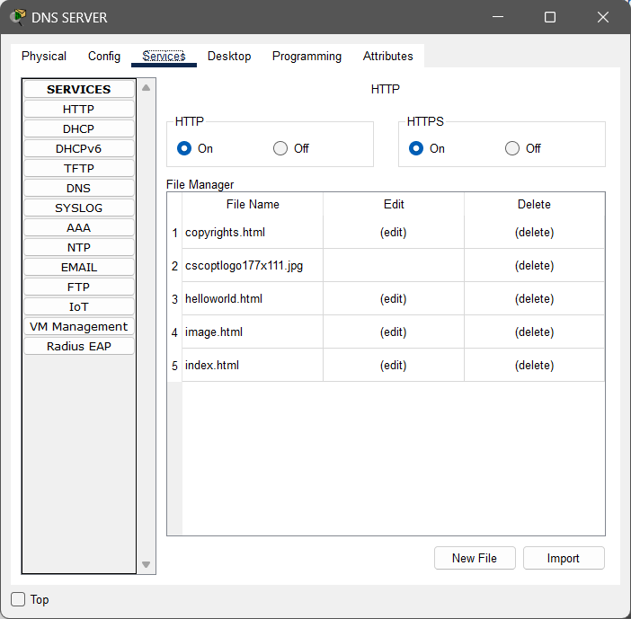

* + 1. **Select DNS from the list of services.**

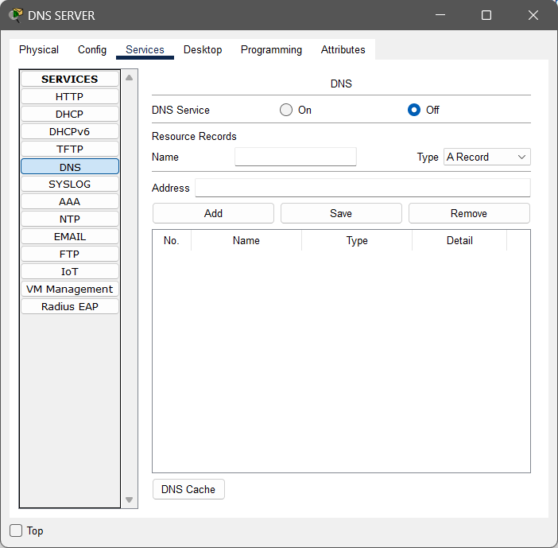

* + 1. **Enter/Update details as specified below in the DNS service.**

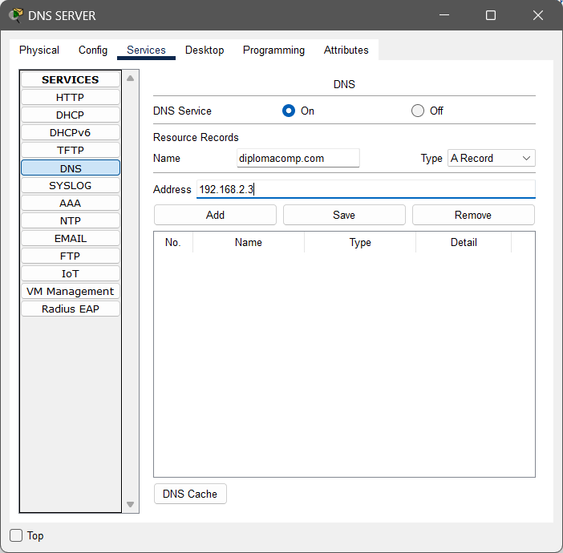

* + 1. **Click on the Add button and you will see the updated details in DNS record list**

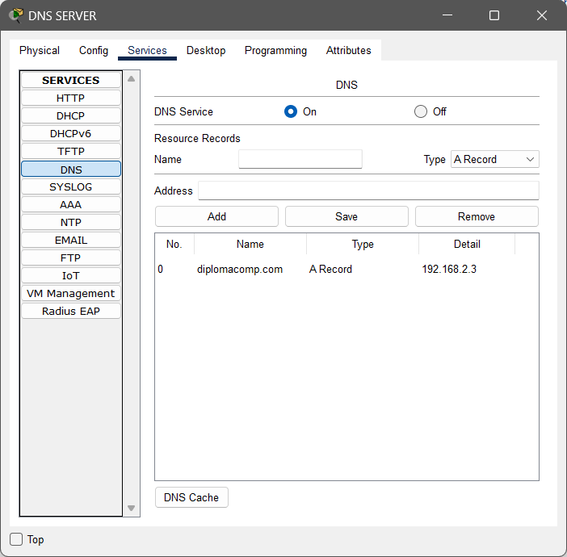

* + 1. **Close the dialog box.**

1. **Configure the WEB SERVER as specified below.**
   1. **Configure IP address, subnet mask and default gateway of the DHCP SERVER as specified follows.**
      1. IP address: 192.168.2.3
      2. Subnet Mask : 255.255.255.0
      3. Default Gateway: 192.168.2.1
      4. DNS: 192.168.2.2

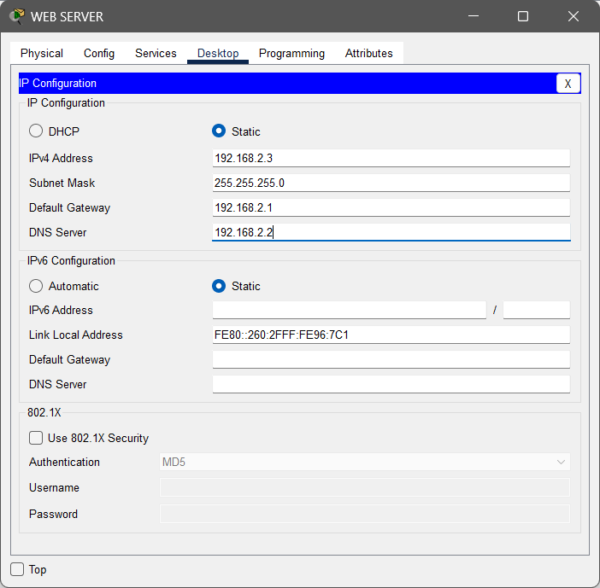

* 1. **Configure Services on the DNS SERVER.**
     1. **Double click on the server and go to services tab.**

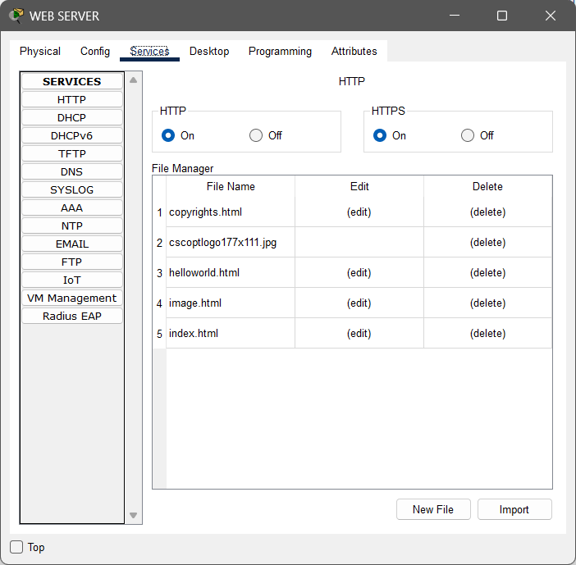

* + 1. Here by default the first service is HTTP/HTTPS in the list of services, and this service is on. The sample website is already loaded with the webserver. If you want to change, then you can change it as per your requirements. But, here we do not change anything. We are considering this website is our sample website i.e. diplomacomp.com.
    2. **Close the dialogbox.**

1. **Open PC1 and do as specified below.**

Double click on PC1 -> Go to Web browser -> Type “diplomacomp.com “ in the URL -> Click on GO or Press Enter -> You will see the webpage in the webbrowser.

1. **Open PC2 and do as specified below.**

Double click on PC2 -> Go to Web browser -> Type “diplomacomp.com “ in the URL -> Click on GO or Press Enter -> You will see the webpage in the webbrowser.

The configuration part done. Now perform the given operations in the practical quiz section.

1. **Practical Quiz**
2. Screenshot of your configured network.
3. What happens when you search for the website from the web browser. Observe the process in the simulation mode and write it step by step in your words here.
4. Show the output of the requested URL (diplomacomp.com) from the PC1 [Paste here the screenshot of the IP configuration]
5. Change the content of the website which is loaded in the WEB server as specified below.(Change index.html file only)

<html>

<center><font size='+2' color='blue'>Diploma Computer Engineering</font></center>

<h1>Advanced Computer Network.</h1>

<h2> Unit-1: Network Layer Protcols </h2>

<h2> Unit-2: Next Generation IP </h2>

<h2> Unit-3: Unicast Routing </h2>

<h2> Unit-4: Transport Layer Protocols</h2>

<h2> Unit-5: Application Layer Protocols </h2>

</html>

1. Show the output of the requester URL (diplomacomp.com) from the PC2 (after suggested changes in problem number-5) [Paste here the screenshot of the IP configuration]
2. **References**

* <https://datatracker.ietf.org/doc/html/rfc1035>
* <https://www.ietf.org/rfc/rfc1034.txt>
* <https://www.ietf.org/rfc/rfc2616.txt>
* <https://www.javatpoint.com/computer-network-dns>
* <https://www.javatpoint.com/http-vs-https>
* <https://ns1.com/resources/dns-protocol>
* <https://www.youtube.com/watch?v=1_8a8-__6ts>
* <https://www.youtube.com/watch?v=yZFBNJLz1z0>
* <https://www.youtube.com/watch?v=XDvQWQW0SCo>
* <https://www.youtube.com/watch?v=vhfRArT11jc>

1. **Assessment-Rubrics**

|  |  |  |  |  |  |  |  |
| --- | --- | --- | --- | --- | --- | --- | --- |
| **Rubric ID** | **Task** | **Criteria** | **%** | **Good** | **Average** | **Poor** | **Mark** |
| **RB1** | Completion of the given task | The student completes all of the tasks required by the assignment. | 30% | All tasks are completed correctly and on time. **(Mark - 3)** | All tasks are completed, but some may be late or incorrect. **(Mark - 2)** | Some tasks are not completed, or they are completed incorrectly or late. **(Mark 1 or 0)** |  |
| **RB2** | Correctness of the given task | The student's work is correct and free of errors. | 30% | All work is correct and free of errors. **(Mark - 3)** | Most work is correct, but there may be a few minor errors. **(Mark - 2)** | There are many errors in the work. **(Mark 1 or 0)** |  |
| **RB3** | Question answers | The student answers all of the questions correctly. | 20% | All questions are answered correctly. **(Mark - 2)** | Most questions are answered correctly, but there may be a few incorrect answers. **(Mark - 1)** | All questions are answered incorrectly. **(Mark - 0)** |  |
| **RB4** | Regularity of the report submission | The student submits the report on time and in the correct format. | 20% | The report is submitted on time and in the correct format. **(Mark - 2)** | The report is submitted on time, but it is not in the correct format. **(Mark - 1)** | The report is late or not submitted at all. **(Mark - 0)** |  |

**Signature With Date**

**Date: ……………**

**Practical No.13:**

Configure File Transfer Protocol (FTP) using relevant software.

1. **Objectives:**

* To configure FTP server using Cisco Packet Tracer.

1. **Expected Program Outcomes (POs):** PO1, PO2, PO3, PO4, PO5, PO6, PO7
2. **Expected Skills to be developed based on competency:**

* The students will learn how to configure FTP server using cisco packet tracer, how to upload files to FTP server and download files from the FTP server. And it will help them to apply the learned concepts in the real time network.

1. **Expected Course Outcomes (COs):** CO5
2. **Practical Outcomes (PROs)**

The students will be able …

* To configure FTP services on a server.
* To troubleshoot FTP related problems.
* To understand the purpose of FTP.
* To understand how FTP works.
* To upload data to FTP server.
* To download data from FTP server.

1. **Expected Affective domain Outcome (ADOs)**

* Practice good housekeeping.
* Follow standard configuration.
* Follow ethical practices.

1. **Prerequisite Theory:**

* Introduction to Cisco Packet Tracer.
* Introduction to various Cisco commands to configure router.
* Introduction to FTP server.
* How FTP works?
* IPv4 Addressing
* Use of network devices such as network switch, routers, and servers.
* Use of different cables for the connections among devices such as copper straight cable, copper cross over cables.
* IPv4 address configuration in the Desktop Computers.
* Introduction to put and get commands to upload and download files.

1. **Resources required.**

|  |  |
| --- | --- |
| **S. No.** | **Equipment Name with Broad Specifications** |
| 1 | Computer System with basic configuration and connected with LAN and Internet. |
| 2 | Cisco Packet Tracer Software |

1. **Safety and necessary Precautions**

* Shut down the computer properly after using it.
* Do not unplug the computer's power cable while it is on.

1. **Procedure**

**To configure the Dynamic Host Configuration protocol, Follow the steps given below.**

1. **Open cisco packet tracer. Arrange different network devices and connect them using appropriate network cable as shown in the diagram below.**

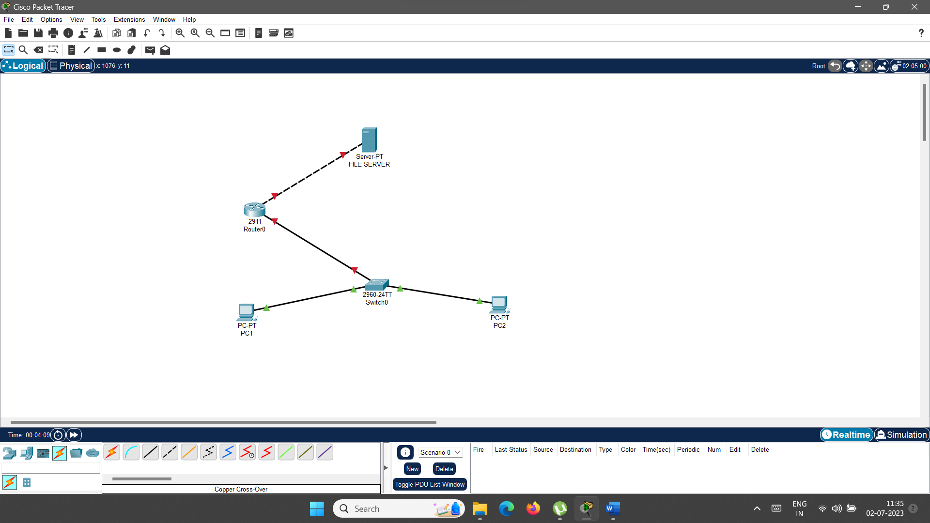

1. **Rename the server to “FILE SERVER” as follows.**

Click on the Server -> Go to Config -> Change Display name to “FILE SERVER”.

1. **Configure IP address, Subnet Mask and Default Gateway of PC1 as follows.**
   1. IP address: 192.168.1.2
   2. Subnet Mask: 255.255.255.0
   3. Default Gateway: 192.168.1.1
2. **Configure IP address, Subnet Mask and Default Gateway of PC2 as follows.**
   1. IP address: 192.168.1.3
   2. Subnet Mask: 255.255.255.0
   3. Default Gateway: 192.168.1.1
3. **Configure the Router0 as specified below.**

--- System Configuration Dialog ---

*Would you like to enter the initial configuration dialog? [yes/no]:*

*Press RETURN to get started!*

*Router>*

*Router>****enable***

*Router#****configure terminal***

*Enter configuration commands, one per line. End with CNTL/Z.*

*Router(config)#****interface gigabitEthernet 0/0***

*Router(config-if)#****ip address 192.168.1.1 255.255.255.0***

*Router(config-if)#****no shutdown***

*Router(config-if)#*

*%LINK-5-CHANGED: Interface GigabitEthernet0/0, changed state to up*

*%LINEPROTO-5-UPDOWN: Line protocol on Interface GigabitEthernet0/0, changed state to up*

*Router(config-if)#****exit***

*Router(config)#****interface gigabitEthernet 0/1***

*Router(config-if)#****ip address 192.168.2.1 255.255.255.0***

*Router(config-if)#****no shutdown***

*Router(config-if)#*

*%LINK-5-CHANGED: Interface GigabitEthernet0/1, changed state to up*

*%LINEPROTO-5-UPDOWN: Line protocol on Interface GigabitEthernet0/1, changed state to up*

*Router(config-if)#****exit***

*Router(config)#*

*Router(config)#****exit***

*Router#*

1. **Configure the FILE SERVER as specified below.**
   1. **Configure IP address, subnet mask and default gateway of the FILE SERVER as specified follows.**
      1. IP address: 192.168.2.2
      2. Subnet Mask : 255.255.255.0
      3. Default Gateway: 192.168.2.1

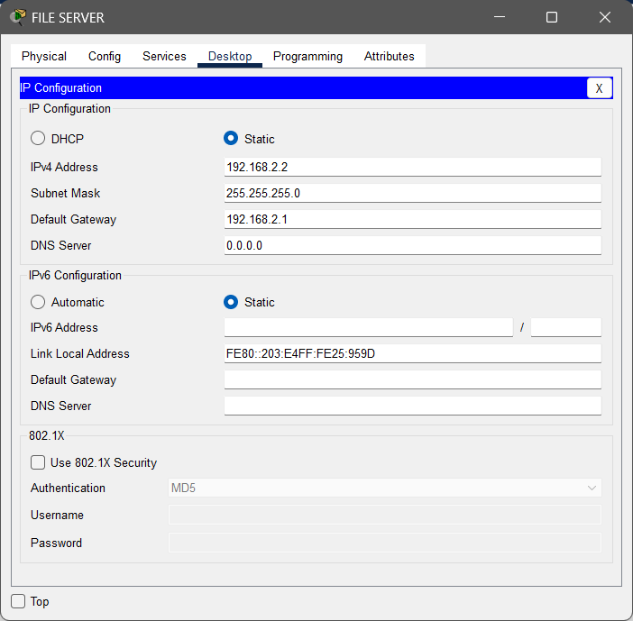

* 1. **Configure Services on the FILE SERVER.**
     1. **Double click on the server and go to services tab.**

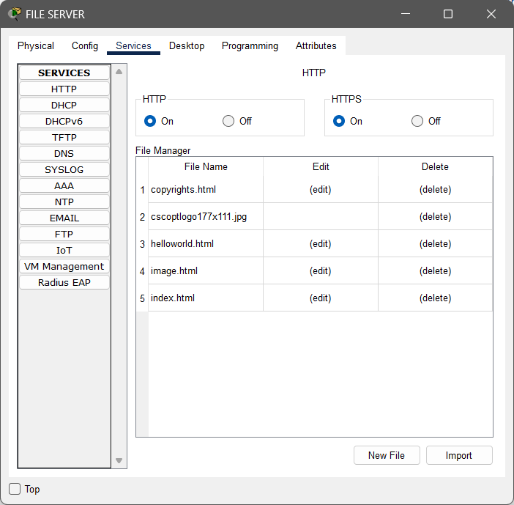

* + 1. **Select FTP from the list of services.**

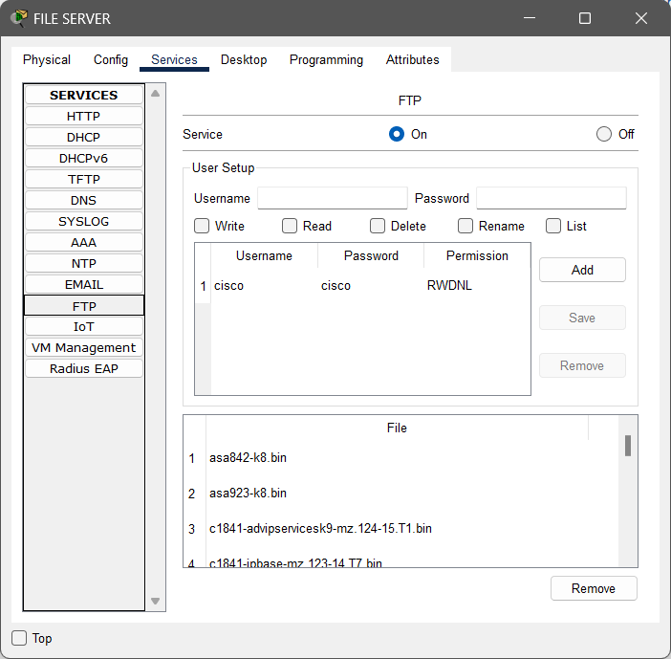

* + 1. **Here you have to create the credententials to access the file server remotely. But here you can see, there is already default username and password are created by the software itself. (Username: cisco and Password: cisco) And software has also set the different access level permission(Write, Read, Delete, Rename and List) for that particular user. So you can use this user for your practical. However, if you want to create new user, then create, set the password and permission for it as per your requirements). Select credentials and click on the save button as shown below.**

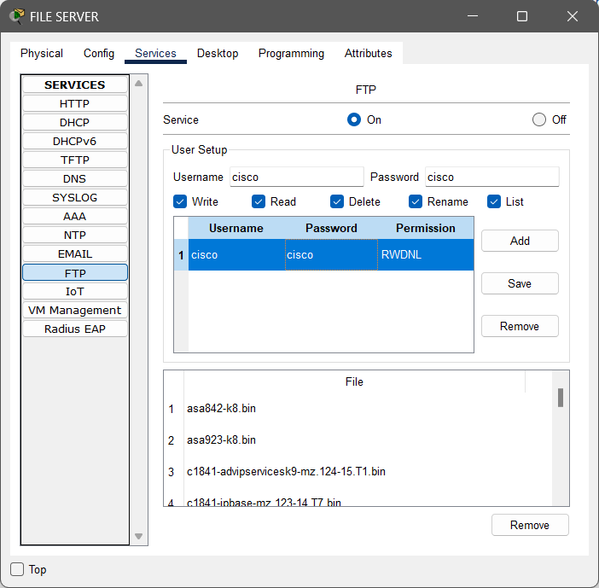

* + 1. **Make sure your FTP service must be on. Then close the dialog box.**

The configuration part done. Now perform the given operations in the practical quiz section.

1. **Practical Quiz**
2. Screenshot of your configured network.
3. Upload any file on the file server from the PC1. [Paste the screenshot of the command prompt after executing the following commands]

Perform the following steps to upload the file from the PC1.

1. Click on PC1 and then goto to Desktop.
2. Open Text Editor.
3. Write the content as shown below in the text editor.
4. Save the text file ( CTRL + S ) with the name upload.txt and close the editor.
5. Open Command prompt and check the connectivity with the file server.
6. Type command: ftp 192.168.2.2
7. Enter username: cisco
8. Enter password: cisco (The password is not visible while you type the password)
9. Type command: put upload.txt
10. Now your file is uploaded to the FILE SERVER, You can check it by executing the command: **dir**
11. Download the uploaded file upload.txt from the file server into PC2. [Paste the screenshot of the command prompt after executing the following commands]

Perform the following steps to download the file from the FILE SERVER.

1. Click on PC2 and then goto to Desktop.
2. Open Command prompt and check the connectivity with the file server.
3. Type command: ftp 192.168.2.2
4. Enter username: cisco
5. Enter password: cisco (The password is not visible while you type the password)
6. Type command: get upload.txt
7. Now your file is dowloaded from the FILE SERVER. It is available in PC2’s directory. To view the downloaded file, type command quit. Prompt will change from ftp to c drive. Then type command dir. Your downloaded file is available in the current directory. You can also open it using text editor(Goto text editor of PC1-> press CTRL+O -> select upload.txt).
8. **References**

* <https://en.wikipedia.org/wiki/File_Transfer_Protocol>
* <https://www.youtube.com/watch?v=SVTQQvIwgbM>
* <https://www.youtube.com/watch?v=tOj8MSEIbfA>
* <https://www.youtube.com/watch?v=Mk5WUsHOK0Y>
* <https://datatracker.ietf.org/doc/html/rfc354>

1. **Assessment-Rubrics**

|  |  |  |  |  |  |  |  |
| --- | --- | --- | --- | --- | --- | --- | --- |
| **Rubric ID** | **Task** | **Criteria** | **%** | **Good** | **Average** | **Poor** | **Mark** |
| **RB1** | Completion of the given task | The student completes all of the tasks required by the assignment. | 30% | All tasks are completed correctly and on time. **(Mark - 3)** | All tasks are completed, but some may be late or incorrect. **(Mark - 2)** | Some tasks are not completed, or they are completed incorrectly or late. **(Mark 1 or 0)** |  |
| **RB2** | Correctness of the given task | The student's work is correct and free of errors. | 30% | All work is correct and free of errors. **(Mark - 3)** | Most work is correct, but there may be a few minor errors. **(Mark - 2)** | There are many errors in the work. **(Mark 1 or 0)** |  |
| **RB3** | Question answers | The student answers all of the questions correctly. | 20% | All questions are answered correctly. **(Mark - 2)** | Most questions are answered correctly, but there may be a few incorrect answers. **(Mark - 1)** | All questions are answered incorrectly. **(Mark - 0)** |  |
| **RB4** | Regularity of the report submission | The student submits the report on time and in the correct format. | 20% | The report is submitted on time and in the correct format. **(Mark - 2)** | The report is submitted on time, but it is not in the correct format. **(Mark - 1)** | The report is late or not submitted at all. **(Mark - 0)** |  |

**Signature With Date**

**Date: ……………**

**Practical No.14:**

Configure Mail Server Using relevant software.

1. **Objectives:**

* To configure Mail Server using Cisco Packet Tracer.

1. **Expected Program Outcomes (POs):** PO1, PO2, PO3, PO4, PO5, PO6, PO7
2. **Expected Skills to be developed based on competency:**

* The students will learn how to configure Mail server using cisco packet tracer. And it will help them to apply the learned concepts in the real time network.

1. **Expected Course Outcomes (COs):** CO5
2. **Practical Outcomes (PROs)**

The students will be able …

* To configure Mail Service services on a server.
* To troubleshoot Mail server related problems.
* To understand the purpose of Mail server.
* To understand how Mail server works.
* To send mail using mail client.
* To receive mail using mail client.

1. **Expected Affective domain Outcome (ADOs)**

* Practice good housekeeping.
* Follow standard configuration.
* Follow ethical practices.

1. **Prerequisite Theory:**

* Introduction to Cisco Packet Tracer.
* Introduction to various Cisco commands to configure router.
* Introduction to SMTP, POP3 and IMAP protocols
* Introduction to Mail server.
* How mail works?
* IPv4 Addressing
* Use of network devices such as network switch, routers, and servers.
* Use of different cables for the connections among devices such as copper straight cable, copper cross over cables.
* IPv4 address configuration in the Desktop Computers.

1. **Resources required.**

|  |  |
| --- | --- |
| **S. No.** | **Equipment Name with Broad Specifications** |
| 1 | Computer System with basic configuration. |
| 2 | Cisco Packet Tracer Software |

1. **Safety and necessary Precautions**

* Shut down the computer properly after using it.
* Do not unplug the computer's power cable while it is on.

1. **Procedure**

**To configure the Mail Server, Follow the steps given below.**

1. **Open cisco packet tracer. Arrange different network devices and connect them using appropriate network cable as shown in the diagram below.**

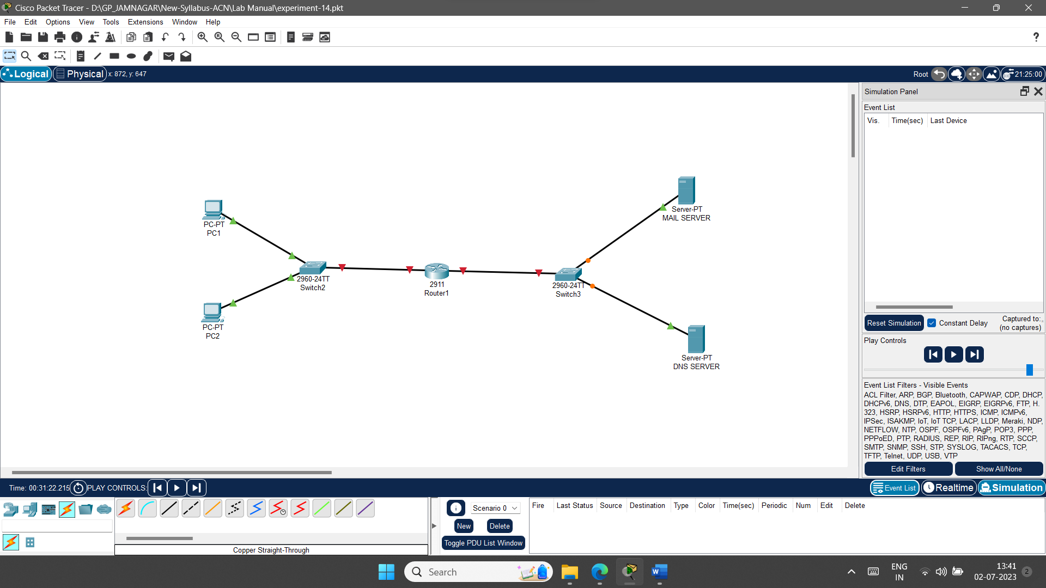

1. **Rename the first server to “MAIL SERVER” as follows.**

Click on the Server -> Go to Config -> Change Display name to “MAIL SERVER”.

1. **Rename the second server to “DNS SERVER” as follows.**

Click on the Server -> Go to Config -> Change Display name to “DNS SERVER”.

1. **Configure IP address, Subnet Mask and Default Gateway of PC1 as follows.**
   1. IP address: 192.168.1.2
   2. Subnet Mask: 255.255.255.0
   3. Default Gateway: 192.168.1.1
   4. DNS Server: 192.168.2.3
2. **Configure IP address, Subnet Mask and Default Gateway of PC2 as follows.**
   1. IP address: 192.168.1.3
   2. Subnet Mask: 255.255.255.0
   3. Default Gateway: 192.168.1.1
   4. DNS Server: 192.168.2.3
3. **Configure the Router1 as specified below.**

*--- System Configuration Dialog ---*

*Would you like to enter the initial configuration dialog? [yes/no]: no*

*Press RETURN to get started!*

*Router>****enable***

*Router#****configure terminal***

*Enter configuration commands, one per line. End with CNTL/Z.*

*Router(config)#****interface gigabitEthernet 0/0***

*Router(config-if)#****ip address 192.168.1.1 255.255.255.0***

*Router(config-if)#****no shutdown***

*Router(config-if)#*

*%LINK-5-CHANGED: Interface GigabitEthernet0/0, changed state to up*

*%LINEPROTO-5-UPDOWN: Line protocol on Interface GigabitEthernet0/0, changed state to up*

*Router(config-if)#****exit***

*Router(config)#****interface gigabitEthernet 0/1***

*Router(config-if)#****ip address 192.168.2.1 255.255.255.0***

*Router(config-if)#****no shutdown***

*Router(config-if)#*

*%LINK-5-CHANGED: Interface GigabitEthernet0/1, changed state to up*

*%LINEPROTO-5-UPDOWN: Line protocol on Interface GigabitEthernet0/1, changed state to up*

*Router(config-if)#****exit***

*Router(config)#****exit***

*Router#*

*%SYS-5-CONFIG_I: Configured from console by console*

1. **Configure the MAIL SERVER as specified below.**
   1. **Configure IP address, subnet mask and default gateway of the MAIL SERVER as specified follows.**
      1. IP address: 192.168.2.2
      2. Subnet Mask : 255.255.255.0
      3. Default Gateway: 192.168.2.1
      4. DNS Server: 192.168.2.3

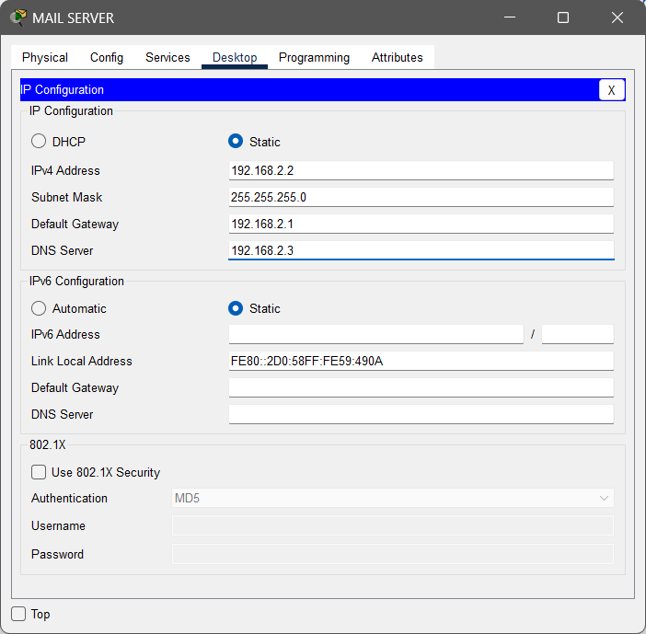

* 1. **Configure Services on the MAIL SERVER.**
     1. **Double click on the server and go to services tab.**

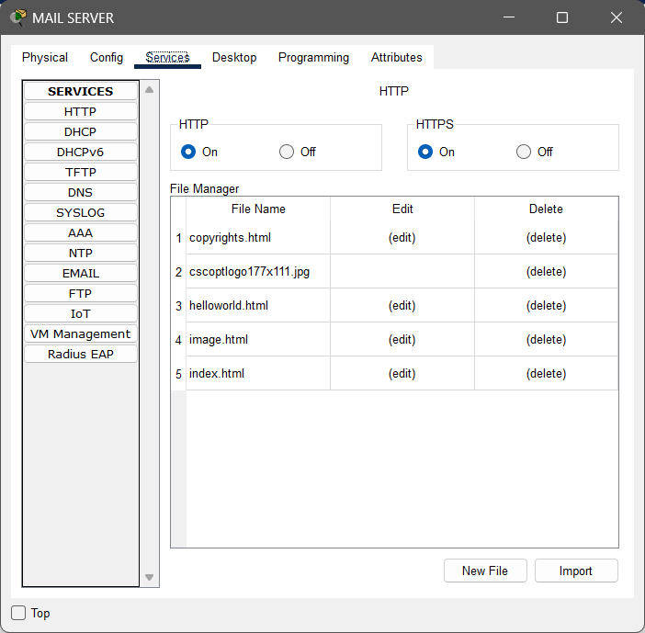

* + 1. **Select EMAIL from the list of services.**

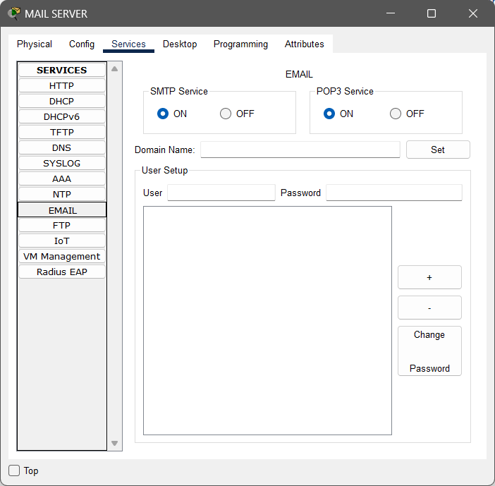

* + 1. **Set the domain for the email. To set domain you have enter the name of the domain then click on the set button as shown below. (Here I have set the domain name: diplomacomp.com)**

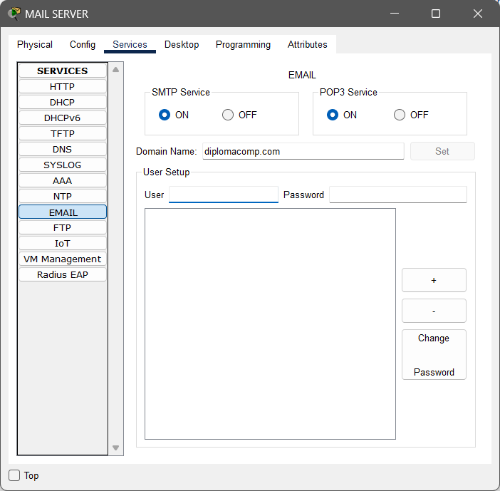

* + 1. **Create two users. To create a user, you have to create a username and password. To create a username and password, type the username and password and press the + button. There are two users created here. The first user name is user1 and the password is admin@123, and the second user name is user2 and the password is admin@123. If you want to change the password, you can change it by selecting the user and pressing the change password button.**

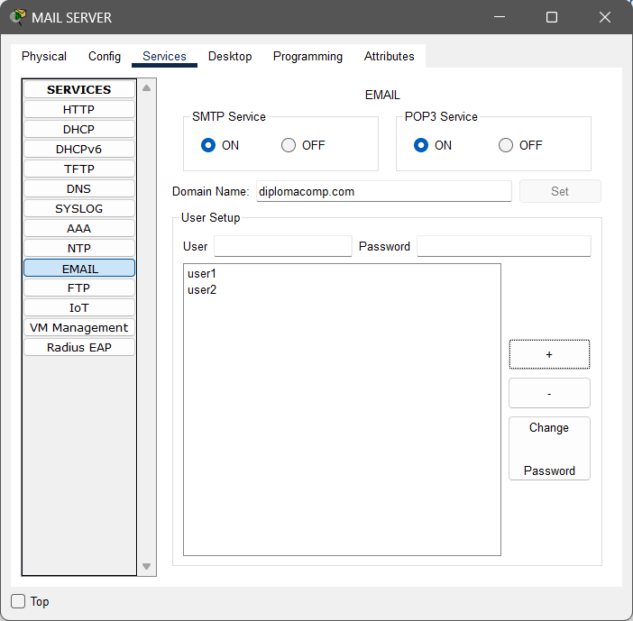

* + 1. **Make sure your SMTP and POP3 services must be on. Then close the dialog box.**

1. **Configure the DNS SERVER as specified below.**
   1. **Configure IP address, subnet mask and default gateway of the DNS SERVER as specified follows.**
      1. IP address: 192.168.2.3
      2. Subnet Mask : 255.255.255.0
      3. Default Gateway: 192.168.2.1
      4. DNS Server: 192.168.2.3

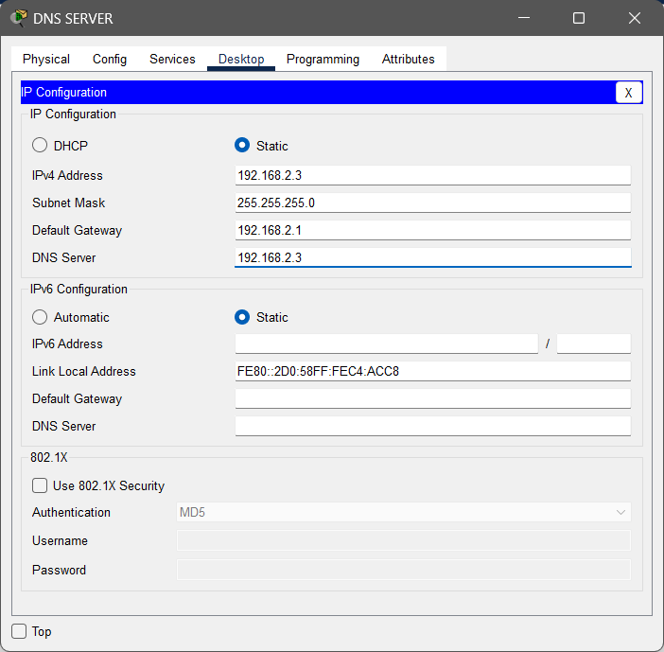

* 1. **Configure Services on the DNS SERVER.**
     1. **Double click on the server and go to services tab.**



* + 1. **Select DNS from the list of services.**



* + 1. **Enter/Update details as specified below in the DNS service.**

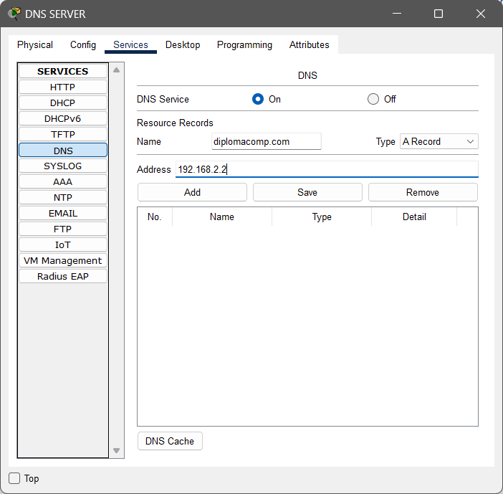

* + 1. **Click on the Add button and you will see the updated details in DNS record list**

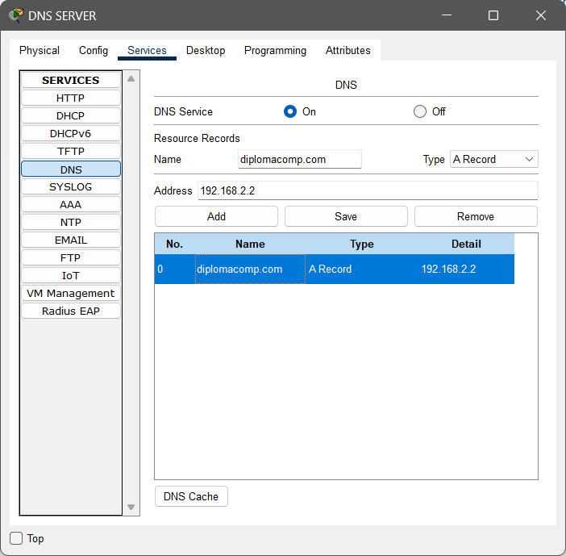

* + 1. **Close the dialog box.**

The configuration part done. Now perform the given operations in the practical quiz section.

1. **Practical Quiz**
2. Screenshot of your configured network.
3. Send mail to user2 from PC1 by using credentials of user1.

To send mail perform the following steps.

1. Open PC1

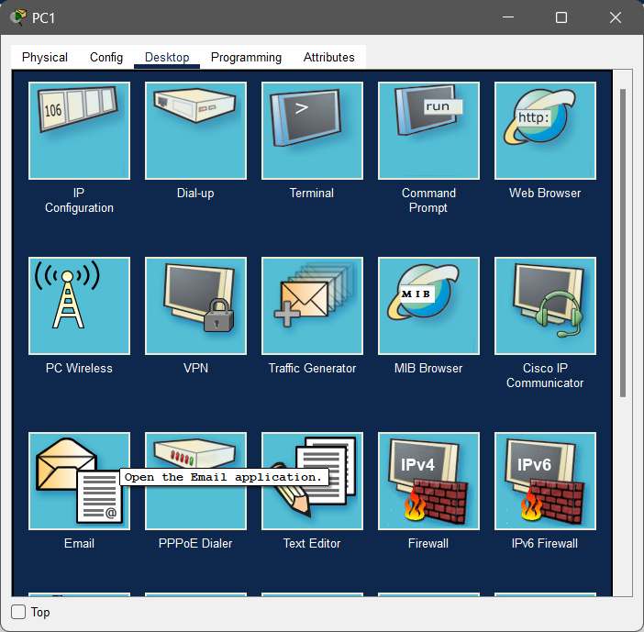

1. Open Email Application and Enter the details as shown below

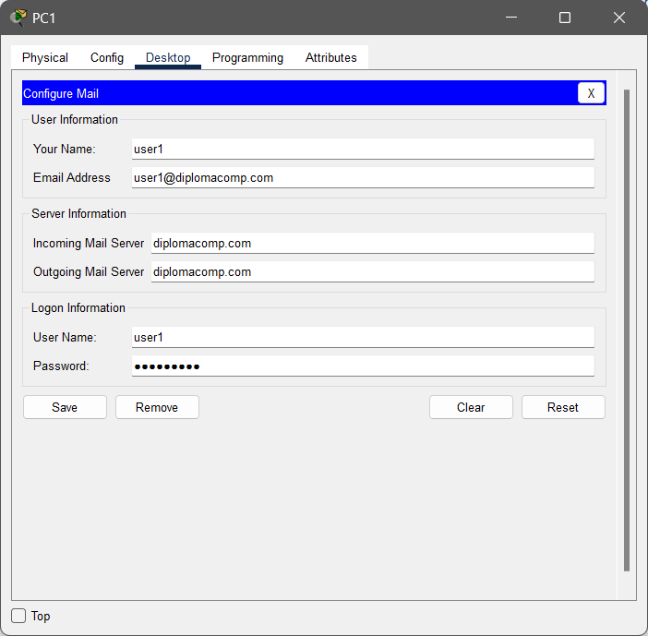

1. Click on the Save button.

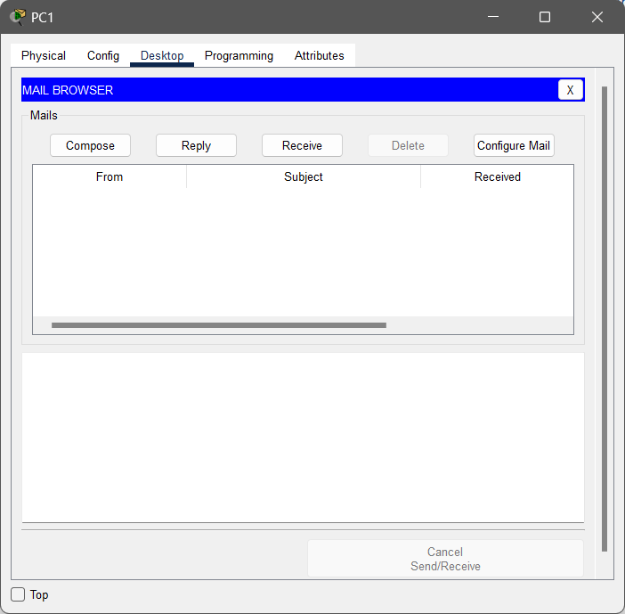

1. Click on the compose mail button. And enter details as shown below.

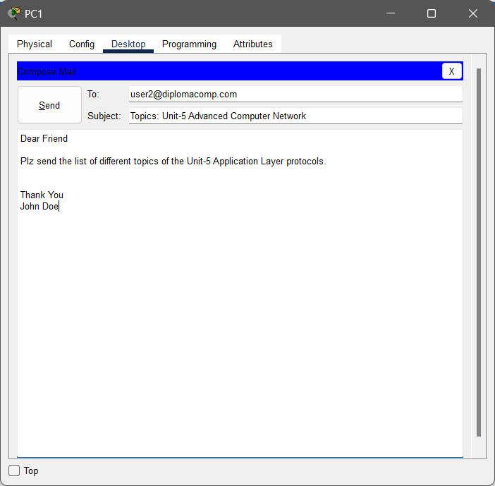

1. Click on send button and You will get the following dialog box.

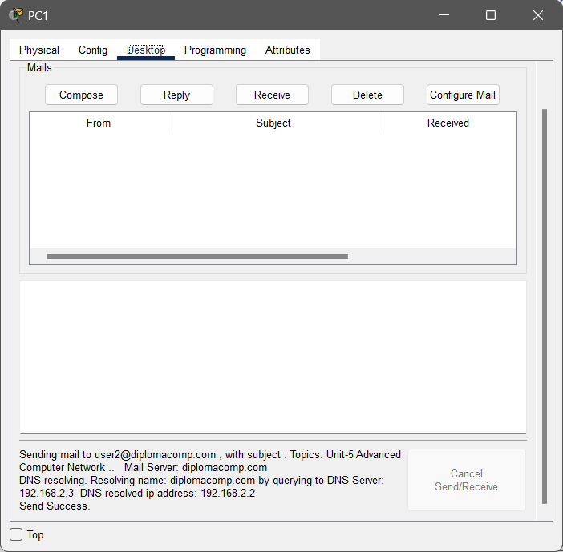

1. Receive mail of user2 in PC2 from mail server.

To send mail perform the following steps.

1. Open PC2

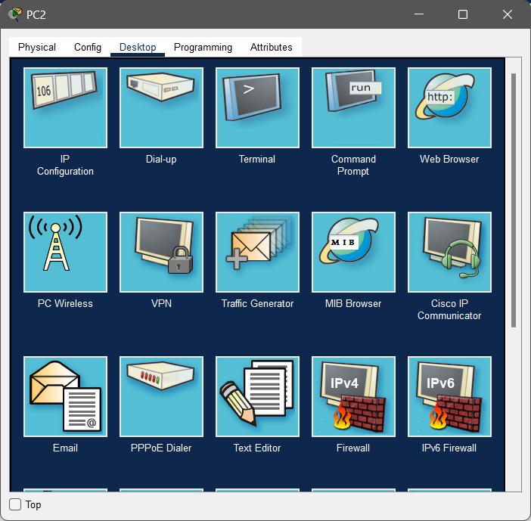

1. Open Email Application and Enter the details as shown below

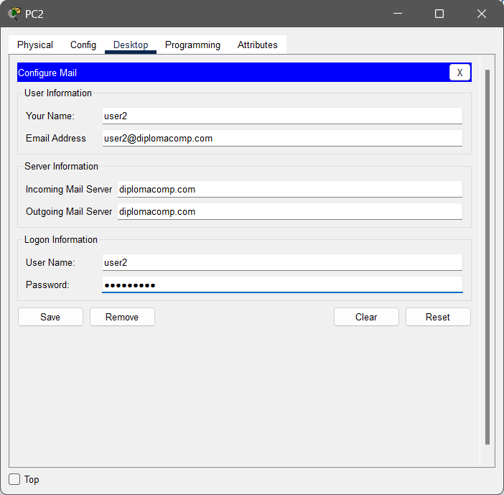

1. Click on the Save button.

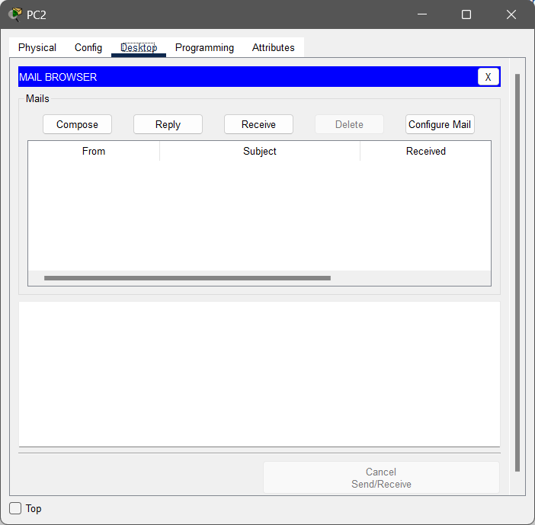

1. Click on the receive button and you will receive all the mail from the mail server. You will get as shown in the image below.

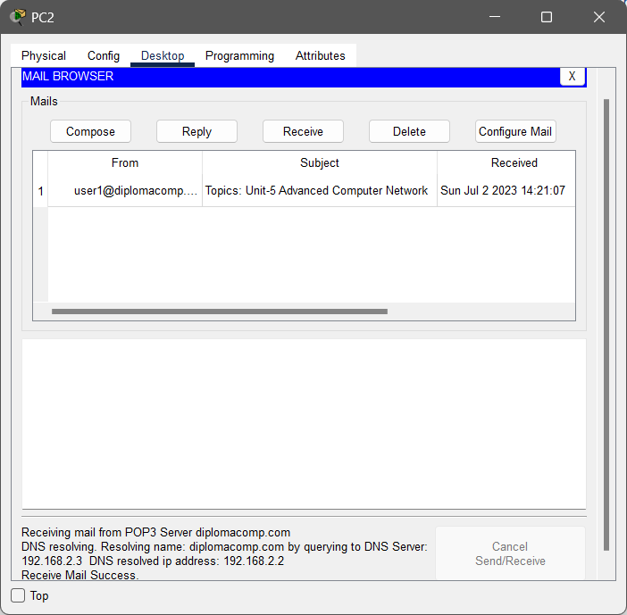

1. Click on the mail and you will get as shown in the image below.

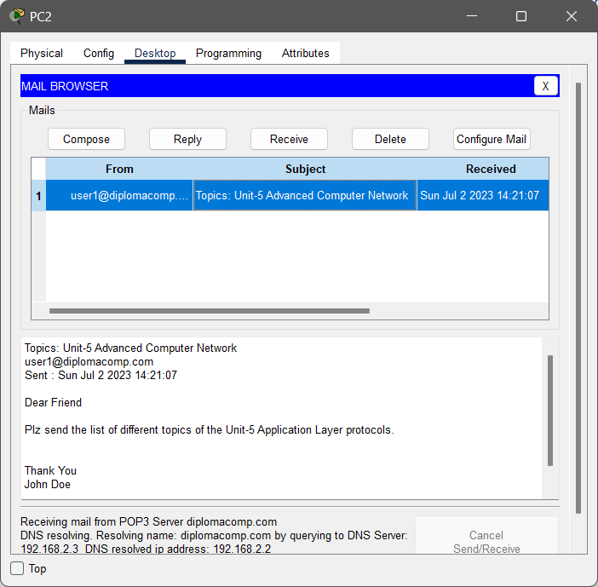

1. If you want to give reply to the particular mail, then select the mail and click on the reply button. Type your reply then click on the send button.
2. Send mail to user1 from PC2 by using credentials of user2. [ Paste screenshot here as shown in the step-v of the question number-2]
3. Receive mail of user1 in PC1 from mail server. [Paste screenshot here as shown in the step-v of the question number-3]
4. **References**

* <https://www.youtube.com/watch?v=D0N1EMQe9SA>
* <https://en.wikipedia.org/wiki/Simple_Mail_Transfer_Protocol>
* <https://datatracker.ietf.org/doc/html/rfc5321>
* <https://www.ietf.org/rfc/rfc2821.txt>
* <https://en.wikipedia.org/wiki/Post_Office_Protocol>
* <https://www.ietf.org/rfc/rfc1939.txt>
* <https://en.wikipedia.org/wiki/Internet_Message_Access_Protocol>
* <https://datatracker.ietf.org/doc/rfc9051/>
* <https://datatracker.ietf.org/doc/html/rfc3501>
* <https://www.youtube.com/watch?v=kVVZ1JAbOoI>
* <https://www.youtube.com/watch?v=sCWjWlX_560>
* <https://www.youtube.com/watch?v=SBaARws0hy4>
* <https://en.wikipedia.org/wiki/Email_client>

1. **Assessment-Rubrics**

|  |  |  |  |  |  |  |  |
| --- | --- | --- | --- | --- | --- | --- | --- |
| **Rubric ID** | **Task** | **Criteria** | **%** | **Good** | **Average** | **Poor** | **Mark** |
| **RB1** | Completion of the given task | The student completes all of the tasks required by the assignment. | 30% | All tasks are completed correctly and on time. **(Mark - 3)** | All tasks are completed, but some may be late or incorrect. **(Mark - 2)** | Some tasks are not completed, or they are completed incorrectly or late. **(Mark 1 or 0)** |  |
| **RB2** | Correctness of the given task | The student's work is correct and free of errors. | 30% | All work is correct and free of errors. **(Mark - 3)** | Most work is correct, but there may be a few minor errors. **(Mark - 2)** | There are many errors in the work. **(Mark 1 or 0)** |  |
| **RB3** | Question answers | The student answers all of the questions correctly. | 20% | All questions are answered correctly. **(Mark - 2)** | Most questions are answered correctly, but there may be a few incorrect answers. **(Mark - 1)** | All questions are answered incorrectly. **(Mark - 0)** |  |
| **RB4** | Regularity of the report submission | The student submits the report on time and in the correct format. | 20% | The report is submitted on time and in the correct format. **(Mark - 2)** | The report is submitted on time, but it is not in the correct format. **(Mark - 1)** | The report is late or not submitted at all. **(Mark - 0)** |  |

**Signature With Date**

**Advanced Computer Network**

**4350706**

This Lab manual is prepared by

Shri Chetan C. Kamani

Lecturer

Government Polytechnic, Jamnagar

Shri Ashok K. Panchasara

Lecturer

A.V. Parekh Technical Institute, Rajkot

Shri Narendrasinh V. Limbad

Lecturer

C.U. Shah Polytechnic, Surendranagar

**Branch Coordinator**

Shri B. H. Kantevala

Head of the Department

Computer Engineering

Government Polytechnic Ahmedabad

**Committee Chairman**

Shri R. D. Raghani

(HOD-EC)

Principal (I/C)

Government Polytechnic, Gandhinagar